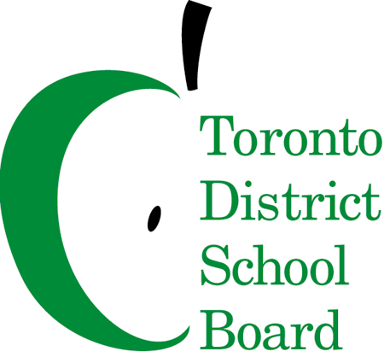

MEETING NOTICE

To: Members of the French-As-A-Second-Language Advisory Committee
FSLAC Meeting - Tuesday, October 10, 2017
6:30 p.m. – Dinner
7:00 p.m. – Meeting
5050 Yonge Street, Committee Room A
Committee Co-Chairs: Lauralyn Johnston (Parent); Robin Pilkey (Trustee)
AGENDA
 | ITEM | LEAD | ACTION | TIME-LINE
 | Call to Order and Acknowledgement of Traditional Lands | Lauralyn Johnston | N/A | 5 min
 | Approval of Quorum  - Welcome/Introductions and Membership Review | Sharon Beason | N/A | 2 min
 | Approval of Agenda | Lauralyn Johnston |  | 2 min
 | Declarations of Possible Conflict of Interest | All Members
 | Approval of Minutes | Lauralyn Johnston | Decision | 5 min
 | Staff Report  - Staff updates incl. Tumpane  - FSL Professional Learning Plan  - CEFR Project Update  - Communication Plan for the SK FI Information Nights  - Presentation and discussion of transportation for FI/Ext students | Kirsten Johnston  Transportation Staff | Information | 10 min  20 min
 | Chair’s Report  - CAC co-chair meeting  - Board consultations: eg. Code of Conduct, Professional Development for Trustees  - Information nights update | Lauralyn Johnston | Information | 20 min
 | Ward Reports | All Members | Information | 20 min
 | Other Business | Lauralyn Johnston | Information | 3 min
 | Adjournment  Next Meeting November 14, 2017 | Lauralyn Johnston | N/A | 2 min

If you wish to participate by teleconference, call-in details are as follows:

• dial 416-849-1983 and enter 8944182 followed by the pound key (#).

Acknowledgement of Traditional Lands

I would like to acknowledge that this meeting is situated upon traditional territories. These territories include the Wendat, the Anishinabek (A NISH NA BECK) Nation, the Haudenosaunee (HOE DENA SHOW NEE) Confederacy, the Mississaugas of the New Credit and the Métis Nation. I would also recognize the enduring presence of Aboriginal peoples on this land.

