Toronto District School Board A Vision for Learning in TDSB

Monday, December 5, 2016 Special Education Advisory Committee

TDSB Vision for Learning

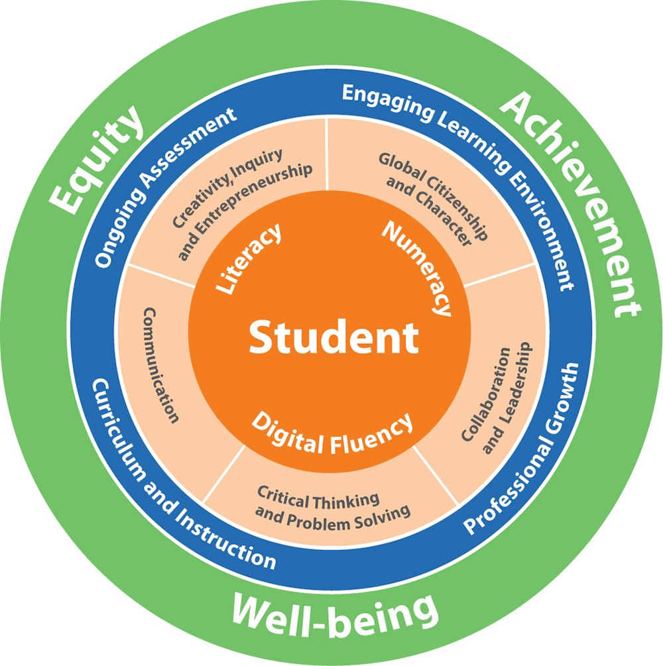We have a foundational commitment to equity, student achievement, and well-being, supported by technology through the lens of global competencies.

Action:
Every school, in partnership with their
superintendent and school community, will
develop authentic foci where equity is
embedded throughout the school
community.

It is through equity, that we will enable student achievement, well-being and learning.

Leadership that Engages and Empowers All

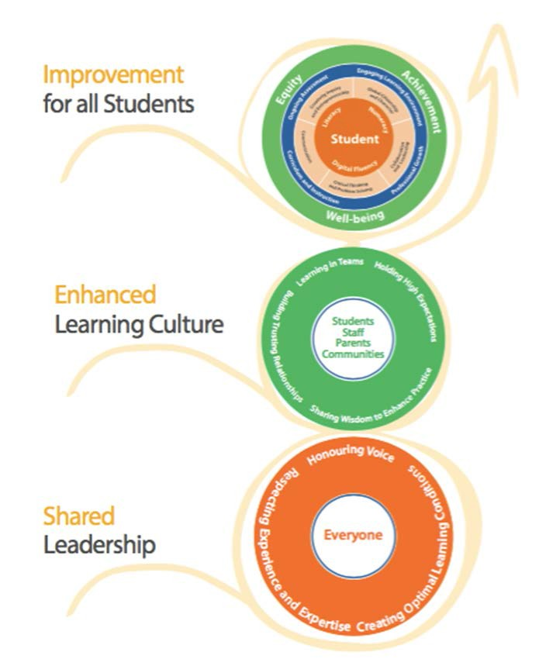We are building a system that supports student learning in a culture of shared leadership

Shared Leadership

- Sharing new learning and solving challenging issues
- Promoting questioning
- Working in collaborative trusting teams
- Encouraging innovation and creativity
- Infusing global competencies through the lens of equity
using rich authentic learning tasks
- Holding high expectations for all learners
- Building relationships that are positive leading to increased
engagement and empowerment of students, staff, parents and
communities

Let’s get started

The lens of equity is relevant to all our schools.

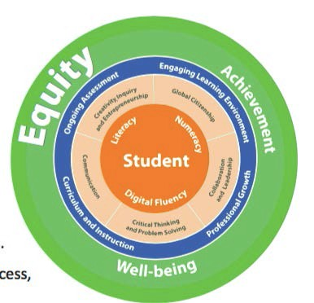Who is not learning?

What are we doing to address barriers, biases and oppression?

5

Equity

Equity and inclusive education aims to understand, identify, address, and eliminate the biases, barriers, and power dynamics that limit students’ prospects for learning, growing, and fully contributing to society.

Barriers may be related to sex, sexual orientation, gender identity, gender expression, race, ethnic origin, religion, socio-economic background, physical or mental ability, or other factors.

It is now recognized that several factors may intersect to create additional barriers for some students. These barriers and biases, whether overt or subtle, intentional or unintentional, need to be identified and addressed.

The outcome of exploring the data will be that each school identify three goals, one each in the areas of equity, well-being and achievement. This exploration includes consideration of content, pedagogy, access and climate, and takes into account school climate, safe schools, demographic and achievement information.

Content:
- What are we teaching (curriculum)?
- How do we ensure the curriculum is inclusive and includes a variety of knowledge of all peoples as the
basis for instruction?
- Whose voices are missing and how do we change that?
- How do we ensure students acquire the skills and knowledge that enable them to challenge unjust
practices, and to build positive and healthy human relationships among their fellow students, and among
all members of society?

Access:
- What are the physical barriers to access (e.g. washrooms, ramps, site safety, special needs equipment,
breakfast programs, etc.)?
- Are there social barriers to access (e.g. language, information and data collection, dress codes, school fees,
social emotional supports, etc.)?

Climate:
- How do we ensure the school environment is welcoming for all (students, staff, parents/guardians, and
community)?
- How do we support student engagement opportunities?
- Do students see diversity and equity represented widely?
- How do we ensure students have input into dress codes and school codes? Is safety an issue? Is there a
means of safe reporting? Do students understand the causes and impacts of inequity in society, and
understand the similarities, differences, intersectionality of multiple social identities and the connections
between different forms of discrimination?

Pedagogy:
- How do we encourage and support student voice?
- How do we demonstrate commitment that all students are capable of learning and achieving?
- How do we engage in conversations about bias and who is achieving/not achieving?
- How do we demonstrate commitment to equity and inclusion?
- How do we engage in culturally relevant and responsive pedagogy?
- Do we employ a variety of assessment strategies as well as instruments used to inform short and long-term
planning to reduce gaps in student achievement and improve student learning and well-being?
- Do we support co-curricular activities that offer student opportunities to achieve success outside the
classroom that can contribute to their engagement in learning and success inside the classroom (e.g. before
and after-school child care and/or programs that are focused on sport, recreation, the arts, and culture)

Professionalism and
professional learning

  - Teachers make professional decisions about lesson plans, supported by colleagues (including the principal) at school while always following the provincial curriculum.

  - The system supports the creation of conditions and supports professional learning at the school level so that these professional decisions are effective.

  - A series of professional learning opportunities for Administrators, Teachers and Support staff on Universal Design for Learning will begin in January.

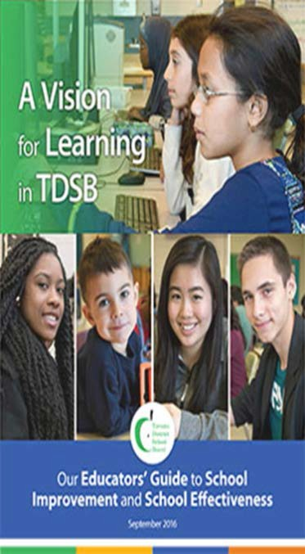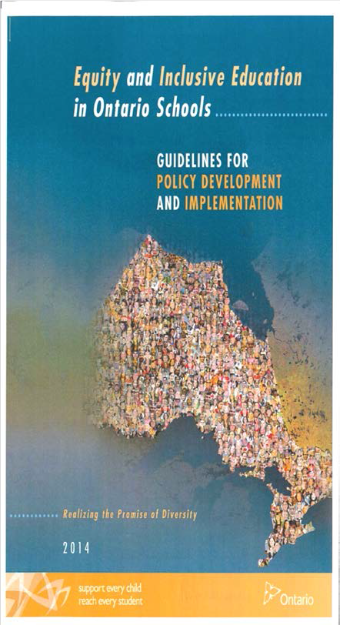Resources

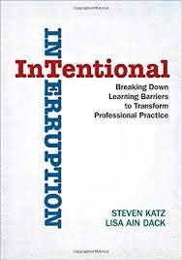PRINCIPAL REFERENCE ONLY – NO NEED TO SHARE

10

Toronto District
'
(School
Board

