Planning and Priorities Committee April 12, 2017 | Page  41 |  | Board Services Agenda Record  PPC:070A  Agenda Item 9.

REVISED PAGE
Report No. 04-17-3089

TORONTO DISTRICT SCHOOL BOARD

BOARDROOM A/V REPLACEMENT AND WEBCAST HUB FOR MULTI-USER GROUPS

TO | Planning and Priorities Committee | 12 April 2017
RECOMMENDATION | IT IS RECOMMENDED that the Board approve the proposed plan to upgrade the existing Boardroom equipment to provide a multi-user audio visual hub for Board, committee, communi- ty and staff use that is compliant with the Association of Acces- sibility for Ontarians with Disabilities’ Act.  That staff be authorized to issue a Request for Proposal for both audio visual equipment and the modular work stations as outlined in the staff report.
STRATEGIC DIRECTION | Make every school an effective school.
RATIONALE | Staff mapped a process to conduct an A/V needs assessment which included meeting with Trustees in committee to get their input on modernizing and replacing the Boardroom A/V system and to wid- en the scope of the use of the Boardroom A/V to include system stakeholders.  Staff also engaged the expertise of a consultant (Global Unified Solutions Services Inc) to advise on replacing current aging Board- room A/V technology with a modern, integrated A/V system. The consultant was also asked to devise an A/V replacement plan that would not only service Board and committee meetings in the Boardroom, but allow the Boardroom A/V system to be used by system stakeholders. The consultant was also asked to come up with a cost estimate range for equipment purchase and installation and should the Board approve, assist in developing the specifica- tions for a competitive tender.  The process has been guided by an inter-departmental staff group with representation from Government, Public and Community Re- lations, Board Services, IT, Purchasing, Web Services and Market- ing and Creative Services. Two sessions were held with Trustees through House Committee. At the April 3 House Committee, staff

Planning and Priorities Committee April 12, 2017 | Page  42 |  | Board Services Agenda Record  PPC:070A  Agenda Item 9.

and the consultant reviewed a proposal to replace the A/V system, and reviewed details of the main hardware and software compo- nents (e.g. cameras, sound, computer and interface hardware, in- ternet broadcast system, software and meeting management hard- ware and software). The presentation also included budget and cost projections on the major components of the proposed A/V system. See Appendix B.

For the past four years, the TDSB has been experiencing technical difficulties and A/V and webcasting failures during Board meet- ings and special events held in the Boardroom. The source of the problems is the aging audio visual integrated platform, micro- phones, cameras and wiring. The equipment is 14 years old (with a maximum 12-year life span) and this, along with out-dated and failing processors and circuit boards has created not only poor au- dio visual performance, but now poses significant reliability risks including complete and catastrophic system failure. In addition, the TDSB is incurring additional overtime costs to have staff pre- sent to trouble shoot in case of failures. Where possible, parts of the system have been replaced (most recently the projectors and a processor) however, due to the age of the equipment and wiring, many older parts are no longer compatible with current A/V, webcasting and sound technology components.

Moreover, our current equipment does not allow for effective host- ing of live webcasts or virtual meetings within the 5050 Yonge site. As the TDSB has recently embarked on a community en- gagement and communications strategy that utilizes live and at times interactive webcasting, the failing system at 5050 has be- come a significant impediment to realizing the full potential of this effective and accessible communications and engagement strategy. Poor A/V performance, coupled with an aging and at times unreli- able webcast system has resulted in frequent webcast interruptions which in turn reduces viewership of the live broadcast. Finally, the current A/V system does not allow for the addition of closed cap- tioning, and therefore undermines the TDSB’s commitment to de- liver accessible webcasts of Board meetings.

As mentioned above, the TDSB is now embracing webcasting as a means of reaching far more parents and stakeholders. Last year we ran pilot interactive webcasts that allowed the TDSB to reach thousands of parents and employees in ways we could not before. Post webcast participant surveys (from parents and employees) show overwhelming support for us to deliver more.

Planning and Priorities Committee April 12, 2017 | Page  43 |  | Board Services Agenda Record  PPC:070A  Agenda Item 9.

Recently, the Special Education Advisory Committee requested using the Boardroom A/V system to webcast and/or video record their meetings to improve participation, communication, transpar- ency and the ability to archive meetings for post meeting viewer- ship. No doubt other advisory committees will follow suit and ex- press interest in doing the same.

The current A/V system cannot support this additional use. Its cur- rent tenuous status and unreliable functionality means that any added use could contribute to a catastrophic system failure.

Central A/V Webcast, Multi-User Hub

The A/V Boardroom upgrades will allow for more flexibility. This means we can be guided by strategic considerations to extend the use and benefit of a new A/V technology well beyond its current use for board meetings.

When equipped with modern A/V technology, the Boardroom can become a hub for A/V and webcast outreach that can be made available not only for Board meetings, but also serve other purpos- es including:

- Community advisory committee meetings;
- Community consultation using interactive webcasts;
- Budget presentations/consultations;
- Student SuperCouncil meetings;
- Parent and employee webinars;
- Virtual ward council meetings.

The A/V replacement plan also includes use of wireless technolo- gy; meaning that the configuration of the Boardroom can be changed to suit different set-up options. Currently the Boardroom desks are hardwired and cannot be moved. A wireless A/V retrofit would allow the Boardroom to be reconfigured to offer the look and feel of a smaller committee room or to theatre, lecture, or classroom style suitable for various presentations and consultations and more intimate meetings.

Proposed Major Component Replacement Plan

Appendix A is a brief Q&A based on questions of staff, the con- sultant and questions about the slide deck presentation.

Planning and Priorities Committee April 12, 2017 | Page  44 |  | Board Services Agenda Record  PPC:070A  Agenda Item 9.

Appendix B is a slide deck prepared by Global Unified Solutions Services Inc. and presented to the House Committee. This pro- posed plan outlines the key major component replacements and features including:
- Conferencing/microphone/audio;
- Broadcasting;
- Video infrastructure system;
- Work stations and interactive screens (also shows who is conferencing);
- Voting/speakers list.

Cost Projections

To replace the Boardroom A/V system based on the major compo- nents outlined above for Boardroom use and for use as a Central TDSB A/V webcast hub, the projected costs for the hardware and software is between $450k and $530k which includes installation, but not any furniture replacement. The consultant has used a cost range at this time. The procurement process will bring more preci- sion to the actual costs. Funds will be allocated from the capital budget (multi-user audio visual hub) for this project.

To create the A/V Webcast Hub with universal work stationsthat can be reconfigured, the additional cost would be between $65k and $75k. As staff worked with the consultant and the House Committee, the concept of a more multi-purpose, multi-user A/V Hub evolved. More precise cost projections may be needed and staff are also investigating whether the existing Boardroom desks can be salvaged in whole or in part to give the universal function- ality that a hub would require.

Recommendation

That the Board approve the proposed plan to upgrade the existing Boardroom equipment to provide a multi-user audio visual hub for Board, committee, community and staff use that is compliant with the Association of Ontarions Accessibility for Ontarians With Dis- abilities’ Act.
That staff be authorized to issue a Request for Proposal for both audio visual equipment and the modular work stations as outlined in the staff report.

IMPLEMENTATION Pending a decision to proceed, installation will take place over the

Planning and Priorities Committee April 12, 2017 | Page  45 |  | Board Services Agenda Record  PPC:070A  Agenda Item 9.

AND REVIEW | summer months and into September if necessary.
APPENDICES | Appendix A: | Q & A’s
 | Appendix B: | Boardroom AV Costing PowerPoint
FROM | Ross Parry, Executive Officer,  Government, Public and Community Relations

Planning and Priorities Committee April 12, 2017 | Page  46 |  | Board Services Agenda Record  PPC:070A  Agenda Item 9.

Appendix A

Common Questions and Answers

- Q: Has staff explored the cost variance of replacing parts of the A/V system gradually to reduce costs?

A: Yes. Compatibility is the major factor. Replacing projectors recently created compati- bility issues with the central functionality hardware. The A/V system is an intelligent sys- tem with components that work in conjunction with one another. Replacing parts would be akin to finding parts to upgrade a VCR to use Blu-ray technology.

- Q: Explain the workstation concept – what does it involve?

A: A work station is comprised of a wireless mic and a 17”-19” Windows touch screen. The screen is similar to a dash board, and displays agenda materials (a paperless agenda is possible), a speakers list, touch screen voting and displays speaker’s time allotment remaining.

- Q: Can webcast viewers see the vote results?

A: Yes, visitors in the Boardroom would see the vote results displayed as would viewers watching the webcast.

- Q: If the room is reconfigured can the cameras also be adjusted?

A: Yes.

- Q: Will the live portion of a webcast for Board meetings be closed captioned to meet AODA (accessibility) compliance?

A: Under provincial AODA legislation we are required to provide closed captions in ar- chived Board meetings. A new A/V system will allow the TDSB to exceed minimum AODA compliance by exploring closed caption for live Board meetings and web broad- casts.

- Q: Is there interest from other groups to use the technology?

A: Yes. SEAC has made this request. We are very certain that other advisory committees would choose to webcast if the option is available to them.

- Q: Is there any staff savings gained from the current system?

Planning and Priorities Committee April 12, 2017 | Page  47 |  | Board Services Agenda Record  PPC:070A  Agenda Item 9.

A: Yes. Currently, we have as many as three technicians including a standby trouble shooting technician for Board meetings. The new system would require at least one less technician resulting in less overtime costs.

- Q: Will senior staff seated in the Boardroom also have work stations?

A: Yes. We are estimating approx. 50 stations (wireless mic and touch screen)

- Q: Currently the desks are very small. Can they be made larger?

A: Yes. This has come up in our discussions about furniture. It will be considered in the furniture cost allotment.

- Q: Given the ability to reconfigure the room, is it anticipated that the Boardroom would be used for some committee meetings?

A: Yes. It is anticipated that P&P would be in the boardroom with desks reconfigured to provide a less formal setting. The advantages will be the larger, lower and upper visitor, delegation and attending staff seating spaces, the ability to webcast or video record P&P and delegate presentations and improved air quality. Other smaller committees could con- tinue to meet in Committee Room A.

- Q: Will the new system allow for multi-media to be played such as videos, CDs etc.?

A: Yes, this functionality would be integrated into the new system.

- Q: In terms of the A/V webcast hub concept, are there any limitations?

A: Not really. The user group can choose to video-record or webcast. They can also se- lect a single camera to record/webcast the meetings or a camera configuration that tracks individual speakers, similar to a Board meetings.

Planning and Priorities Committee April 12, 2017 | Page  48 |  | Board Services Agenda Record  PPC:070A  Agenda Item 9.

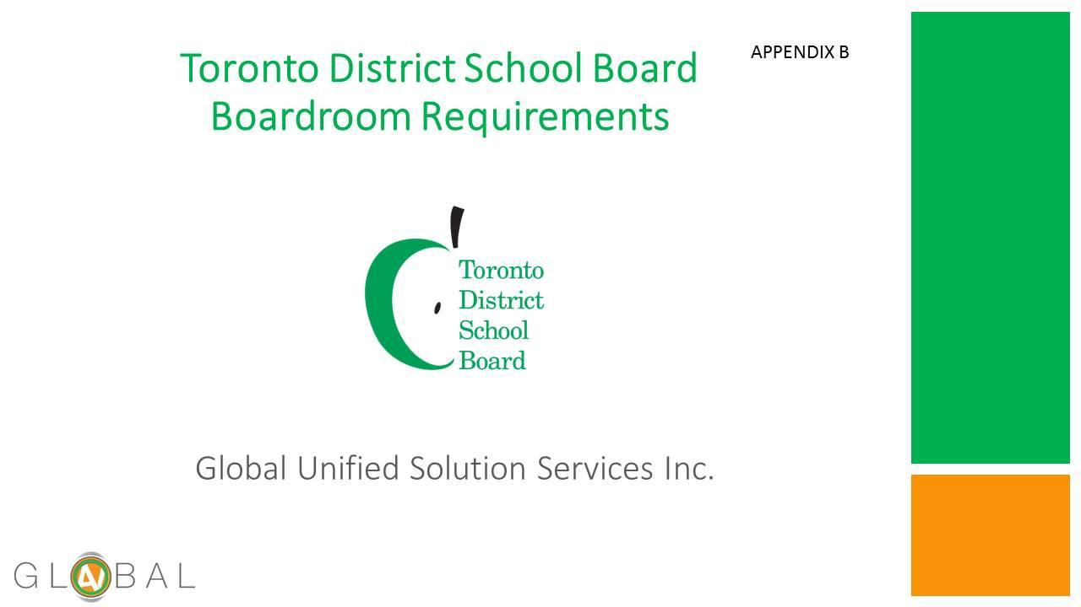

Planning and Priorities Committee April 12, 2017 | Page  49 |  | Board Services Agenda Record  PPC:070A  Agenda Item 9.

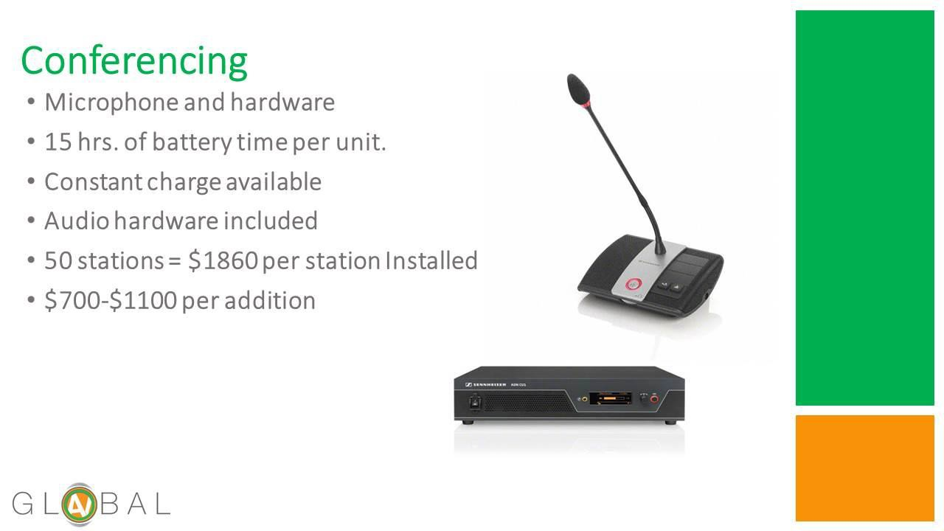

Planning and Priorities Committee April 12, 2017 | Page  50 |  | Board Services Agenda Record  PPC:070A  Agenda Item 9.

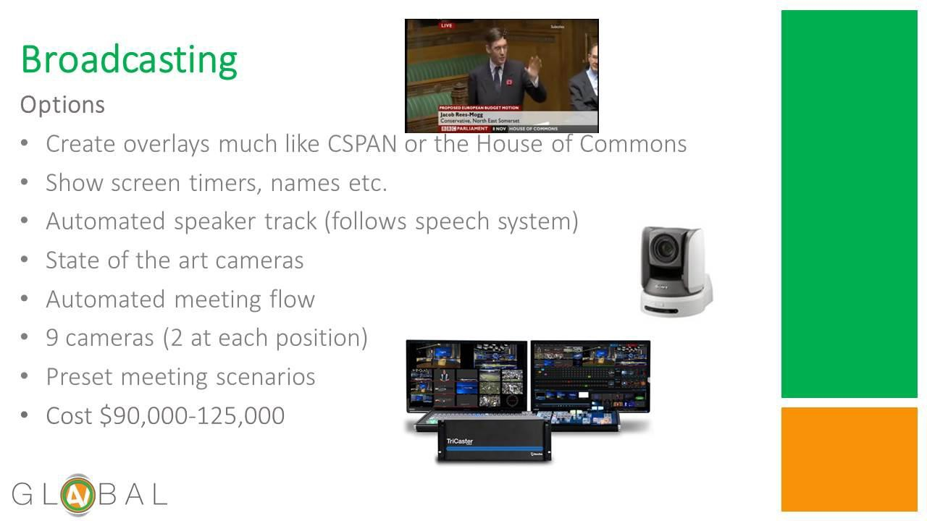

Planning and Priorities Committee April 12, 2017 | Page  51 |  | Board Services Agenda Record  PPC:070A  Agenda Item 9.

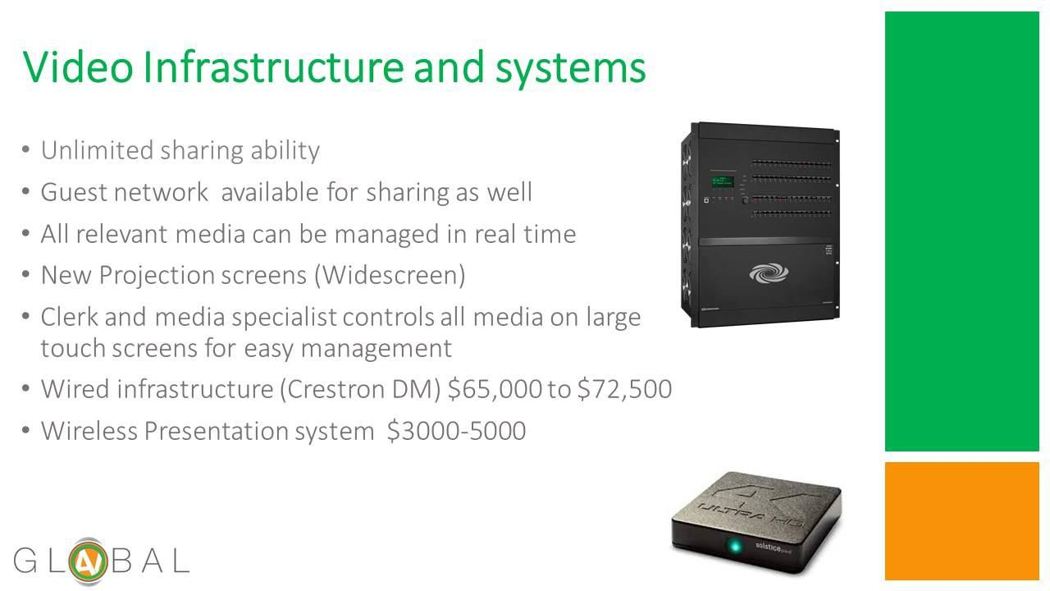

Planning and Priorities Committee April 12, 2017 | Page  52 |  | Board Services Agenda Record  PPC:070A  Agenda Item 9.

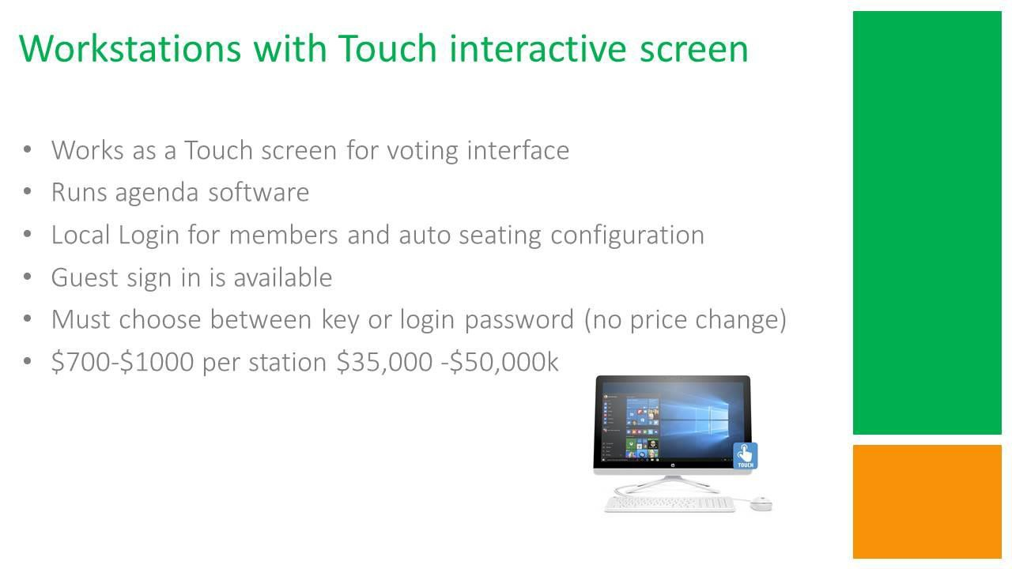

Planning and Priorities Committee April 12, 2017 | Page  53 |  | Board Services Agenda Record  PPC:070A  Agenda Item 9.

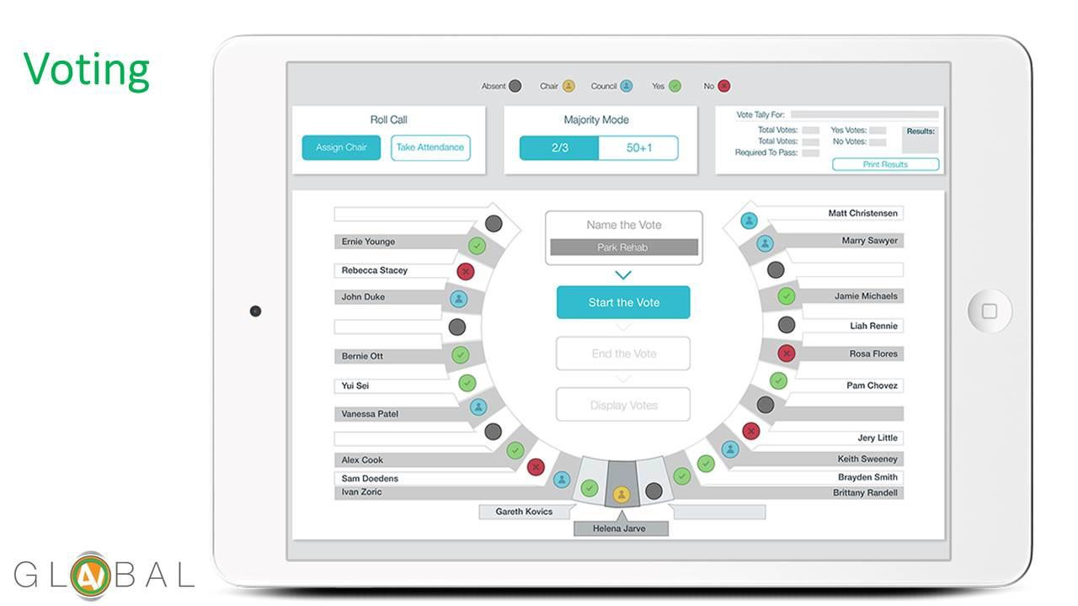

Planning and Priorities Committee April 12, 2017 | Page  54 |  | Board Services Agenda Record  PPC:070A  Agenda Item 9.

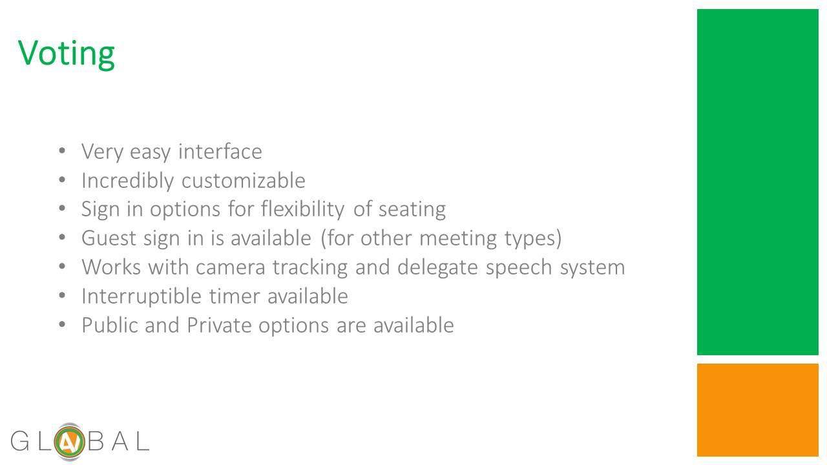

Planning and Priorities Committee April 12, 2017 | Page  55 |  | Board Services Agenda Record  PPC:070A  Agenda Item 9.

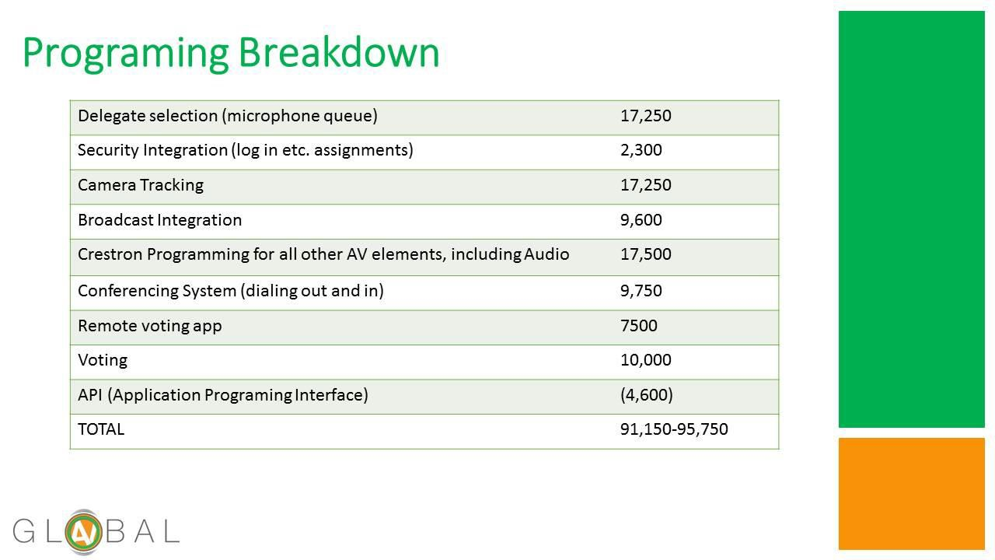

Planning and Priorities Committee April 12, 2017 | Page  56 |  | Board Services Agenda Record  PPC:070A  Agenda Item 9.

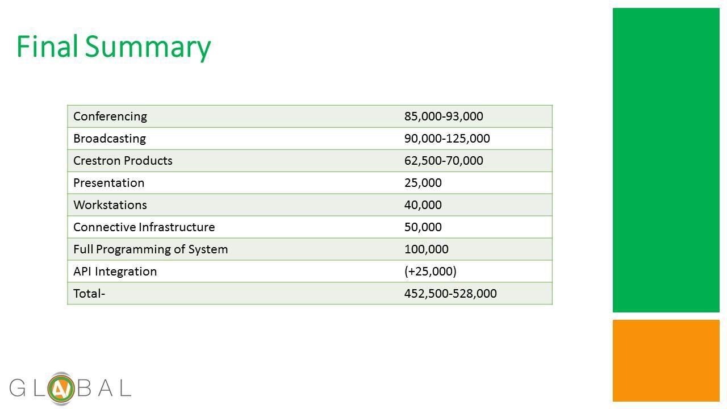

Planning and Priorities Committee April 12, 2017 | Page  57 |  | Board Services Agenda Record  PPC:070A  Agenda Item 9.

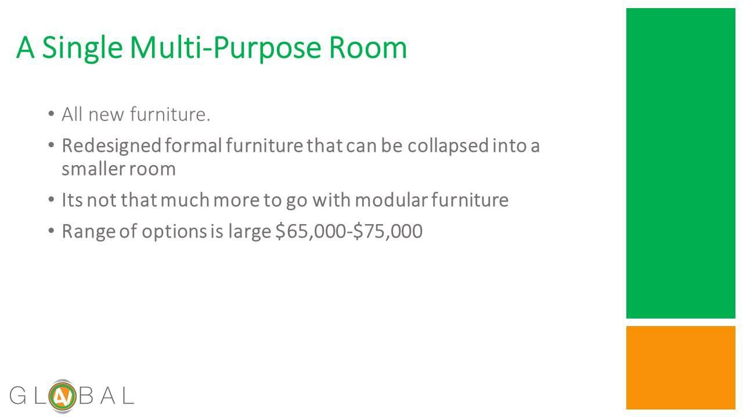

Planning and Priorities Committee April 12, 2017 | Page  58 |  | Board Services Agenda Record  PPC:070A  Agenda Item 9.

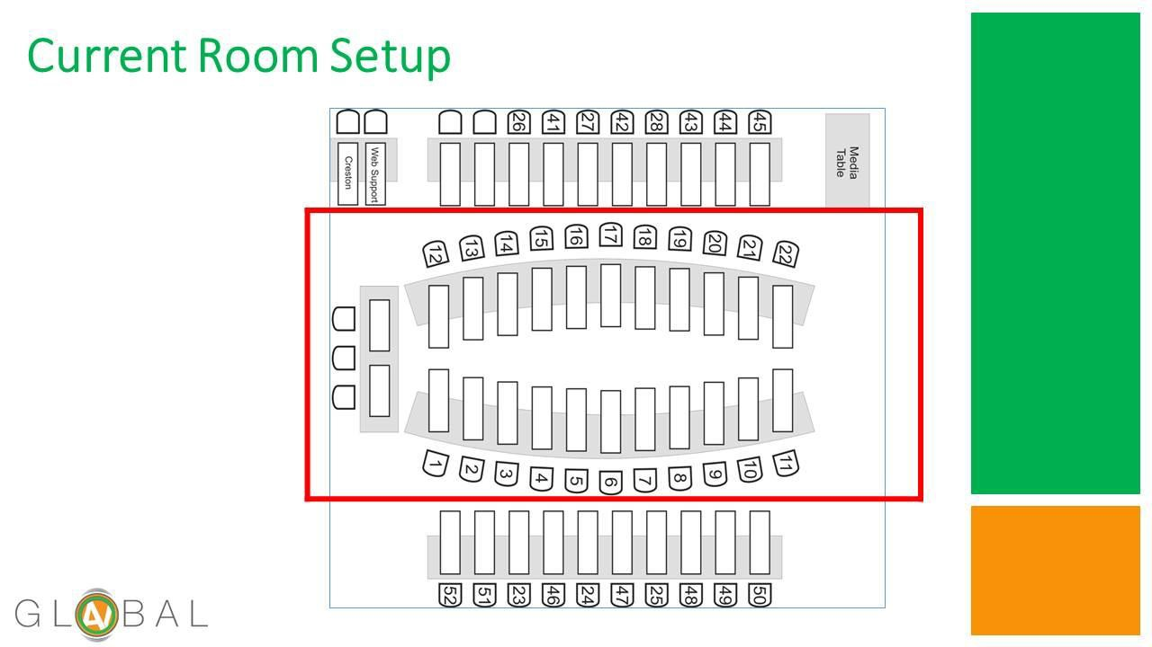

Planning and Priorities Committee April 12, 2017 | Page  59 |  | Board Services Agenda Record  PPC:070A  Agenda Item 9.

Planning and Priorities Committee April 12, 2017 | Page  60 |  | Board Services Agenda Record  PPC:070A  Agenda Item 9.

Planning and Priorities Committee April 12, 2017 | Page  61 |  | Board Services Agenda Record  PPC:070A  Agenda Item 9.

Planning and Priorities Committee April 12, 2017 | Page  62 |  | Board Services Agenda Record  PPC:070A  Agenda Item 9.

Planning and Priorities Committee April 12, 2017 | Page  63 |  | Board Services Agenda Record  PPC:070A  Agenda Item 9.

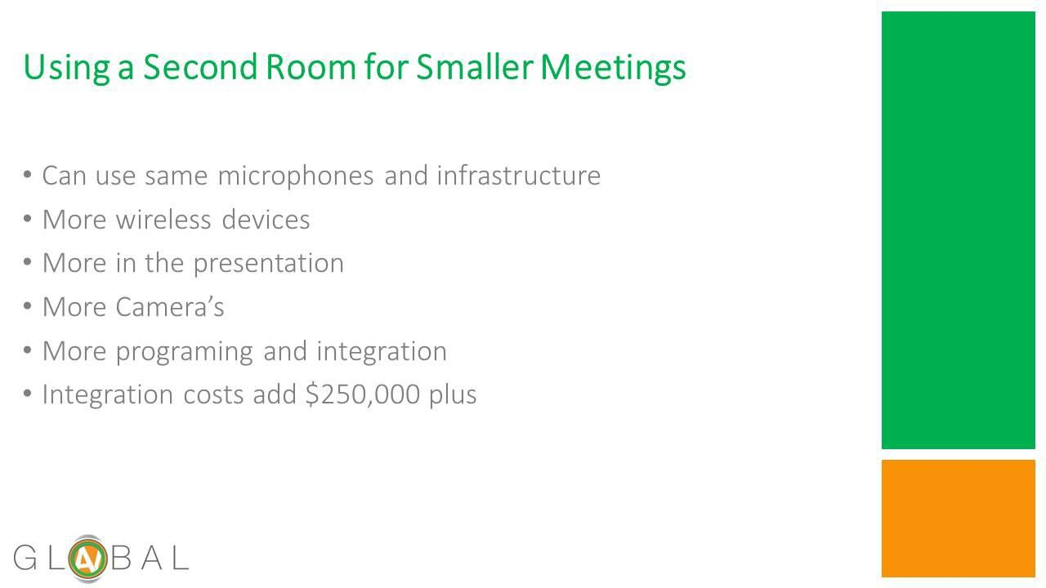

Planning and Priorities Committee April 12, 2017 | Page  64 |  | Board Services Agenda Record  PPC:070A  Agenda Item 9.

Blank Page

