Committee: Black Student Achievement Community Advisory Committee
Date: Monday, October 5, 2020
Time: 7:00 – 9:00 p.m.
Location: Virtual Zoom Space - https://zoom.us/j/95501619477

Meeting ID: 955 0161 9477
Dial-in Details
6473744685,,95501619477#
6475580588,,95501619477#

Committee Co-Chairs: Trustee Chris Moise, Community Alexis Dawson
Acknowledgement of Traditional Lands

"We acknowledge we are hosted on the lands of the Mississaugas of the Anishinaabe, the Haudenosaunee Confederacy and the Wendat. We also recognize the enduring presence of all First Nations, Métis and Inuit peoples."

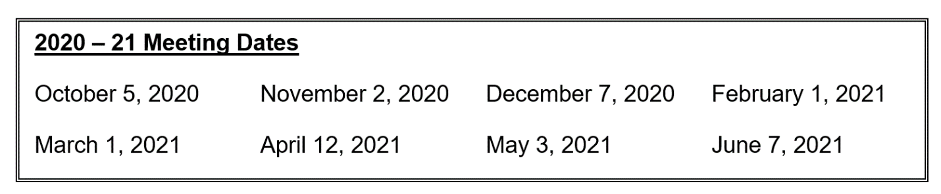
AGENDA:
 | Item | Information | Timeline
1. | Welcome and Land Acknowledgement/ Introductions |  | 5 min.
2. | Call to Order/Confirmation of Quorum |  | 4 min
3. | Approval of Agenda |  | 2 min.
4. | Declarations of possible conflict of interests |  | 2 min.
5. | Co-Chair Update – Alexis Dawson, Trustee Chris Moise |  | 20 min.
6. | Community Updates |  | 20 min
7. | Staff Update – Curtis Ennis, Jackie Spence |  | 30 min
8 | Other Business
 | Adjournment

