To: Members of the Alternative Schools Advisory Committee (ASAC)
Date: Monday, January 15, 2018
Time/Location: 7:00 pm (6:30 pm dinner), 5050 Yonge Street, Committee Room A
Committee Co-Chairs: Boriana Karan, Prafulla Prabhu, Liam Rodrigues, Trustee Ausma Malik

Teleconference Details: Dial: 416-849-1983 Participant Code: 8818338#

AGENDA:

 | ITEM | ATTACHMENT | TIMELINE
 | Welcome & Introductions |  | 5 min
2. | Confirmation of Quorum |  | 2 min
3. | Approval of Agenda |  | 5 min
4. | Approval of Minutes – November 20, 2017 | 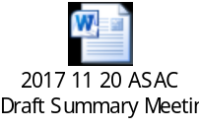 | 5 min
5. | Emerging Concerns |  | 15 min
6. | Supporting Documents for Alternative Administrators |  | 15 min
7. | Towards Equity Admissions: Committee to Review and Inform Existing Practices |  | 15 min
8. | Developing Relationships with Post-Secondary Institutions |  | 15 min
9. | Discussion on ASAC Mandate, Terms of Reference and Annual Report | 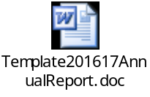 | 10 min
10. | Adjournment  Upcoming Meeting Dates – Monday, February 26, 2018 |  | 5 min

