OFFICE OF THE DIRECTOR OF EDUCATION
5050 Yonge Street, Toronto, Ontario M2N 5N8

January 1, 2018

Craig Snider
Executive Officer - Finance
Dear Craig,
During the 2017-2018 school year, I would ask you to focus on the following key areas while fulfilling all of the duties of your position:
- Lead the Business Services Department and Compensation Services by strengthening the performance of all Managers by enhancing orientation and leadership learning opportunities for growth.
- Assist with the development of the Board’s operating and capital budget to align resources more effectively with our commitments to equity and student achievement.
- Continue with the implementation of the cashless school initiative and examine financial processes to determine if they can be streamlined to support schools from being overly burdened by finance administration that can be done centrally.
- Working with Business Services and Compensation Services to infuse service excellence and equity into all policies and procedures.
- Effective support of the Finance, Budget and Enrolment Committee and the Planning and Priorities Committee.
I ask that you collaborate intentionally and strategically with the following colleague(s):
- Chris Ferris, Sabrina Wang, Marisa Chiu, Garry Green, Julia Oliva and Ann Anderson to review, identify and implement service excellence procedures within Business Services and Compensation Services to improve supports to schools.
- Support the themes identified below:
- Support learning for all Business and Compensation Services areas so that outstanding service excellence is realized using an equity lens.
- Assist the service/business side of the organization to understand and implement our commitment to being responsive through leadership, effective learning environments and focused improvement.

… 2 …

- Continue to Support the Toronto Lands Corporation (TLC).
- Audit Committee.
- Planning and Priorities Committee.
Please develop an action plan with deliverables, measurements and the data when various aspects of the plan will be completed.
Thank you for your exemplary leadership in TDSB.
Sincerely,

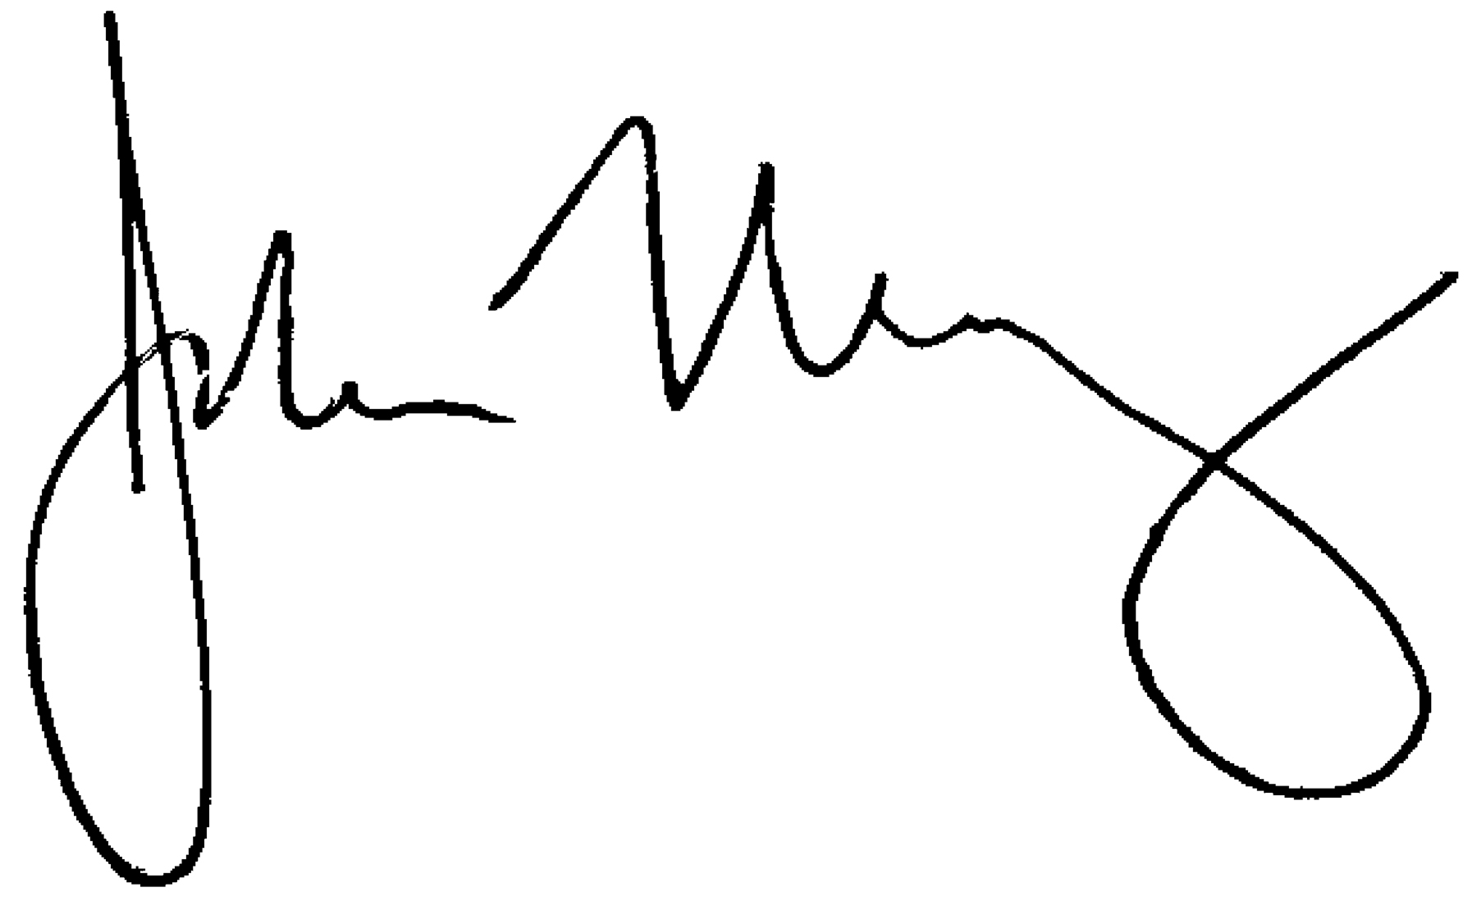
John Malloy
Director of Education

