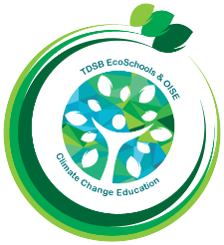
TDSB/OISE Action Research
Team Research Summary

Introducing the Teacher-Researcher, Students & School
Bonnie Mullrooney - Eco-champion at McKee Public School facilitating climate change learning and action for over 100 EcoKids.

Monica Fennema - Second year OISE teacher candidate interested in meaningful, hands-on environmental education in public schools.
Research Question
Umbrella question - How do we intentionally build a community of environmental leaders that have the capacity to take Climate Action within their school community?

Sub-question for this year's inquiry - What compels elementary students in Ontario public schools to participate in and commit to co-curricular clubs centred around the environment? Or, put simply, WHY ECOKIDS?
Curricular Implementation
Not applicable as this is a co-curricular project, however, Eco Club and Green Team initiatives include classroom learning (i.e., suggesting resources for teachers in the monthly newsletter).
Data Collection Strategies
- Observation during Eco Club meetings
- Student work samples
- Semi-structured group interviews with students and teachers (Eco Club leaders and Action Research team members at other TDSB schools)
Insights from this Action Research Study w/ Photos
While it is hard to narrow down the countless reasons for why students join Eco Club, these three themes were evident throughout the data collection process.
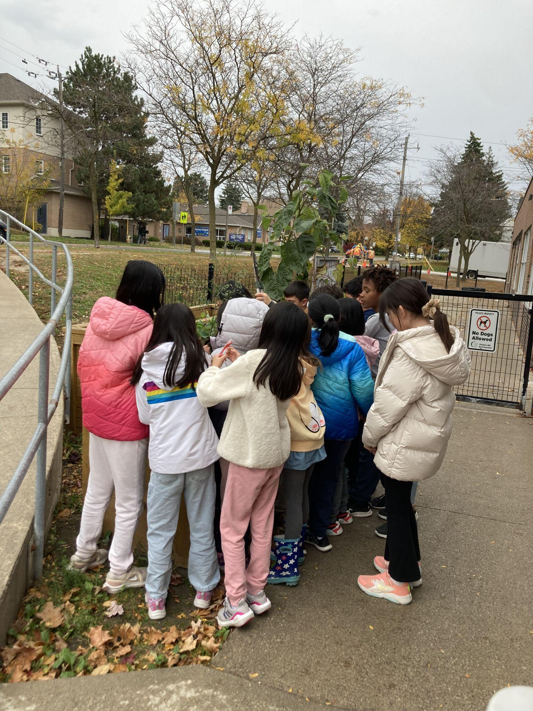
1 - A passion for the environment.

Eco Club students, the EcoKids, deeply care about the environment. They continually express their love and concern for Mother Earth in their words and actions and are consistently seeking for new ways to make positive changes in their everyday lives.

Picture 1: EcoKids gather around the school garden, excited to engage their senses with the colourful tomatoes and nasturtiums.

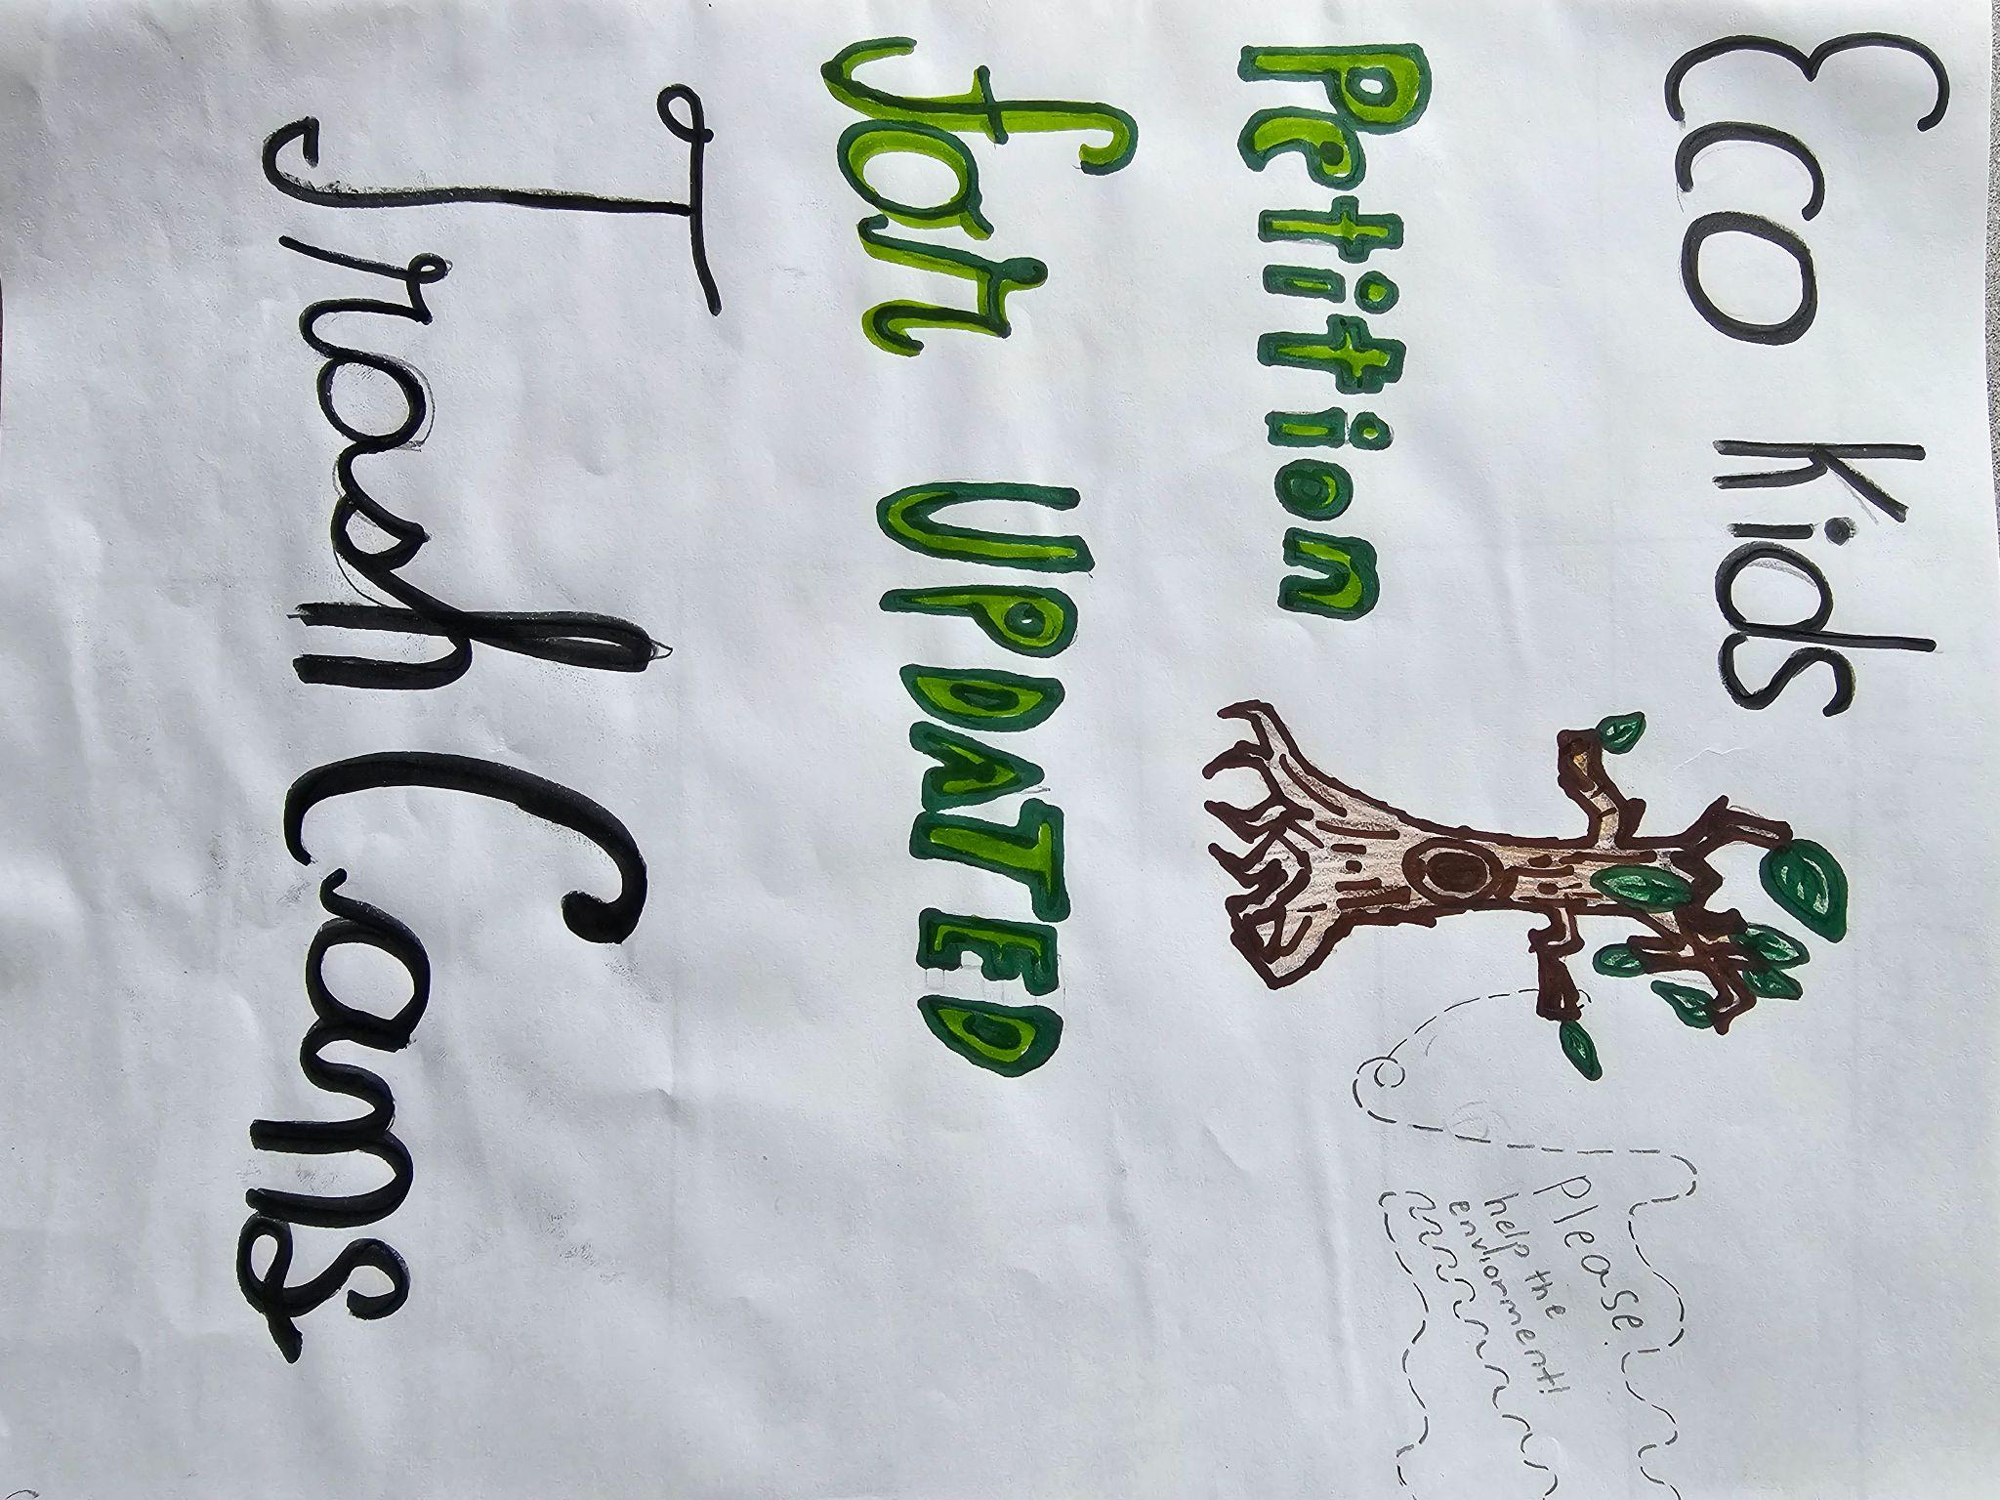
2 - Eco Club creates space for student-led initiatives.

Eco Club facilitates student independence and creativity. Their natural leadership is evident in the stories they share about modelling eco-conscious behaviour for their peers, from waste management in their classrooms to caring for trees and ants in the school yard.

Picture 2: Grade Five EcoKids started a petition after noticing that the outdoor trash receptacles contributed to a lot of fly away garbage. They are now collecting signatures from their peers and teachers to request improved trash cans for their school community.

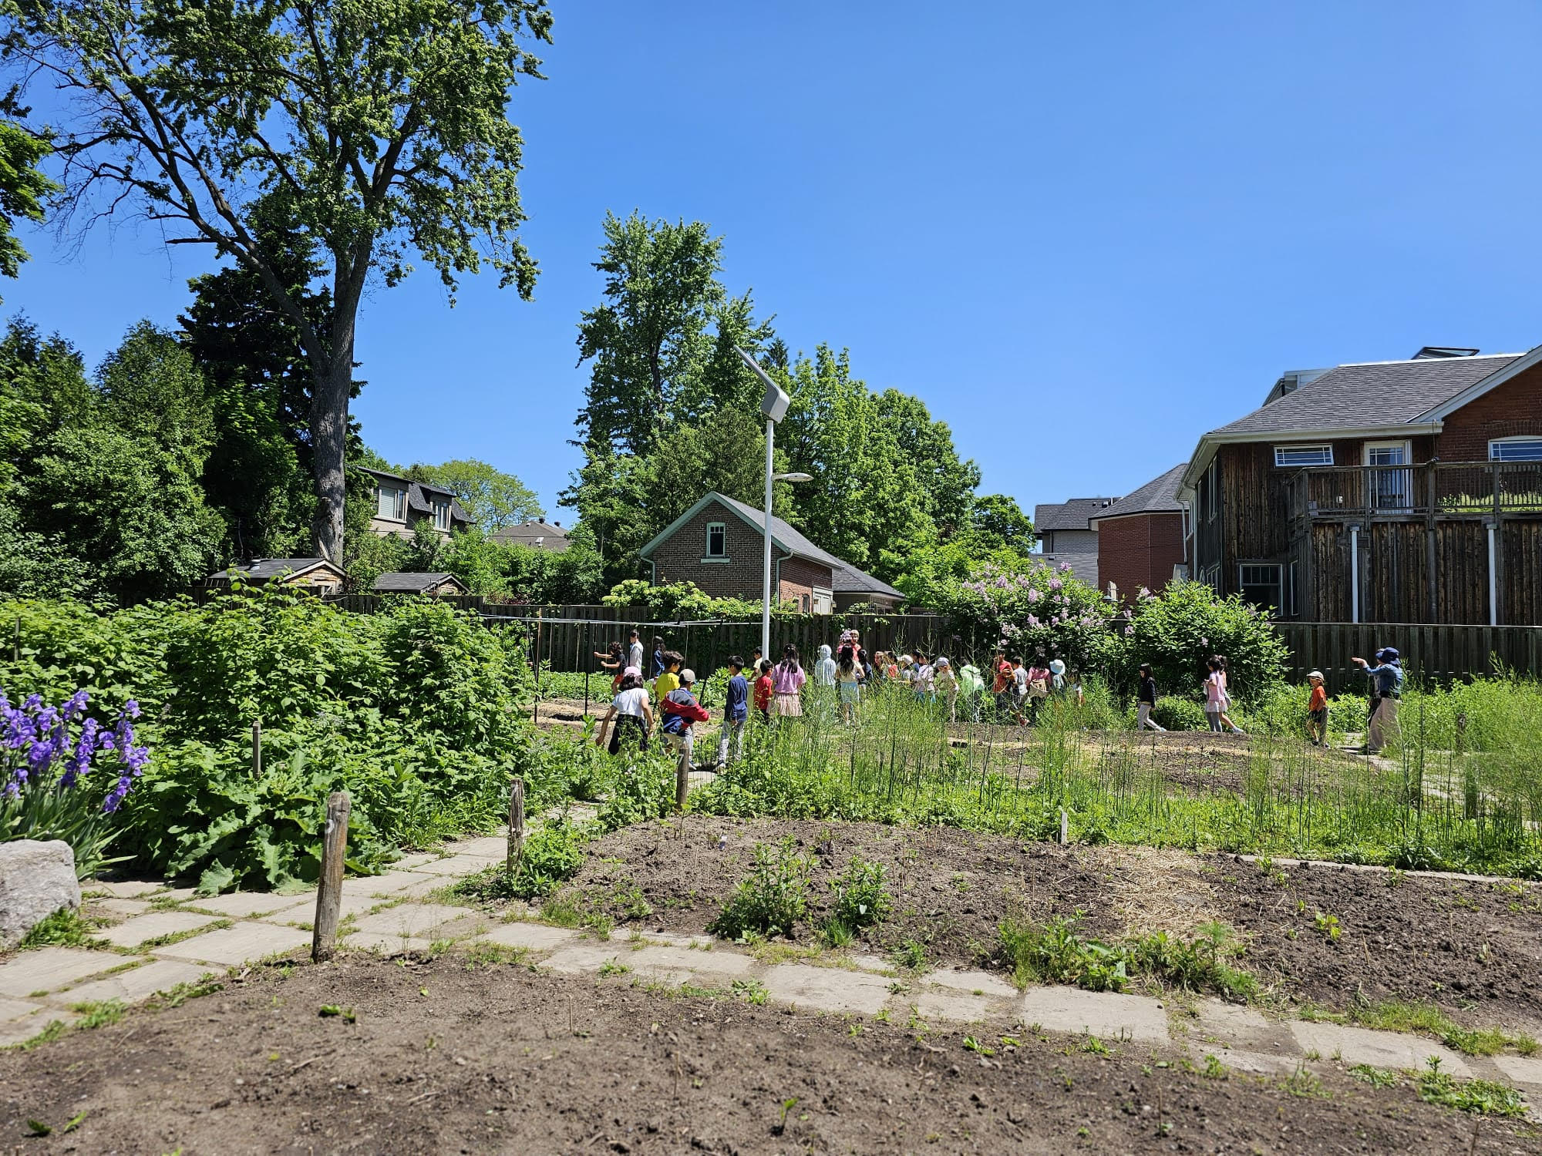
3 - Learning beyond the classroom.

Climate change learning and action must be holistic and extend beyond instructional time. The shift between individual to communal responsibility also happens during Eco Club.

Picture 3: During the interviews, students highlighted the walking excursion to the community garden as one of their favourite Eco Club experiences.

Other Notes

There are many ways to organize an Eco Club. This year, McKee transitioned from two student representatives per class, to implementing an open invitation model. The turnout was incredible, there were 140 students at the first meeting!

