
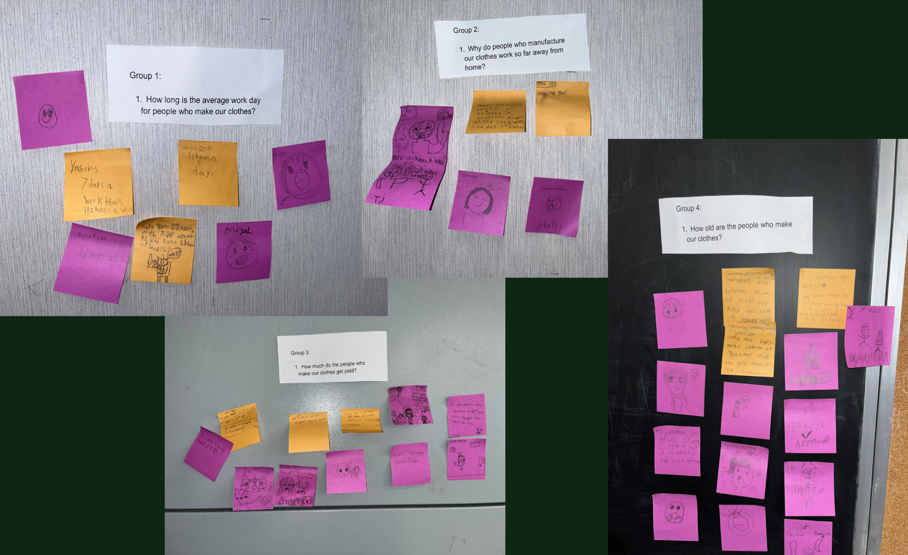
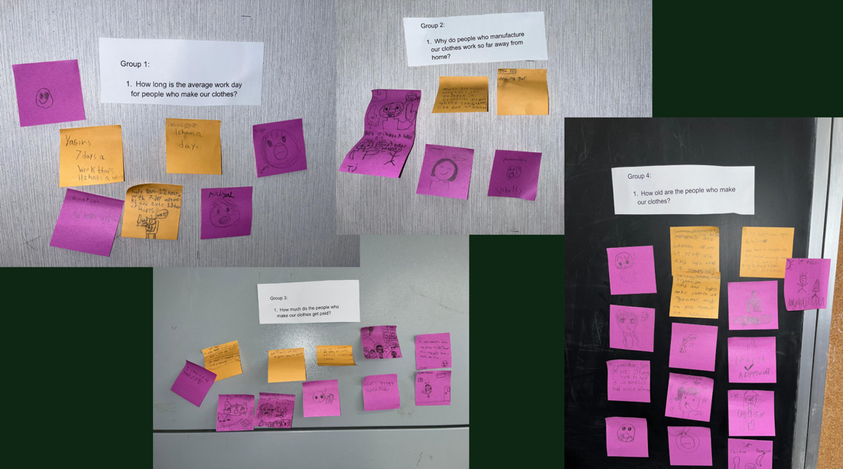
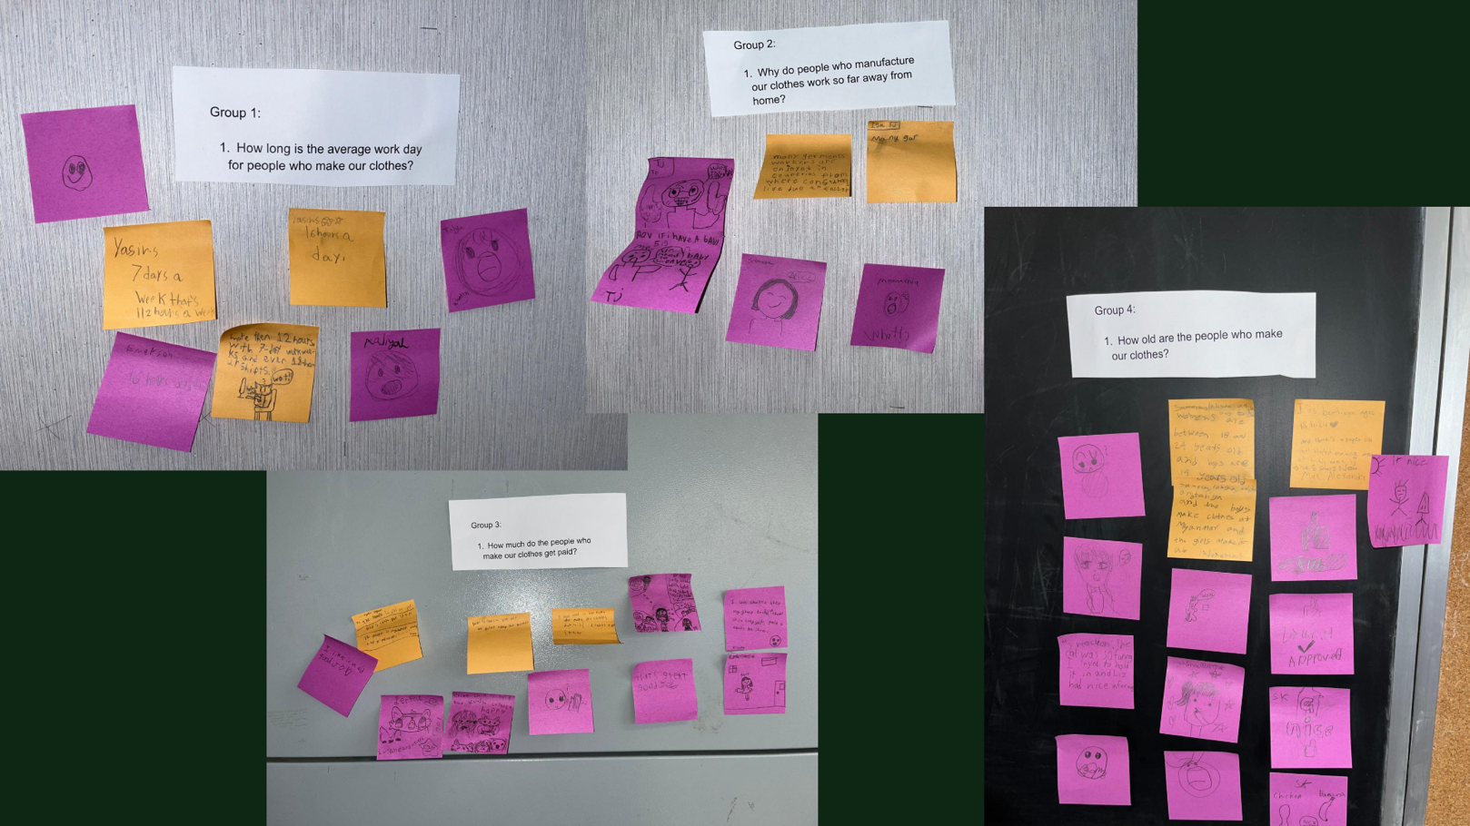
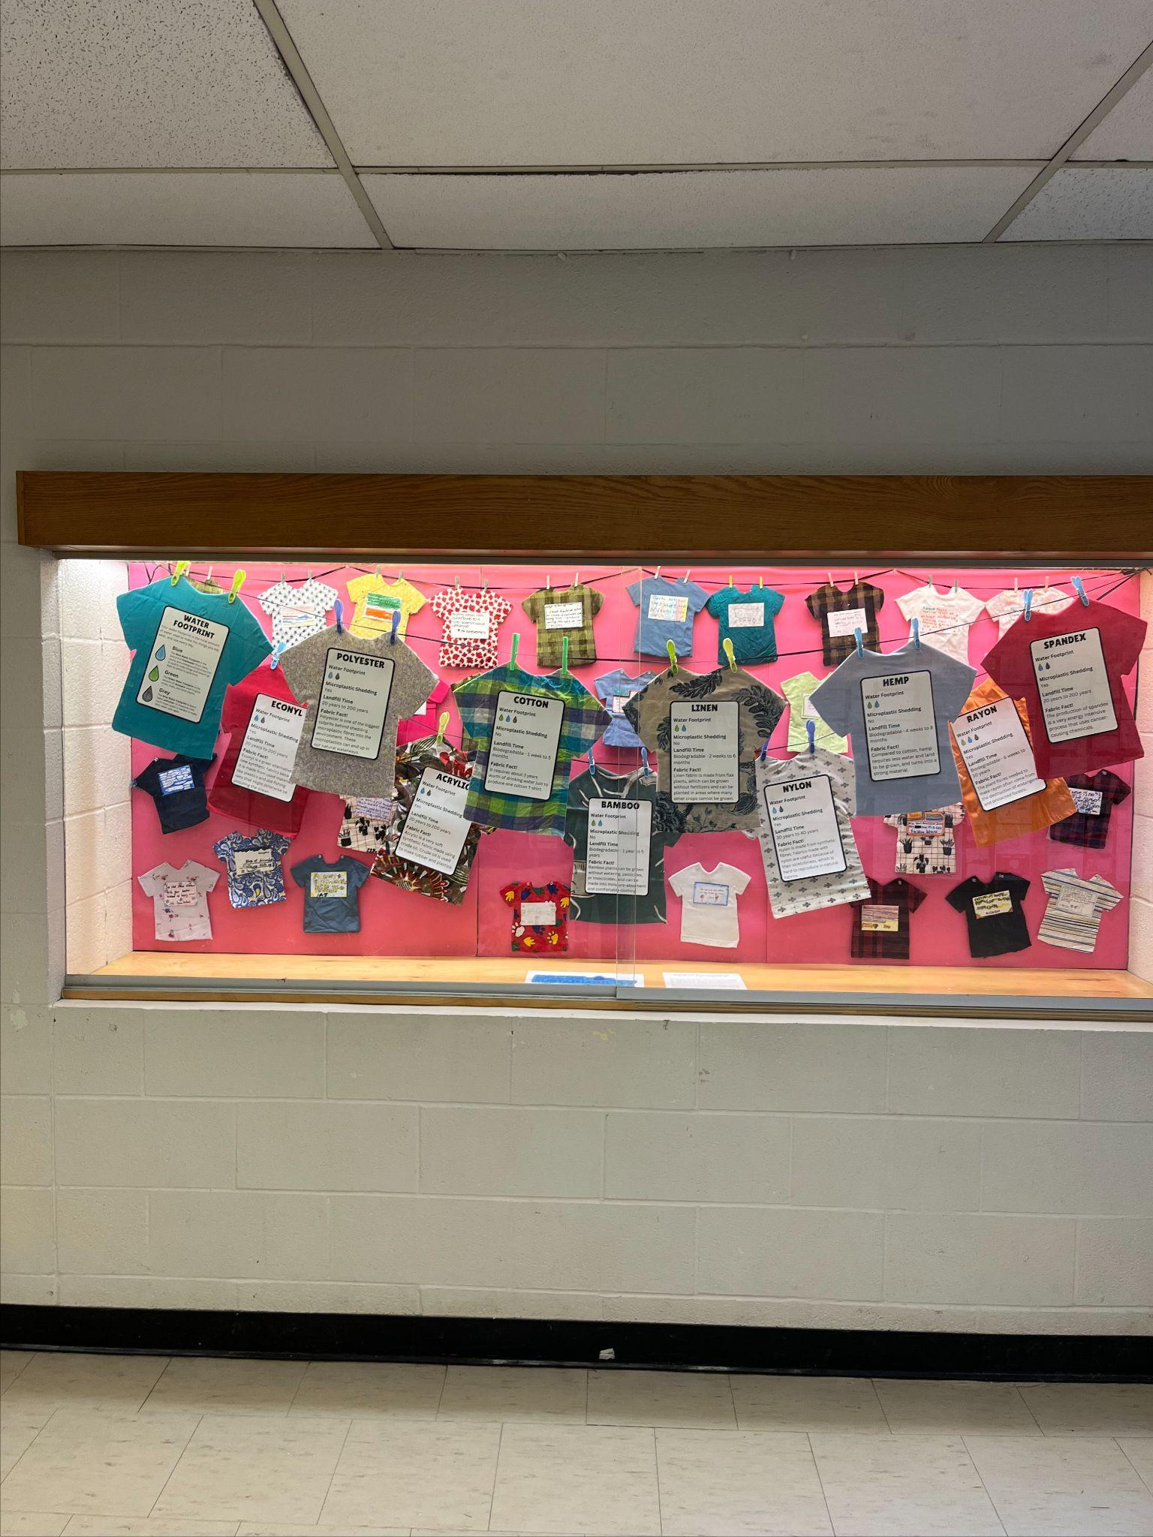
Stories of Climate Change Education
Toronto District School Board - Climate Literacy & Leadership Program
The True Cost of Clothing:
Learning How Fast & Sustainable Fashion Affects Our Earth

Florencia Esteverena, Teacher &, Sarah Sgambelluri, OISE Teacher Candidate
Islington Junior Middle School, Grade 4
Learning Outcomes:  Students will...  - explain how their clothing choices impact climate change by reflecting on their personal experiences as consumers  - evaluate the environmental impact of their clothing choices and propose more sustainable alternatives. | Climate Concepts:  - Consumer Choices and Climate Impact: Understanding how individual decisions, such as clothing purchases, contribute to environmental issues like pollution and resource depletion.  - Sustainable Consumer Choices: Exploring alternatives to fast fashion, such as purchasing second-hand clothing, choosing eco-friendly materials, and supporting ethical brands.
Learning Activities:  Collaborative Inquiry Question: How might we collaboratively design and facilitate rich learning experiences that support students in critically examining fast fashion and adopt sustainable fashion practices?  - Inspired by an installation featured at the Ontario Science Centre, we considered how students could leverage art to share with the community the ecological impact of the fashion industry.  - In the school's main foyer display, students created t-shirts highlighting facts of the fashion industry's impact on water and the climate. Some students added a call-to-action for viewers to consider the true cost of fashion and make changes to their consumer habits. Accompanying the student work were larger t-shirts with infographics showcasing textile facts, including notes on each fabric's water footprint, how long it takes for the material to decompose, as well as a fast fashion fun fact.  - In the spirit of sustainability, the materials used in this eco-art display were repurposed from school lunch pizza boxes and fabric scraps from school plays.  - Continuing our learning, our students investigated the labels on their clothing. Using Google Earth, students mapped where their clothes were made on a collaborative class Google Map. Once mapped, we identified trends as a group asking, "Were our clothes made far away, or close to Canada?" | 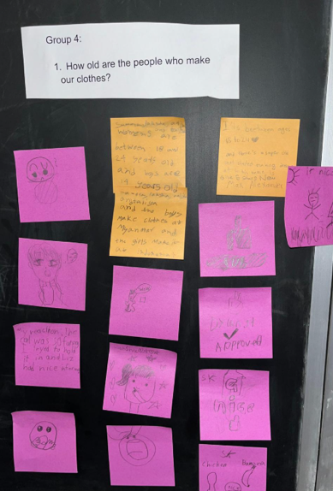  - To deepen our understanding, students engaged in wonderings with a critical lens to generate questions about issues related to fairness, equity and social justice. Some of the questions included, "Who makes these clothes? How much do they get paid? What does a factory look like?" To begin to explore these questions, we facilitated a jigsaw in which students responded to these questions.  - As we learned about fast fashion, we made connections to our on-going social studies unit on ancient societies. Ancient/older societies did not have ready-to-wear fashion. The making of fabrics, textiles, and ultimately clothes was a methodical process that contrasted greatly from how clothing is manufactured today. We also considered the impact of modern societies’ global impact, both on the environment and the ethical considerations for the peoples who make their clothing.  - Students were thrilled to conclude our inquiry with a trip to the Royal Ontario Museum (ROM) and participating in a Sustainable Fashion Presentation and Workshop. Here, students continued learning how different methods of textiles manufacturing impact the climate and environment.  Additional Climate action(s)  - Clothing swap at school to promote reusing clothes instead of buying new ones.  - Learn to repair clothes (e.g., simple sewing or patching activities) instead of discarding damaged items.

Lessons Learned:  - Climate change education must be undertaken and facilitated in community and in the spirit of collaboration. We were able to accomplish so much as a teaching team that would not have been possible independently.  - Eco-art is a powerful catalyst for behavioural change and inquiry within and beyond the school community. Students, staff, and school visitors would reflect upon the display, sparking discussion and inspiring actions to practice sustainable action. | Key Resources:  - Sustainable fashion a guide for teachers | Oxfam  - Overview for Sustainable Threads Teacher Resource  - Clothing & Climate Change - Let's Talk Science  - SDGs- Corporate Citizenship - Sustainability  - How Does Fast Fashion Affect the Environment?  - Classroom Education — Fashion Takes Action
Toronto District School Board 2025 https://www.tdsb.on.ca/environment/

