September 13, 2018

Dear Parents/Guardians,

For the last three years, Ontario’s school boards have been required to use the updated 2015 Health and Physical Education Curriculum (HPEC) in both elementary and high schools. As you may know, the Ministry of Education recently directed all school boards across the province to use the re-issued 2010 HPEC (Grades 1-8) as of this September. Secondary teachers will continue to teach the 2015 HPEC - the secondary school curriculum will not be changing from the 2015 HPEC. The Ministry of Education has the right to set curriculum for Ontario students and the TDSB expects teachers to use the re-issued 2010 HPEC (Grades 1-8) for the coming school year.

You can learn about the re-issued 2010 HPEC (Grades 1-8) by visiting the Ministry’s [2010 HPEC-Grades 1-8](http://www.edu.gov.on.ca/eng/curriculum/elementary/healthcurr18.pdf). Based on a preliminary review of the re-issued 2010 HPEC (Grades 1-8) by Board staff, while the wording may be different than the 2015 curriculum, the 2010 curriculum still contains many critically important topics. However, some areas of the 2015 version may not be specifically included or included but at a different grade level. That’s why Board staff have prepared information to help you understand what can be taught and when. The information will also help you understand the differences between the 2015 curriculum and the re-issued 2010 HPEC (Grades 1-8) in the classroom. This information can be found at [Guide to the Revised Ontario HPE Curriculum](http://www.tdsb.on.ca/portals/0/docs/Guide_to_the_Revised_Ontario_HPE_Curriculum.pdf).

At the same time, we have provided resources for our teachers that will assist them to deliver the appropriate HPEC. I am confident our teachers will continue to deliver the provided curriculum in ways that meet the Ministry direction, and create a learning environment for students that is safe, inclusive and focused on their success and well-being.

Going forward should you have any questions or concerns about how the curriculum will be or is being taught in your child’s classroom, we encourage you to speak with your child’s teacher, who can help answer your questions and usually resolve any concerns. In rare instances where this isn’t the case, we recommend parents follow the [TDSB Parent Concern Protocol](http://zwebppfprd/uploads/files/live/97/169.pdf) which may involve sharing your concerns with the school’s Principal or Superintendent.

As noted above, the Ministry of Education requires school boards to use the re-issued 2010 HPEC. Parents who have concerns about the re-issued 2010 HPEC (Grades 1-8) itself should direct concerns to the Ministry of Education at [www.edu.gov.on.ca](http://www.edu.gov.on.ca); see the Contact Us options on the right side of the webpage.

The Ontario government will be reviewing the Health and Physical Education Curriculum (Grades 1-8) and will be consulting with parents. Once consultation details are available, we will be providing parents with that information.  
  
Sincerely,

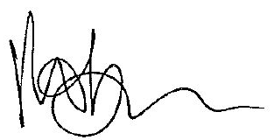 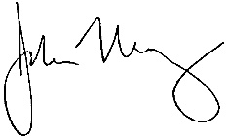

Robin Pilkey Dr. John Malloy

Chair Director of Education

