Students, Have Your Say!

EcoSchools Toolkit

© 2016 Toronto District School Board

EcoSchools Toolkit

Students, we want to know about your experiences as an EcoTeam as an EcoTeam this year. Your submission should answer the four questions below. You can either write a reflection or create an alternative submission.

1. What did you do as a team this year?  
   Click here to enter text.
2. What are some of your team’s highlights? What is your team most proud of?  
   Click here to enter text.
3. What are some of your team’s challenges and how did you overcome them?  
   Click here to enter text.
4. What advice would you give to next year’s team?  
   Click here to enter text.

**Get creative! Here are some other submissions ideas:**

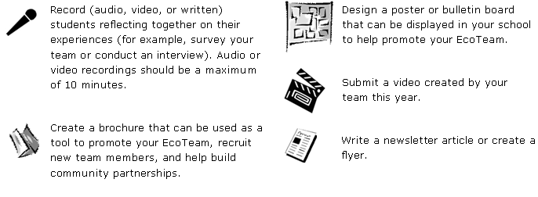

Record (audio, video, or written) students reflecting together on their experiences (for example, survey your team or conduct an interview). Audio or video recordings should be a maximum of 10 minutes.

Create a brochure that can be used as a tool to promote your EcoTeam, recruit new team members, and help build community partnerships.

Design a poster or bulletin board that can be displayed in your school to help promote your EcoTeam.

Submit a video created by your team this year.

Write a newsletter article or create a flyer.



Record (audio, video, or written) students reflecting together on their experiences (for example, survey your team or conduct an interview). Audio or video recordings should be a maximum of 10 minutes.

Create a brochure that can be used as a tool to promote your EcoTeam, recruit new team members, and help build community partnerships.

Design a poster or bulletin board that can be displayed in your school to help promote your EcoTeam.

Submit a video created by your team this year.

Write a newsletter article or create a flyer.

