Please complete the following application, designed to understand your school’s need, ensure the future use of bike racks, and assess your commitment to promoting active transportation.

Application submitted by:
School: Click to enter text.

☐ Please check to acknowledge your principal’s approval regarding the installation of bike racks at your school in 2018.

Team Structure
Who are your active transportation champions?
Please list the members of your school staff that will ensure project commitments are fulfilled.

Name | Role | Email
Click here to enter text. | Click here to enter text. | Click here to enter text.
Click here to enter text. | Click here to enter text. | Click here to enter text.
Click here to enter text. | Click here to enter text. | Click here to enter text.
Site Information
- What barriers currently prevent your staff and students from riding to school?
Click here to enter text.

- In good weather, what percentage of your staff and students do you estimate bike to school regularly? (Mark with an ‘X’)
☐0-10% ☐10-20% ☐20-30% ☐30-40% ☐40-50%
☐50-60% ☐60-70% ☐70-80% ☐80-90% ☐90-100%
- If your school were to receive bike racks through this application, what do you estimate is the potential percentage of staff and students that could bike to school in good weather? (Mark with an ‘X’)
☐0-10% ☐10-20% ☐20-30% ☐30-40% ☐40-50%
☐50-60% ☐60-70% ☐70-80% ☐80-90% ☐90-100%

- Please indicate the style of rack(s) your school currently has and the number of bike spaces the rack(s) could reasonably accommodate. If you do not have any bike racks, select N/A.

 | Bike rack style | Number of bike spaces
☐ | 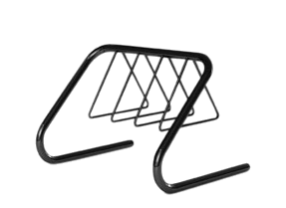 Hanger | Click here to enter text.
☐ | 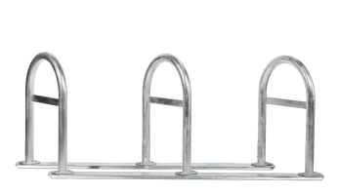 Inverted U | Click here to enter text.
☐ | 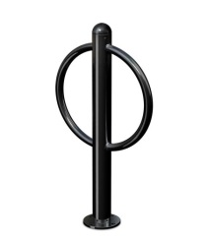Post and Ring | Click here to enter text.
☐ | 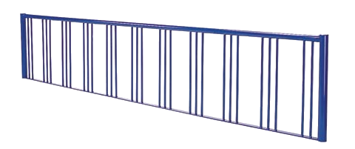 Rail | Click here to enter text.
☐ | 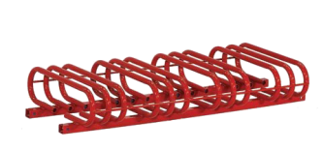  Wheel Bender | Click here to enter text.
☐ | Other | Click here to enter text.
☐ | N/A | Click here to enter text.

School Commitment
- How has your school demonstrated a commitment to promoting active transportation in the past? Please describe any relevant EcoTeam actions, school commitments and/or teaching and learning related initiatives. Strong applications will include details on duration and level of engagement (see rubric).

Click here to enter text.

- How is your team planning to promote the use of bike racks at your school? (Please keep in mind the timeframe when planning)
Successful applications will have at least two targeted initiatives. One must be connected to an EcoTeam action and one must be connected to teaching and learning in the classroom. For ideas on what this might look like please refer to the Bike Rack Application ideas and resources section listed on the EcoSchools website.

*Tip: Successful applicants had a number of initiatives that contributed to a single campaign e.g., posters, announcements, walking/wheeling Wednesdays, and a bike rodeo. Be sure to describe the duration and level of engagement for each initiative (see EcoAction rubric and Teaching and Learning rubric for more details).

- EcoTeam Action:
Click here to enter text.
- Teaching & Learning Action:
Click here to enter text.
Additional plans (optional):
Click here to enter text.

- Are you including any attachments to support your application (e.g., photos that highlight need, evidence of past campaigns etc.)? ☐Yes ☐No
Attach any supporting documents to your email when submitting this application.

☐ Please check to acknowledge your commitment to having evidence of your Active Transportation related projects in your portfolio binder for the EcoSchools certification audit in spring 2018.

Note: Connections could be made to the following portfolio requirement:
- Healthy Communities: Example of a community project that shows learning and action.

Please send this application to Cynthia Chan using one of the following methods:
Email: Kristen.Evers@tdsb.on.ca
Fax: (416) 396-3447
Interoffice Mail: McGriskin, Kristen Evers, NE24

Applications received by June 30th, 2017 will be considered for the spring 2018 installation period.

