AN INTERSECTIONAL VIEW OF TDSB STUDENTS WITH SPECIAL EDUCATION NEEDS
This fact sheet is the second in a series of four fact sheets examining a range of topics impacting students with special education needs (SEN) within the Toronto District School Board (TDSB). The first fact sheet provided an introductory overview of TDSB students with SEN in the 2023-24 school year. The current fact sheet will explore comparisons between students with SEN in the TDSB, Greater Toronto Area (GTA) school boards and the province of Ontario, as well as the intersections between special education needs and demographic variables such as race, income, and gender. Intersectional analyses will be conducted for the 6 exceptionality categories which account for the majority (97%) of students identified with exceptionalities in TDSB. These categories are autism, gifted, developmental disability, learning disability, mild intellectual disability, and behaviour.

Comparisons between TDSB and the Province
The following section explores comparisons between TDSB students with SEN and the province using special education data from the Ministry of Education. These comparisons were done using the most recent data available, which is from the 2021-22 school year.
Figure 1: Distribution of TDSB Students with SEN Compared to the Province, 2021-22
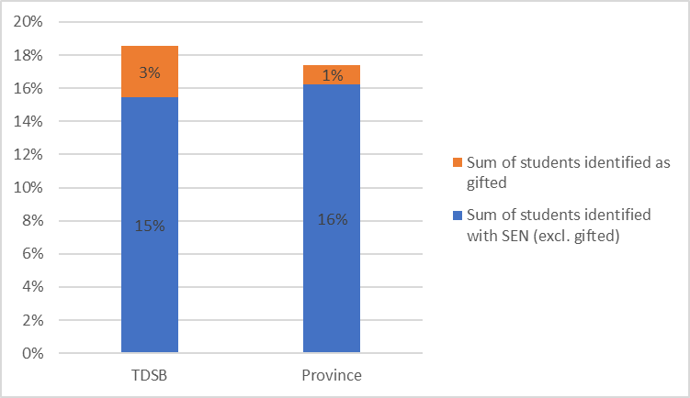

Figure 1 demonstrates that while the proportion of students identified with SEN within the TDSB is very similar to the province, the TDSB has three times more students identified as gifted.

Exceptionalities: TDSB, GTA Boards, Province
The figures below show comparisons between the percentage of students at the TDSB within each category of exceptionality, as well as GTA boards and the rest of the province. For more detailed information, please see Table 1.

Figure 2: Distribution of Exceptionalities between TDSB, GTA and Province, 2021-22
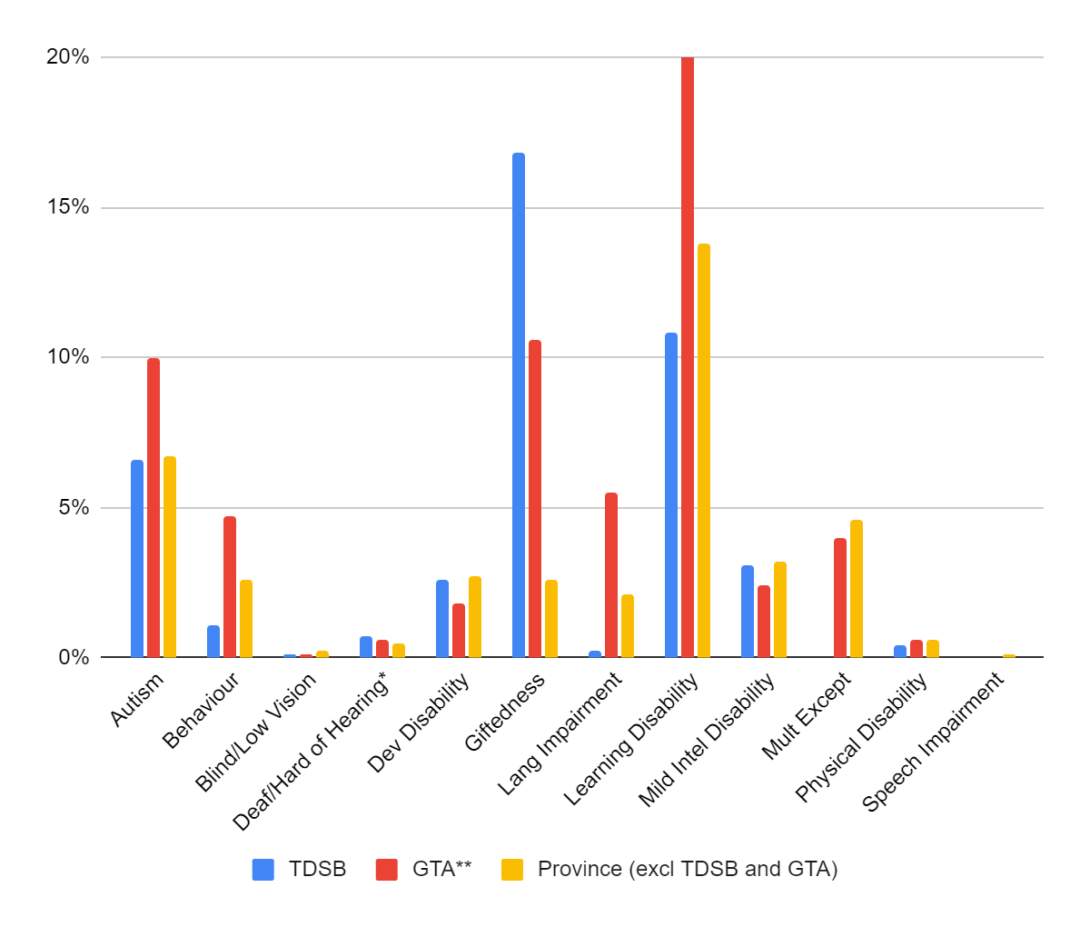
**GTA (excl. TDSB) includes the following school boards: Dufferin-Peel CDSB, Durham CDSB, Durham DSB, Halton CDSB, Halton DSB, Peel DSB, Toronto CDSB, York CSDB, York Region DSB.
- When compared with GTA boards and the rest of the province, the TDSB has a lower proportion of students with a behavioural exceptionality or learning disability.
- Of students with exceptionalities, the TDSB also has a large proportion with a gifted exceptionality (40% compared to 18% in GTA boards and 7% in the province).

Figure 3: Distribution Comparisons between TDSB, GTA and Province for Students with SEN, 2021-22
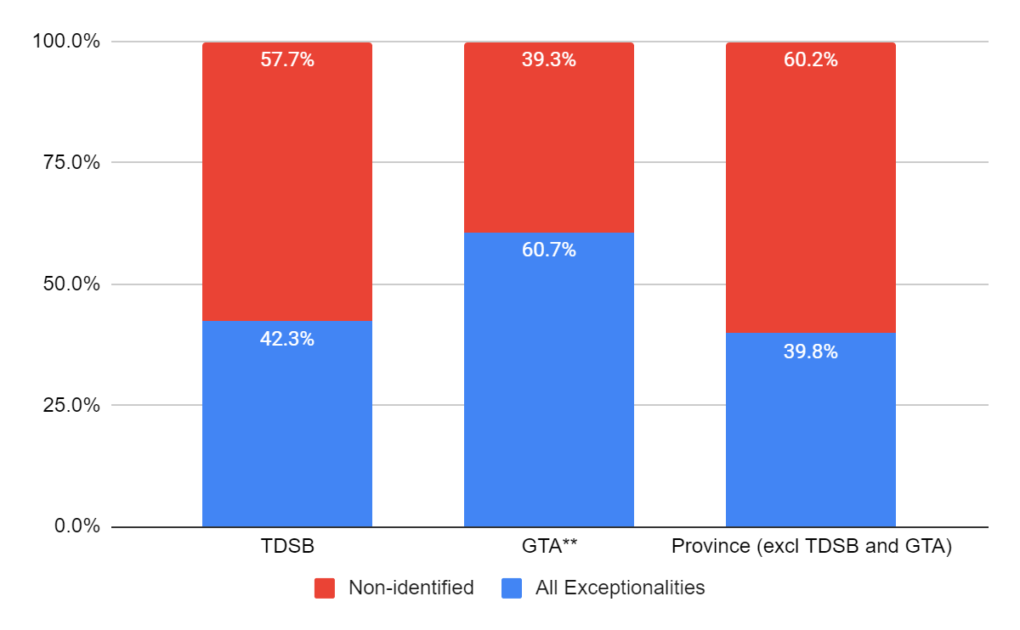
**GTA (excl. TDSB) includes the following school boards: Dufferin-Peel CDSB, Durham CDSB, Durham DSB, Halton CDSB, Halton DSB, Peel DSB, Toronto CDSB, York CSDB, York Region DSB.

- Figure 3 shows that while the TDSB proportions of students with SEN are similar with the province, the GTA boards have a higher ratio of students with exceptionalities versus non-identified.

Table 1: Exceptionalities Within TDSB, GTA** and the Province (2021-22)
 | TDSB |  |  | GTA** (excl. TDSB) |  |  | Province (excl. TDSB and GTA)
Exceptionality | Number of Students | Percent of All Students with an Exceptionality | Percent of All Students Receiving Special Education | Number of Students | Percent of All Students with an Exceptionality | Percent of All Students Receiving Special Education | Number of Students | Percent of All Students with an Exceptionality | Percent of All Students Receiving Special Education
Autism | 2,861 | 15.6% | 6.6% | 10,657 | 16.4% | 10.0% | 13,576 | 16.8% | 6.7%
Behaviour | 476 | 2.6% | 1.1% | 5,005 | 7.7% | 4.7% | 5,306 | 6.6% | 2.6%
Blind/Low Vision | 34 | 0.2% | 0.1% | 113 | 0.2% | 0.1% | 321 | 0.4% | 0.2%
Deaf/Hard of Hearing* | 279 | 1.5% | 0.7% | 636 | 1.0% | 0.6% | 1,045 | 1.3% | 0.5%
Dev Disability | 1,104 | 6.0% | 2.6% | 1,922 | 3.0% | 1.8% | 5,536 | 6.9% | 2.7%
Giftedness | 7,260 | 39.7% | 16.8% | 11,312 | 17.5% | 10.6% | 5,349 | 6.6% | 2.6%
Lang Impairment | 76 | 0.4% | 0.2% | 5,854 | 9.0% | 5.5% | 4,306 | 5.3% | 2.1%
Learning Disability | 4,650 | 25.4% | 10.8% | 21,841 | 33.7% | 20.4% | 28,055 | 34.8% | 13.8%
Mild Intellectual Disability | 1,358 | 7.4% | 3.1% | 2,542 | 3.9% | 2.4% | 6,465 | 8.0% | 3.2%
Mult Except | <10 | <0.1% | <0.1% | 4,315 | 6.7% | 4.0% | 9,280 | 11.5% | 4.6%
Physical Disability | 188 | 1.0% | 0.4% | 597 | 0.9% | 0.6% | 1,193 | 1.5% | 0.6%
Speech Impairment | <10 | <0.1% | <0.1% | 25 | 0.0% | 0.0% | 273 | 0.3% | 0.1%
Total for All Exceptionalities | 18,288 | 100% | 42.3% | 64,819 | 100% | 60.7% | 80,705 | 100% | 39.8%
Non-Identified | 24,919 |  | 57.7% | 42,023 |  | 39.3% | 122,105 |  | 60.2%
Total for All SEN Students | 43,207 |  | 100% | 106,842 |  | 100% | 202,810 |  | 100%
* Includes pre-school data for TDSB
**GTA (excl. TDSB) includes the following school boards: Dufferin-Peel CDSB, Durham CDSB, Durham DSB, Halton CDSB, Halton DSB, Peel DSB, Toronto CDSB, York CSDB, York Region DSB.
Intersectionality of Race, Income and Gender with SEN
Using preliminary data from the 2022-23 Student Census, the following section provides information on the demographic characteristics of students within the six largest exceptionality categories (autism, gifted, developmental disability, learning disability, mild intellectual disability, and behaviour). These categories were chosen for analysis because they represent the majority (97%) of students with exceptionalities in the TDSB. Additionally, the small number of students in the other exceptionality categories would not allow for an intersectional analysis due to suppression rules. While data for comparisons outside of TDSB was not available beyond 2021-22, for the analyses in this section we were able to use exceptionality data from October 2023 using the TDSB’s Student Information System.

Table 2: TDSB Exceptionality Categories (October 2023)
Exceptionality | Number | Percentage
Autism | 3393 | 19.4%
Deaf/Hard of Hearing incl. Preschool | 248 | 1.4%
Learning Disability | 3662 | 20.9%
Language Impairment | 47 | 0.3%
Giftedness | 7266 | 41.5%
Mild Intellectual Disability | 1251 | 7.1%
Developmental Disability | 1107 | 6.3%
Blind/Low Vision | 34 | 0.2%
Physical Disability | 167 | 1.0%
Behavioural | 325 | 1.9%
Blind/Low Vision and Deaf/Hard of Hearing | <10 | <0.1%
Figure 4: Exceptionality Intersected with Race*, October 2023
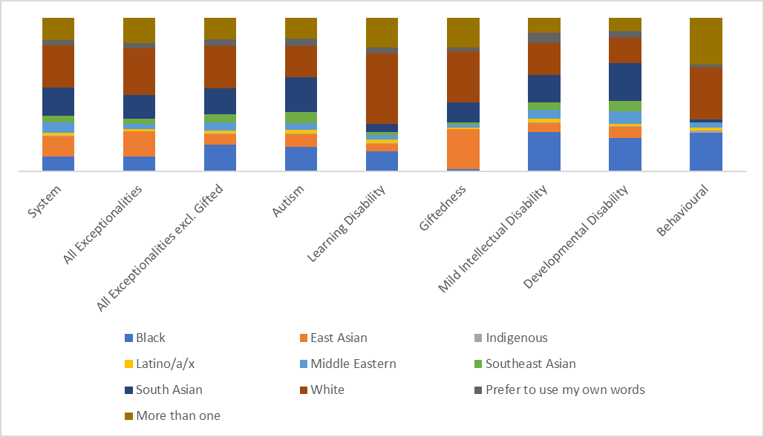
*The 2022-23 Student Census typology for race differed from previous Censuses by including the Prefer to use my own words category and replacing Mixed with the More than one racial category.
- Comparing all students with exceptionalities to the entire TDSB system, proportions across racial categories are similar. However, excluding gifted increases the proportion of Black students with exceptionalities and lowers the proportion of East Asian students with exceptionalities. While the overall proportions in each racial category of all exceptionalities combined are similar to the system, there are differences within each exceptionality.
- There are proportionally more White students in learning disability, gifted, and behaviour exceptionalities, while Black students are overrepresented in autism, mild intellectual disability, developmental disability and behaviour and are underrepresented in gifted.
- East Asian students make up a significant proportion of the students with a gifted exceptionality, but are less prevalent in other exceptionality categories.
- Students selecting more than one racial category make up a large proportion of students with learning disability, gifted, and behaviour exceptionalities.
- The largest proportions of South and Southeast Asian students with exceptionalities were in autism and developmental disability.
- With the exception of gifted, the proportions of Latino/a/x and Middle Eastern students with exceptionalities were generally consistent with the proportions found in the system overall.
- Relative to the system, Indigenous students are underrepresented in gifted and overrepresented in behaviour.

Table 3: Income Comparison Between System and Exceptionalities, October 2023

 | Low Income | Medium Income | High Income
System (N=236,253) | 32% | 34% | 33%
All Exceptionalities (N=17,449) | 30% | 32% | 38%
All Exceptionalities excluding Gifted (N=10,199) | 41% | 33% | 27%

- By dividing the TDSB into 3 income levels (low, medium and high), we can analyse how the income distribution differs across exceptionalities.
- Looking at all exceptionalities, the high-income proportion is greater than medium or low incomes.
- Excluding gifted, the proportion of higher income students decreases, and the proportion of lower income students increases.

Figure 5: Exceptionality Intersected with Income, October 2023
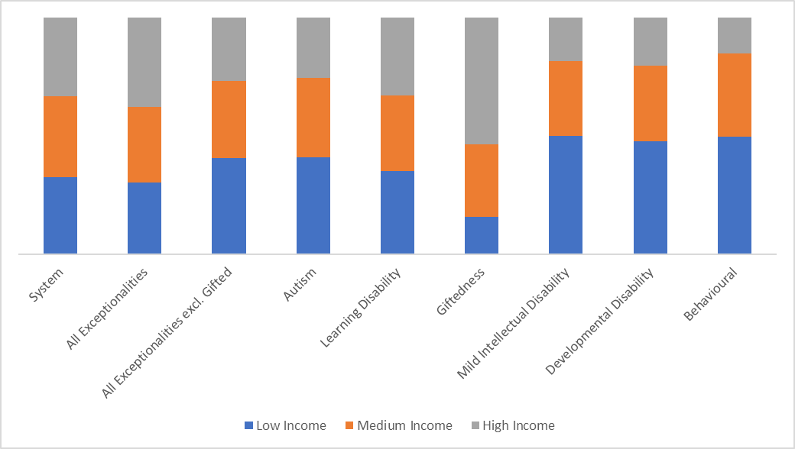
- Over half of students with a gifted exceptionality came from the high income category, while fewer students came from the low income category.
- The exceptionalities of mild intellectual disability, developmental disability and behaviour all had higher proportions of students in the low income category (approximately half) and lower proportions of students in the high income category.
- All exceptionalities had similar proportions of medium income students compared to the system.

Figure 6: Exceptionality Intersected with Gender*, October 2023
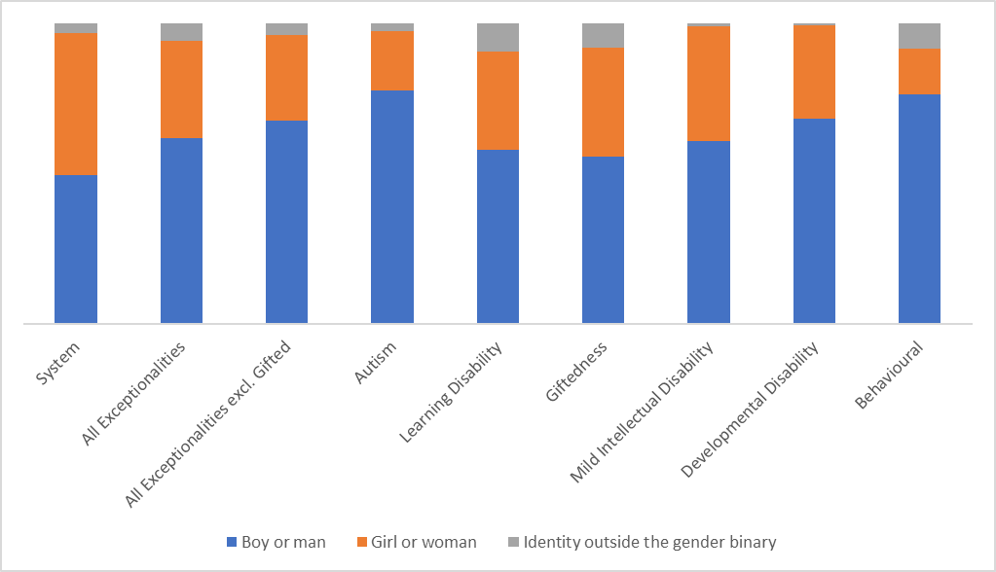
*The 2022-23 Student Census typology for gender identity differed from previous Censuses by including many more gender identities for students to select (or write-in) and were grouped here as Identity outside the gender binary.

- Comparing all exceptionalities to the distribution of gender identities within the system, students identifying as boys/men are overrepresented across all exceptionality categories.
- Over three-quarters of students with an autism or behaviour exceptionality identified as boys/men.
- There were higher proportions of students who selected an identity outside of the gender binary within learning disability, gifted and behaviour exceptionalities.
- Due to the overrepresentation of boys/men, the proportion of girls/women was lower than the overall system in all exceptionality categories, particularly autism and behaviour.

Conclusion
The TDSB proportion of students with SEN is generally consistent with the province of Ontario, with a few notable differences. When looking at the distribution of exceptionalities across the TDSB, GTA boards and the province, the differences that can be seen are:
- When compared with GTA boards and the rest of the province, the TDSB has a lower proportion of students with a behavioural exceptionality or learning disability.
- Of students with exceptionalities, the TDSB also has a large proportion of students with a gifted exceptionality (more than 2 times the GTA boards and nearly 6 times more than the rest of the province).
- While the TDSB proportion of non-identified students (IEP-only) is similar to the rest of the province, the GTA boards have a comparatively lower proportion.

It is important to consider students with SEN through an intersectional lens that takes into account other aspects of their identity. By analysing race, income and gender, significant differences are apparent across all exceptionality categories.
- Comparing all students with exceptionalities to the entire TDSB system, proportions across racial categories are similar. However, excluding gifted increases the proportion of Black students with exceptionalities and lowers the proportion of East Asian students with exceptionalities. While the overall proportions in each racial category of all exceptionalities combined are similar to the system, there are differences within each exceptionality.
- Looking at all exceptionalities, the high-income proportion is greater than medium or low incomes. Excluding gifted, the proportion of higher income students decreases and the proportion of lower income students increases.
- Comparing all exceptionalities to the distribution of gender identities within the system, students identifying as boys/men are overrepresented across all exceptionality categories.

Looking Ahead
Subsequent fact sheets will focus on the following areas:
- Placement (regular class, ISPs, congregated settings)
- Outcomes (achievement, pathways and post-secondary trajectories)

