Fact Sheet #1

INTRODUCTORY OVERVIEW OF TDSB STUDENTS WITH SPECIAL EDUCATION NEEDS

This fact sheet is the first in a series of fact sheets examining a range of topics impacting students with special education needs (SEN) within the Toronto District School Board (TDSB). This fact sheet provides an introductory overview of TDSB students with special education needs in the 2023-24 school year.

How are Students with Special Education Needs Identified?
- Through a formal Identification, Placement and Review Committee (IPRC), a student is identified as an “exceptional pupil” who has one or more of the 5 exceptionalities outlined by the Education Act (behavioural, communicational, intellectual, physical, and multiple).
- An Individual Education Plan (IEP) is developed for a student identified with one or more exceptionalities at an IPRC.
- In the TDSB, an IEP may be created for a student who has not been identified with one or more exceptionalities at an IPRC if the student requires special education programs or services to access the Ontario curriculum.

How many Students with Special Education Needs are in the TDSB?
- In 2023-24, 41,075 students out of 238,106 (17% of the TDSB student population) were classified as students with SEN.
- Of those 41,075 students, 17,501 or 43% are formally identified with exceptionalities, while 23,574 or 57% have IEPs with no formally identified exceptionalities (see Figure 1).

Figure 1: Percentage of TDSB Students with Special Education Needs (Formally Identified with Exceptionalities and IEP-Only)
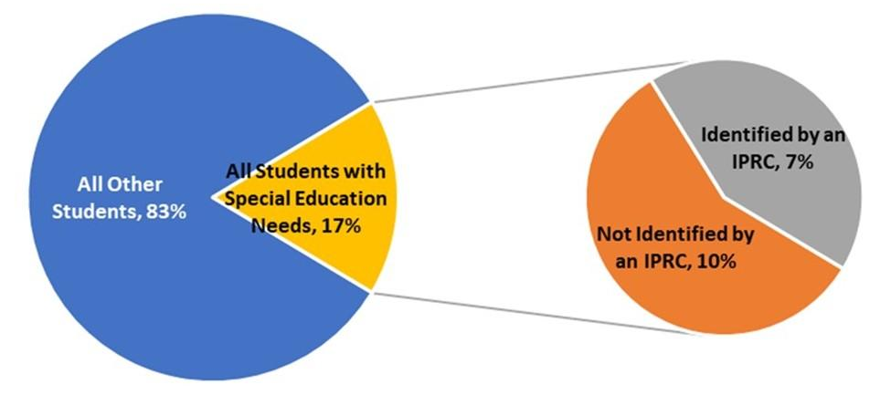

Inclusion
- Students with SEN have unique strengths and needs that may require them to have special education programs or services. However, in line with Ontario Regulation 181/98 and in consultation with families and students (where appropriate), the TDSB strives to meet the needs of students with SEN within regular classroom settings with support.
- When looking at all students with special education needs (including the 23,574 with an IEP-only), 75%( 30,767 students) are in regular classes, while 25% (10,308 students) are in special education classes.
- However, of the 17,501 students formally identified with exceptionalities, 41% (7,193 students) are in regular classes, while 59% (10,308 students) are in special education classes (see Figure 2).

Figure 2: Special Education Classroom Settings
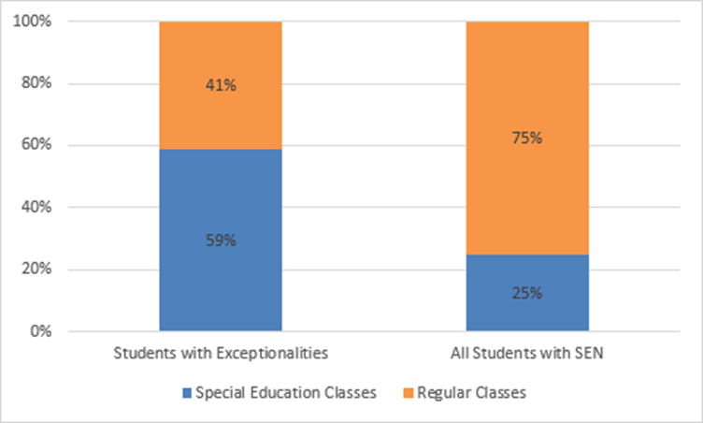

Select Key Findings
- There are 11 subcategories of exceptionalities within the 5 categories of exceptionalities. The majority of formally-identified TDSB students with SEN are in five categories: Learning Disability (LD), Giftedness, Mild Intellectual Disability (MID), Autism, and Developmental Disability (DD).
- According to the 2022-23 Student Census, the overall TDSB student population is closely split between boys/men (49%) and girls/women (47%) with 3% identifying outside the gender binary. However, 60% of students with SEN excluding gifted are boys/men, over 10% higher than the overall TDSB student population. Gifted students also have a higher representation of boys/men (56%).

- The 2022-23 Student Census also reveals disproportionalities by racial groups in students with SEN excluding gifted and the overall TDSB student population. Students who identified as Black represent 10% of the overall TDSB student population, but are 16% of students with SEN excluding gifted. Conversely, gifted students are more likely to identify as White (34% compared to 26% overall) and East Asian (26% compared to 13% overall).
- Students with SEN excluding gifted are more highly represented in families with low income (39%), whereas gifted students are much more represented in high income families (54%).
- Looking at a variety of achievement results, Gifted students achieve at a much higher level than the TDSB average. On the other hand, all students with SEN excluding gifted (exceptionalities without gifted, non-identified/IEP-only) achieve at a much lower level than the TDSB average.
- While graduation rates have been increasing since at least 2000, there has always been a gap in graduation rates between the overall TDSB student population and students with SEN excluding Gifted. However, the size of the gap has been declining since 2007-08 and as of the Grade 9 cohort of 2016-17, approximately 74% of students with SEN excluding Gifted graduated compared with approximately 88% of students overall (a gap of ~14%).
- Post-secondary confirmations have been increasing since 2007-08. However, a gap between students with SEN excluding Gifted and TDSB overall has remained fairly stable. In the Grade 9 cohort of 2016-17, approximately 67% of TDSB students confirmed a post-secondary offer compared to 46% of students with SEN excluding Gifted (a gap of ~21%).
- Overall, the vast majority of post-secondary confirmations at TDSB are to universities. However, as of the 2016-17 Grade 9 cohort, post-secondary confirmations for students with SEN excluding Gifted were more evenly split between colleges and universities.

Looking Ahead
Subsequent fact sheets will focus on the following areas:
- Identification (exceptionalities)
- Placement (regular class, Intensive Support Programs, congregated settings)
- Outcomes (achievement, pathways and post-secondary trajectories)

Percentages do not add up to 100% due to rounding.

