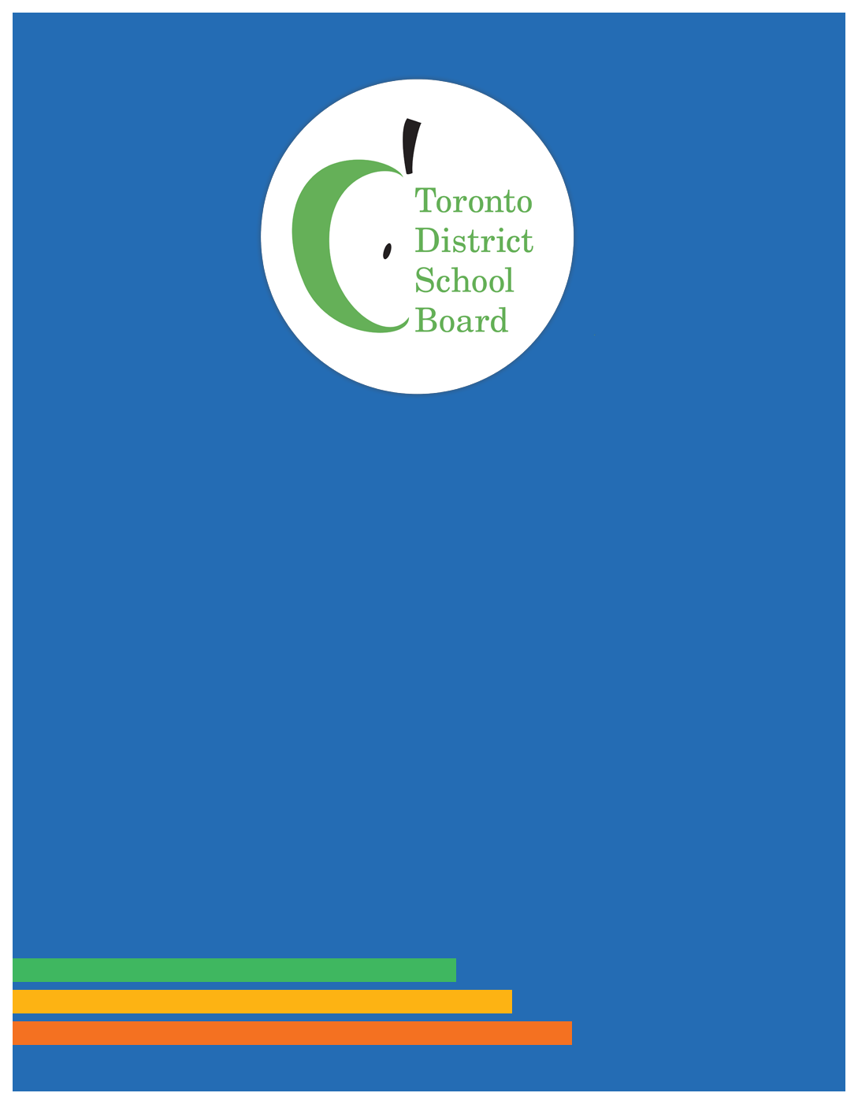

French as a Second Language Community Advisory Committee (FSLCAC)
2022-23 ANNUAL REPORT

French as a Second Language Community Advisory Committee (FSLCAC)
2022-23 ANNUAL REPORT

French as a Second Language Community Advisory Committee (FSLCAC)
2022-23 ANNUAL REPORT

French as a Second Language Community Advisory Committee (FSLCAC)
2022-23 ANNUAL REPORT
Advisory Committee

French as a Second Language Community Advisory Committee (FSLCAC)
2022-23 ANNUAL REPORT
sory Committee

French as a Second Language Community Advisory Committee (FSLCAC)
2022-23 ANNUAL REPORT

French as a Second Language Community Advisory Committee (FSLCAC)
2022-23 ANNUAL REPORT

French as a Second Language Community Advisory Committee (FSLCAC)
2022-23 ANNUAL REPORT
sory Committee

Table of Contents

Mandate/Purpose 3
Activities and Outreach 4
Meetings
Recruiting New Members
Committee Members
Email
Newsletter
Conferences, Workshops and Meetings
Opportunities and Challenges-Growth and Excellence in TDSB FSL Programs 7
Covid-19 and Student Participation in FSL
Common European Framework of Reference (CEFR) and the DELF
Transportation: Secondary French Immersion/Extended TTC Support
2018 French Review
Diversity and Inclusion
FSLCAC Recommendation to Ensure Inclusive Practices in all FSL Programs
FSLCAC Recommendations on Access to Childcare (Before and After School)

Mandate/Purpose
The French as a Second Language Community Advisory Committee (FSLCAC) was created by the Board in 2005. In 2007, our mission was adopted by the Board and was reconfirmed with the adoption of our Terms of Reference in 2016:
“To consult with and advise the Board on French as a Second Language matters. As a Board community advisory committee, the FSLAC will contribute to the work of trustees and staff. This partnership of trustees, staff and parents will foster excellence and growth in FSL programs at the Board.”
NB: FSL (French as a Second Language) programs are: Core, Early and Middle French Immersion. Extended French programs are being phased out.

Activities and Outreach
Meetings
The FSLCAC held four formal and four informal meetings in 2023-24. From September to February the meetings were virtual, held on Zoom and from April on, they were hybrid. Our membership reflection from the end of the school year in 2022 found our membership preferred in-person meetings, with a hybrid option to ensure that we provided flexibility if needed. It is a continuation of how we met prior to COVID albeit now with Zoom rather than phone in.
We experienced challenges this year in meeting quorum on time. While participation from home is convenient, it also means being the on-call parent during the meetings. Additionally, parents continue to experience burn out and volunteering may not be the priority it was pre-COVID. We expect it will take time and creative solutions to bring attendance and engagement in committee work back to pre-COVID levels.
In February 2023, we had a presentation from International Student Exchange (iseontario.on.ca) which facilitates exchanges with students from France. In May 2023, we had a presentation from FSL Disrupt (fsldisrupt.org) which is a teacher initiative to collectively identify and source culturally relevant and responsive texts for secondary core and French immersion students.
The FSLCAC executive met virtually throughout the year to coordinate and advance committee work and communications. A new parent member welcome and orientation in-person off site get together was held in December 2022. A second in-person off site get together for all parent members – new and experienced, in March 2023 was well attended.
The FSLCAC Parent co-chair meets with the Trustee co-chair and staff lead prior to each scheduled formal committee meeting. Meeting notices, agendas, minutes and FSL resources are posted on the FSLCAC page on the TDSB website (www.tdsb.on.ca/fslcac ). Members/alternates also receive electronic access to a Member Briefing Book via Google Drive which is updated annually. We receive administrative support to organize meetings, for minutes and reporting to the Board from the assigned committee assistant. Additional support would be welcome, particularly for FSLCAC communication with school councils and parents/caregivers.
Upcoming Meetings: 2023 – September 19, October 17, November 14. When available, agendas and 2024 meeting dates will be posted at www.tdsb.on.ca/fslcac .

Recruiting New Members
As a committee, we are committed to ensuring that we have parent/caregiver participation from across the TDSB. Since the 2022 Trustee election, we have been working with Trustees to encourage elections for members/alternates as required in 2023 by our Terms of Reference. We have offered to have FSLCAC members attend ward meetings to help recruit new members or to provide content about the committee for their e-newsletters – especially in areas where new French Immersion sites are being opened. We look forward to continuing to support Trustees in the recruitment of new FSLCAC members in the fall of 2023.
Committee Members/Alternates (Alt) as of June 13, 2023:
Trustee Co-chair Rachel Chernos Lin
Parent Co-chair Lynne LeBlanc (W8)
Parent Vice co-chair Lisa McAvoy (W2 Alt)
Parent Vice co-chair Sharlene Henry (W5/6)
Parent Vice co-chair Charles Zhu (W11/8)

Frances Shawera (W2)
Maevis Ayippey (W4)
Crystal Stewart (W6)
Mandy Moore (W7)
Elizabeth Carvalho (W7 Alt)
Cheryl Batty (W8 Alt)
Divya Chandra (W11 Alt)
Randy Samuel (W14)
Bahira Abdulsalam (W14 Alt)
Madelaine Hamilton (W16)
Gail Miller (W22)

Note: where there is more than 1 ward next to a parent’s name, it indicates that they live in one ward but their child(ren) attends school in another ward.

Mary Cruden (Canadian Parents for French)
Rosemary Sutherland (CPF Alt)
Sharon Beason (CPF Alt)
2023-2024 FSLCAC Executive: At the June 13, 2023, Annual General Meeting, Lynne Leblanc was elected as parent co-chair for a 1-year term. Bahira Abdulsalam, Sharlene Henry, Lisa McAvoy and Charles Zhu were elected as parent vice co-chairs for a 1-year term. Canadian Parents for French member/alternates were appointed as non-voting community representatives for a 2-year term.
Email
FSLCAC volunteers continue to use our Gmail account: fslactoronto@gmail.com for correspondence. Parents and stakeholders write to us with FSL related questions. Common enquiries are on accessing programs and special education support and for referrals to the appropriate staff member on FSL specific concerns.
Newsletter
The FSLCAC newsletter was produced and distributed in December 2022, March 2023 and June 2023 and short time sensitive items were sent out as needed. News is sent out to more than 150 schools with French immersion/extended programs, Trustees, and over 900 individual parents and FSL stakeholders who have signed up. Information is shared about new developments in FSL and tips for parents in supporting their children learning French. The sign-up button and past newsletters are available at www.tdsb.on.ca/fslcac . We continue to seek email addresses for Parent/School Councils to add to our distribution to fulfill our mandate as a partnership between Trustees, staff and parents.
During the fall 2022 municipal election, the FSLCAC hosted a virtual all candidates meeting by creating and disseminating a survey to all Trustee candidates with publicly available contact information. The survey asked three questions about their experiences with learning French and support for French programs. Of the 128 Trustee candidates who received the survey, 58 responded. Survey responses were compiled and sent via email to our distribution list. Similar surveys were done in 2014, 2018 elections and by-elections. Election activities by Community Advisory Committees are governed by PR533, Section 6.2.5.
Conferences, Workshops & Meetings
In our continued effort to reach out to more parents directly, FSLCAC members presented virtually in the Parents and Caregivers as Partners hybrid conference in November 2022, where the theme of the presentation was “French - Helping your child succeed”. FSLCAC members also presented at PIAC’s in-person parent conference ‘Bridge the Gap’ in May 2023. The theme of the FSLCAC workshop was “What’s new in French as a Second Language”. The power point slides that accompany these workshops are available at www.tdsb.on.ca/fslcac.
Our usual range of activities which includes meeting parents and supporting presentations by staff at FSL information nights and presenting at school/ward councils was limited mostly to zoom participation, with a handful of opportunities to participate in-person. Our “Intro to the FSLCAC” is available for school/ward council meetings. Power point slides are posted at www.tdsb.on.ca/fslcac. Inquiries to have this presentation done may be directed to fslactoronto@gmail.com .

Opportunities and Challenges-

Growth and Excellence in TDSB FSL Programs

Covid-19 and Student Participation in FSL
FSL parents, like all parents, have had many challenges and numerous pivots from March 2020 on. Staff work during the pandemic to provide resources and flexibility in FSL is greatly appreciated. However, we are concerned that enrolment, as reported by staff at the FSLCAC meetings, at the new JK entry point and for Middle French Immersion is not reaching pre-COVID (2019) levels. No data has been made available about the impact of COVID on retention in core and immersion to Grade 12. We do know that some families found it too challenging to continue in French programs during COVID. FSLCAC has raised the need for better, effective communication and outreach to prospective and continuing families.
Common European Framework of Reference (CEFR) and the DELF
The DELF (Diplôme d'études en langue française) returned in person in May 2023 after being unavailable from 2020-2022 due to COVID. A limited number of students in Grade 12 are offered the opportunity to do the DELF exams.
In February 2019, the FSLCAC made a formal recommendation to PSSC asking that staff be asked to provide a briefing note on TDSB DELF (Diplôme d'études en langue française) Capacity Building and Cohort Results (from 2013 on). TDSB has teachers who are trained examiners and the continued provision of this training is essential to increasing opportunities for students to participate.
The DELF is an internationally recognized exam that tests proficiency in French and awards a credential to French immersion/extended/core students based on the benchmarks of the Common European Framework of Reference (CEFR). The DELF motivates and validates student achievement and informs parents. The FSLCAC supports providing the opportunity for all grade 12 French immersion/core students to take DELF exams as is done at some other Ontario school boards. Limited funding and support is provided by the Ministry of Education. Parent and student information: https://destinationdelf.ca/
Transportation: Secondary French Immersion/Extended TTC support
The 2019/20 budget cut of TTC tickets to secondary French immersion/extended (FI/Ext) meeting distance criteria continues to be of concern. In June 2019, all Grade 7-12 FI/Ext parents were advised by the TDSB that secondary students in need would be able to continue receiving support through their FI/Ext school principal. The FSLCAC is concerned that those students drop quietly out of FI/Ext rather than self-identify. On May 27, 2020, the Board forwarded the FSLCAC recommendation that staff consider this equity issue in their on-going review of transportation. While Staff assured the FSLCAC that principals may use school funds for this, it remains unclear if the availability of this support is communicated to all incoming Grade 7-12 FI/Ext families and how this has been addressed in the transportation review.
2018 French Review
The FSLCAC continues to be very engaged in the 2018 French Review, the June 2019 decisions and implementation work. We have received staff updates and had detailed discussions on the French Review at every meeting this year. The open conversations and the expectation shared throughout the consultation phase of the process showed a strong TDSB commitment to working together to improve FSL programs for all students and as such, the FSLCAC continues to provide feedback during meetings drawing on lived experience and the extensive French Review parent/student survey results.
Diversity and Inclusion Impact: 2018 French Review
We are hopeful that the addition of new early French immersion sites in underserved areas in September 2022 – as well as in September 2023, along with the on-going professional development for FSL educators will help achieve the objective in P080 (FSL Programs) to have FSL classrooms that “are inclusive and reflective of a diverse community”. However, the absence of results reporting means it is impossible to know if these equity initiatives and the decisions from the French Review are having a positive impact on inclusion in FSL programs.
At the May 2021 Board meeting, Trustees adopted the recommendation of the FSLCAC “to continue annual reporting on FSL programs including enrolment”. The last publicly reported demographic data on FSL programs was used in the French Review and it is now 7 years old. The last detailed FSL annual report, with more than basic enrolment data, was done in anticipation of the French Review, in June 2017. The previous detailed FSL annual report was in 2011, in response to a similar Board decision in November 2007.
FSLCAC Recommendation to Ensure Inclusive Practices in all FSL Programs:
2018 French Review
At the April 2023 FSLCAC meeting staff presented on the Ontario Human Rights Commission “Right to Read” public inquiry report (February 2022) and early reading approaches at the TDSB. “Right to Read” made recommendations to the Ministry of Education and education sector partners, including school boards and schools. Among the recommendations is early, regular screening for foundational reading skills for all JK-grade 2 students including those in French immersion to facilitate early intervention. To date, the Ministry of Education has not provided guidance on screening to school boards, including the TDSB, despite the urgency for parents with children having difficulties with reading.
As noted above, the last publicly available data on students with Individualized Education Plans (IEP) in French immersion was used in the French Review and is now 7 years old. It is difficult to know if current efforts, including the K-1 IEP Strategy, implemented since the 2018 French Review, are making French programs more “inclusive and reflective of a diverse community” (P080 FSL Programs) that includes students with special education needs.
In April 2019, the FSLCAC made a formal recommendation to the Program and School Services Committee (PSSC) on improving inclusion of students with Special Education needs in FSL and asked that the relevant section of PR597 be revised to be more useful to parents. This was referred to Staff which committed to reviewing and revising that section of PR597 in the June 2019 French Review Staff Report. This work is still needed to support students and inclusive growth in FSL programs.
FSLCAC Recommendations on Access to Childcare (Before and After School):
2018 French Review
In April 2021, the FSLCAC made a formal recommendation to PSSC to improve access to childcare (before and after school) for French immersion/extended Students (JK-6) which Trustees referred back to FSLCAC. The FSLCAC followed up by having Early Years staff present at the September 2021 FSLCAC meeting and by continuing the discussion at the February 2022 meeting, and again in April 2023.
FSLCAC members continue to be concerned that French immersion/extended parents face additional barriers in accessing childcare that most parents in English do not. These barriers include the lack of coordination with bussing, lack of access to the neighbourhood school childcare and the lack of priority access granted to students coming from on-site toddler childcare as is provided for English programs in dual track schools. Better access to childcare (Before and After School) can help achieve FSL classrooms that “are inclusive and reflective of a diverse community” (P080 FSL Programs).

