SEAC Meeting of March 02, 2020
Leadership, Learning and School Improvement

Kathy Witherow, Associate Director Leadership, Learning and School Improvement
Angela Nardi-Addesa, System Superintendent of Special Education & Inclusion

Parents as Partners (PAP)

The PAP committee passed a motion to postpone the PAP Conference until the fall of 2020 due to the following:
- Uncertainty of future sanctions that may result in the loss of OSSTF (PSSP) staff as facilitators. This would compromise the integrity and quality of the conference
- Increased sanctions that has resulted in the postponement of all school council/family activities in the TDSB
- Concerns around families perception of the Board actions in hosting a family event while cancelling all other events
- Postponement allows time for labour negotiations to be settled families not be concerned about students programming/schedules

IEP Review

As mentioned at an earlier SEAC and as part of our MYSP, we are in the emergent stages of an IEP Review. We will be analysing IEP data and exploring the following:
- Who are the students that have IEPs?
- What is the intended purpose of the IEP? (non-identified)
- How might we improve the effectiveness of IEPs so the intended outcome is reached? How do we monitor gap closing?
- What are the equity and pedagogical considerations when creating/carrying out an IEP?
- How might we improve parent consultation practices? Student voice?
- How might we incorporate SEAC IEP feedback to improve our process?
- How might we deepen Principal and school staff understanding of effective IEP writing?

We will be seeking feedback from SEAC and include information from the SEAC survey that was completed as it relates to IEPs to assist with the IEP Review.

Staffing
We are in the midst of staff allocation for 2020-2021. We are working towards maintaining the current staffing allocation for the upcoming academic year. There may be fluctuations however at individual schools due to variables such as enrolment and the opening or closing of ISP classes. Any changes in individual school allocations were carefully deliberated between Centrally Assigned Principals of Special Education and Inclusion and the Superintendent of Education of the schools.

Special Needs Assistant allocations will be not determined until June 2020. Final staffing is completed over the summer in collaboration with Employee Services up to the beginning of the new school year. Any remaining vacancies after that point are posted.
For details on ISP classes as it relates to student caps and staff allocation please see the link below:
Special Education Class Size and Support Staff Allocation

Special Education Plan
We are listening to the concerns shared from our SEAC members and parent groups, and have begun an extensive revamping of the Special Education Plan. The purpose is to make the Special Education Plan parent friendly, easy to navigate and relevant.

Once a draft copy is created, we will be seeking feedback from SEAC members.

Project SEARCH
Congratulations to our staff and students of Project SEARCH! On February 13, CTV visited Holland Bloorview to highlight the great work of TDSB staff and students. Project SEARCH, is a school-to-work internship for students with developmental disabilities. We are excited to share the link (The clip on ProjectSEARCH at the 31 minute and 10 second mark)
CTV News Toronto at Six for Thursday, February 13, 2020

Care, Treatment, Custody and Corrections
The following was shared with Trustees last week Trustee Weekly - Care, Treatment, Custody and Corrections

LC 1-Effie Stathopoulos, Special Education & Inclusion CAP
Diagnostic Kindergarten (DK)
LC1 has had many successes with integration of our students in the Diagnostic Kindergarten (DK) programs into regular Full Day Kindergarten classrooms. Both DK classroom staff and the Full Day Kindergarten staff are working collaboratively to effectively integrate students in the daily program. At Maple Leaf PS students from the DK class are fully included for the day and participate in all student inquiry learning such as exploring ants and their habitats, active engagement in music and physical education classes, joining library read-a-louds, as well as engaging in outdoor investigative play.

LC 2-Susan Moulton, Special Education & Inclusion CAP

Accessing the Curriculum

The Special Education Inclusion Consultants have been collaborating with secondary school staff to look at changing the way courses are organized for many of the students with Special Education needs to be more inclusive of students. In the past, many students had challenges accessing the curriculum at grade level and their programs were being modified which would result in not achieving the credit. In many of our schools, Consultants been providing on-going professional learning with teachers which has included identifying core competencies with teachers, in particularly Mathematics and Language, to help teachers identify how students can

meet those criteria and expectations and achieve success. They have been developing further understanding of the difference between accommodations and modifications to credits and exploring creative alternatives so that students can acquire credits if that is what is desired.

LC 3-Cynthia Zwicker-Reston , Special Education & Inclusion CAP
Making Lemonade out of Lemons
Teachers at White Haven Public School contacted the Kearney Outdoor Education Centre and inquired as to what could be done to organize an outdoor education experience for grade six students at their school while there are currently no field trips. Staff at Kearney offered to come down to Toronto to do activities with students at their school. The students had a blast! There was plenty of snow so students participated in many outdoor activities and accommodations were made where needed. Everyone had fun, including the grade 6 students in the Autism Intensive Support Program who participated in all of the activities as well. Inclusion and accommodations at its best!

LC 4-Jennifer Newby, Special Education & Inclusion CAP
Schools continue to work towards building a culture of inclusion & acceptance through various media including visual arts. Visual Arts provides a great opportunity for student voice and expression in the classroom environment. This can be of particular benefit for students with special education needs who may, at times, feel very different from their peers. Through the arts, we can learn to see things from another person’s point of view and enjoy a fresh perspective.

Here is a link to a City News story about Queen Alexandra and portraits that specifically references inclusion and diversity. https://toronto.citynews.ca/video/2020/02/26/portraits-of-students-and-staff-line-school-wall/

Below are photos of student artwork including self-portraits created by primary students JK- gr 3.

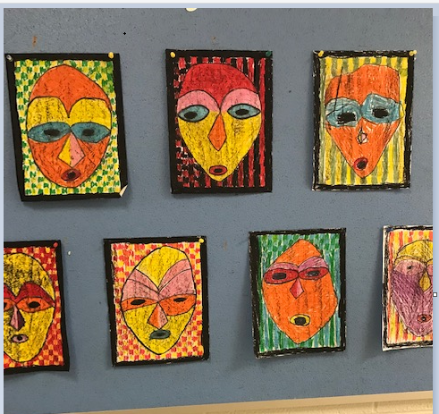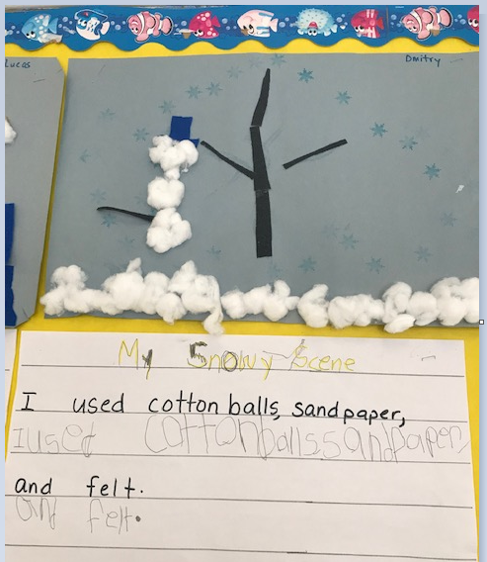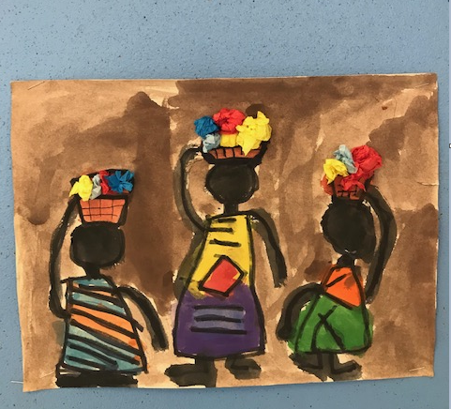

CTCC- Joy Reiter, Special Education & Inclusion CAP
Library Presentation at Agency Partnership Meeting
In January our CTCC Principal and Vice Principal Team had a half day meeting with all of our agencies, both elementary and secondary. We invited two librarians from the Toronto Public Library to present to our agencies. One of the librarians specializes in programming for children and the other specializes in programming for teens. They shared insights on the various programs / activities that our youth might be able to access in the public library. Our agencies look forward to supporting families to access public libraries so that they may enjoy positive experiences in their community.

Transitions for September 2020 and Optional Attendance
In December of each school year, we begin transition planning for students leaving our program at the end of this school year, returning to a TDSB school for September 2020. Accessing the possibility of attending another school, aside from a student’s home school, is an opportunity that can be appealing to students in CTCC if they want a fresh start in a new community. This time of year is Optional Attendance Season: applications were due and students will soon hear the results of their application. Students attending a secondary school next year are completing their course selection forms. The buzz in the air about possibilities for next year is energizing and we enjoy supporting our students with the various pathway plans.

