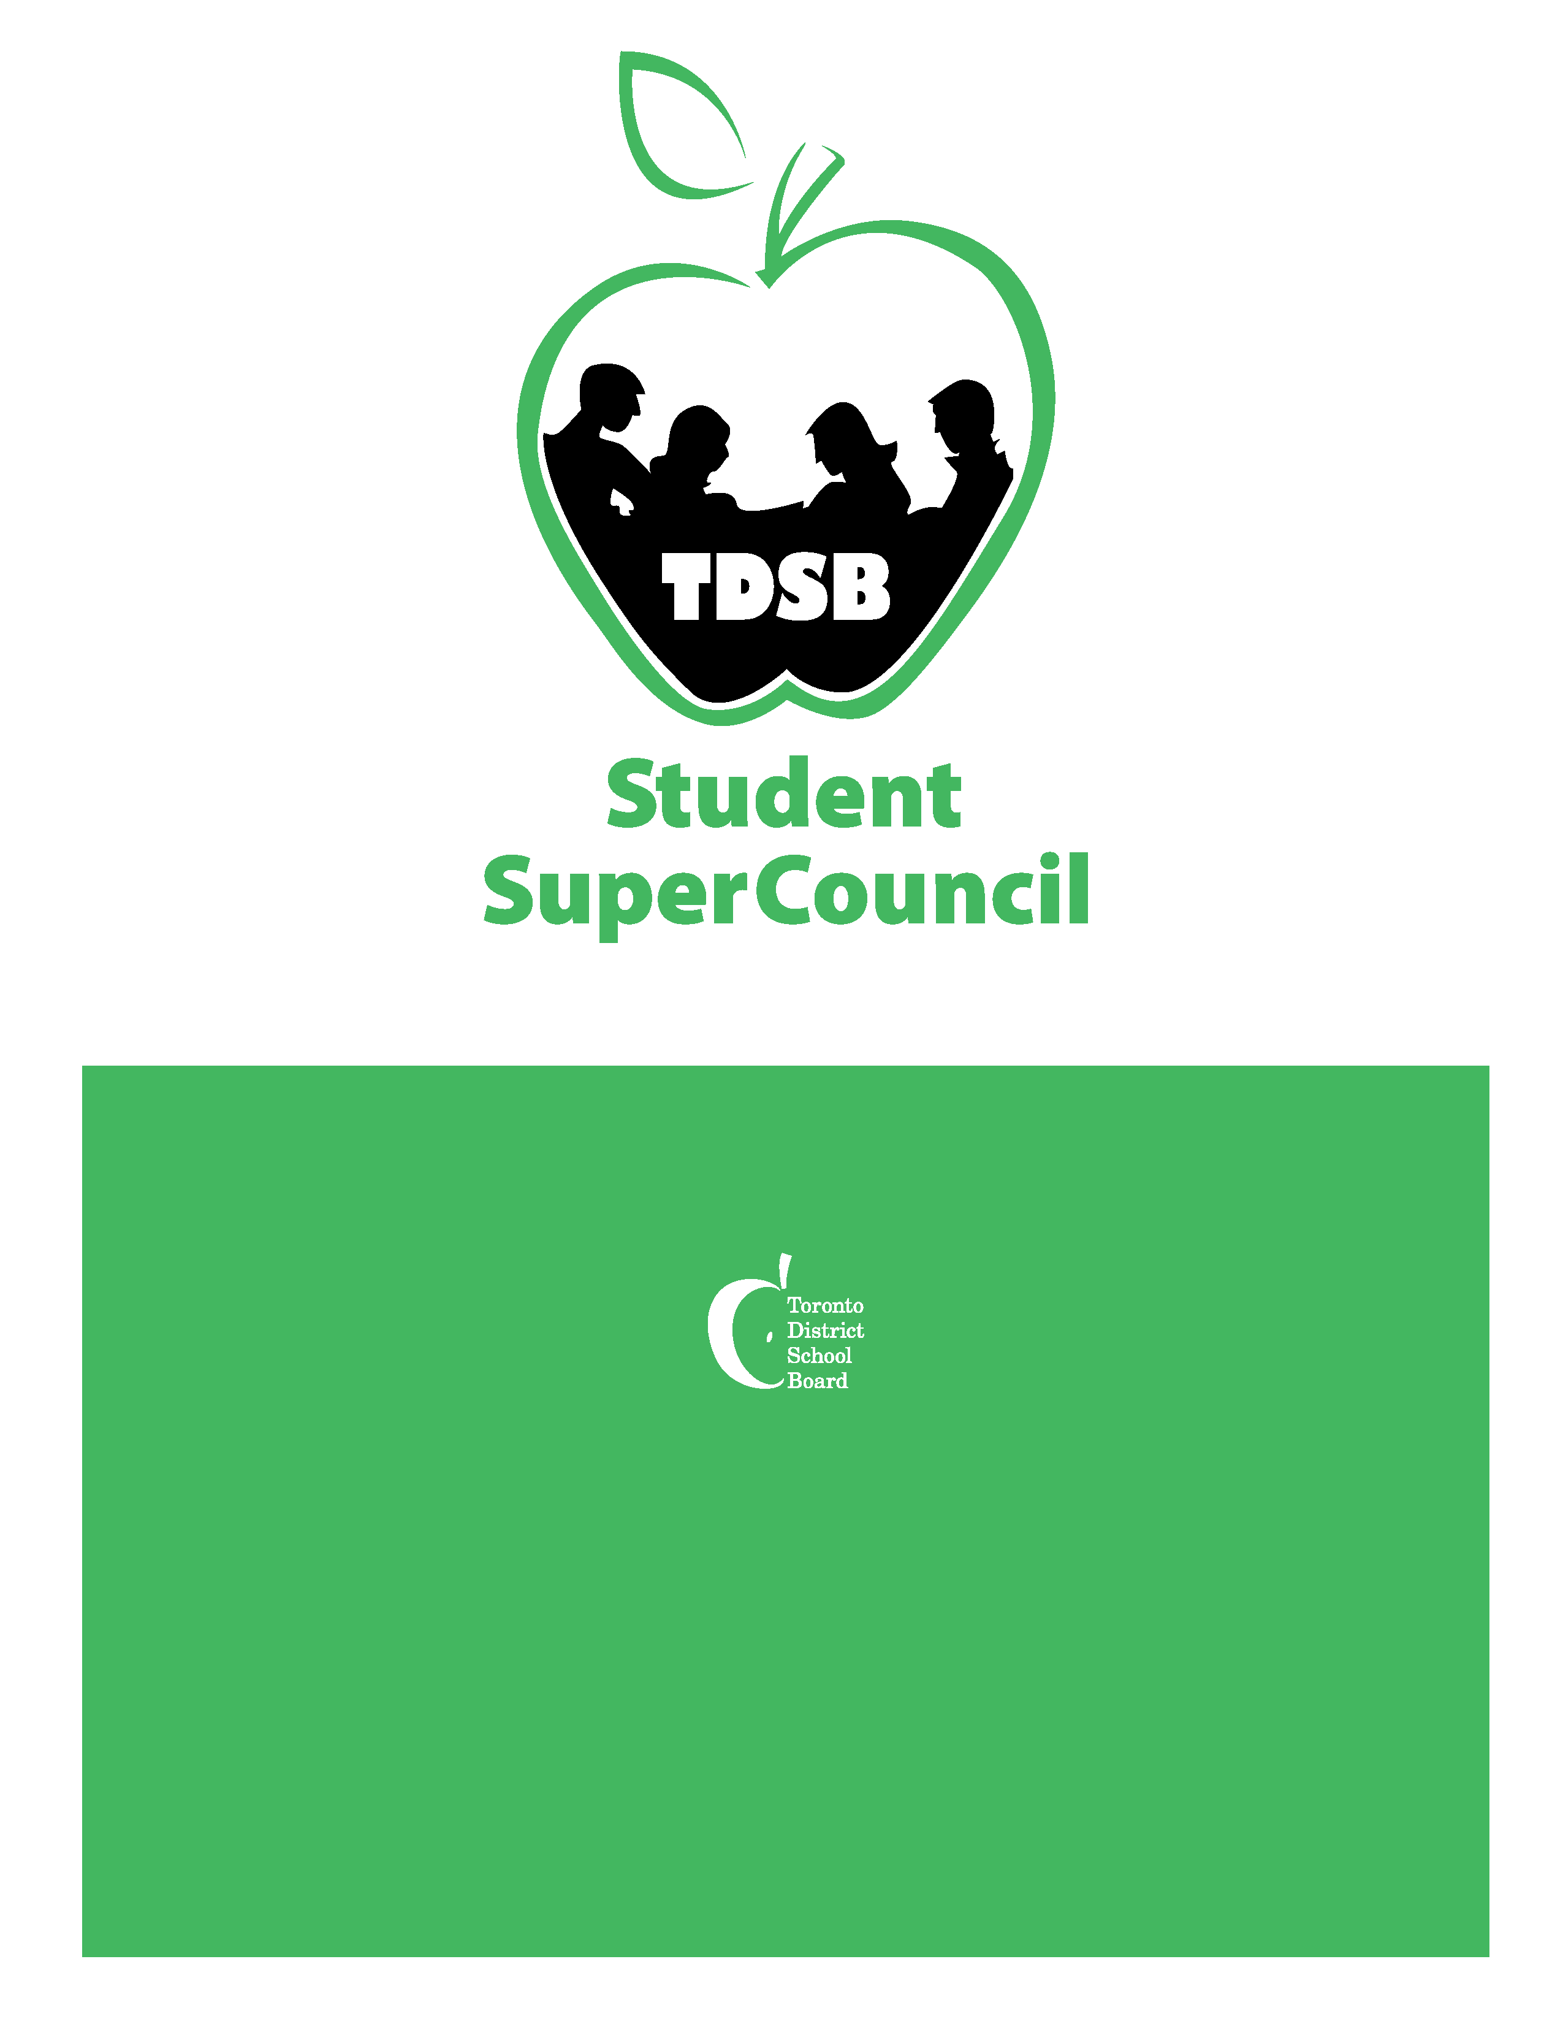

Presented by:
Toronto District School Board Student SuperCouncil

Elections Conference 2017 Registration Package

Date: Friday, May 5, 2017 Time: 8:00am – 3:00pm
Location: North York Civic Centre

DATE: March 21, 2017

TO: All Intermediate & Secondary Principals and Vice-Principals

RE: ANNUAL SUPERCOUNCIL ELECTIONS CONFERENCE 2017

The SuperCouncil elections conference is held each year to elect both a Student Trustee and the Student SuperCouncil Executives.

TDSB Student SuperCouncil is a group of 24 democratically elected students who work on advocating for students, promoting students’ voice and supporting active student governance. Furthermore, SuperCouncil facilitates communication between Trustees, staff and all students in the TDSB and provides opportunities that foster student leadership through conferences, retreats, mentoring and various other activities.

School administrators play a key role in supporting student leadership and the election of a new team of student leaders who will be the voice for TDSB students.

PRINCIPALS/VICE PRINCIPALS – PLEASE NOTE THE FOLLOWING:

- Schools can send a maximum of three (3) students. These students can be candidates, delegates, or a combination of the two (2). Strict adherence to the cap is necessary to be equitable and fair.

- A Principal or Vice Principal must short-list/select the three (3) students who they will be sending to the conference as candidates and/or delegates.

- The Principal or Vice Principal must register these three (3) students that the school will be sending to the conference by using the Google link: Registration Link

- Students who wish to run for any Executive position must have the support of their Principal or Vice Principal and be a full-time student with a minimum of eight (8) credits successfully completed or passing eight (8) credits at the time of the application.

- A Principal or Vice Principal must sign the necessary Candidate Application forms for students who are wishing to run for an Executive position in order for the applications to be considered.

- Following the on-line registration, Principals/Vice Principals must submit the hard copy excursion and media release forms for delegates and/or application forms for candidates (Candidate Application Form, Candidate Reference Form, TDSB Student Media/Website Release Form) to Cynthia Nguyen, Vice Principal, Etobicoke School of the Arts via Board mail or by email to cynthia.nguyen@tdsb.on.ca by 12 NOON Thursday, April 6, 2017.

Registration/Candidate application packages will NOT be accepted after this date.

- A suggested P.A. announcement can be found in this package to assist schools in publicizing this event.

Thank you for your ongoing support of our students and we look forward to seeing you at the Student SuperCouncil elections conference on Friday, May 5, 2017.

Important Timelines/Deadlines: All Candidates must adhere to these timelines/deadlines.

Tuesday, March 21, 2017:
    - SuperCouncil Elections Conference Package shared with Principals and Vice Principals

Friday, March 31, 2017:
  - On-line registration of delegates/candidates using the Google link: Registration Link

Thursday, April 6, 2017:
    - All Delegates/Candidates’ Excursion Forms and Application Forms (see above) due by 12 Noon to Ms. Nguyen via Board Mail or email (cynthia.nguyen@tdsb.on.ca)

Wednesday, April 12, 2017:
    - MANDATORY All Executive Candidates’ Meeting: at 5050 Yonge Street – Cafeteria from 4:30 p.m. - 7:30 p.m., for students running for an Executive position (i.e. Student Trustee, President, Vice-President, Secretary/Treasurer, Communications Officer, Conference Chair).

    - 4:30-5:00: Overview of Elections Process

    - 5:00-5:30: Executive Candidates – Breakout meeting with Current SuperCouncil Executives (President, Vice-President, Secretary/Treasurer, Communications Officer, Conference Chair)
    - Student Trustee Candidates – meet with Board Chair, Staff Advisors, current Student Trustees

    - 5:30-7:30: Participate/Observe in SuperCouncil Executive meeting

Thursday, April 20, 2017 (5050 Yonge Street - Toronto District School Board Office):
    - Student Trustee Candidate Interviews – more information will be emailed to Student Trustee candidates

Monday, April 24, 2107:
    - Candidate Poster & Speech are due to Ms. Nguyen (cynthia.nguyen@tdsb.on.ca) via email by this deadline.

Thursday, April 27, 2017:
    - Campaign officially begins (provided that candidate posters have been approved by Staff Advisors).

Thursday, May 4, 2017:
    - Last day of Campaigning for all candidates.

Friday, May 5, 2017 (North York Civic Centre):
    - SuperCouncil Elections Day – No campaigning permitted!
    - Registration – 8:00 AM

TDSB STUDENT SUPERCOUNCIL: EXECUTIVE COUNCIL POSITIONS & RESPONSIBILITIES
President
- Acts as the primary spokesperson (news and media outlets) for the SuperCouncil
  - Sets meeting dates, and sets agendas in consultation with Executive and Staff Advisors for all Learning Centre (LC) and Executive meetings
  - Is responsible for hosting a meeting with VP & Student Trustees to plan LC Agenda prior to the weekend before LC meetings to take place
  - Is responsible for hosting four separate calls with each LC to go over agenda to ensure that each LC understands the agenda and is prepared for their meetings (These four calls can take up to three hours.)
  - Is responsible for emailing the agenda to SuperCouncil Staff Advisors
  - Participates in Conference Call with Staff Advisors to review Executive Agenda to make any last-minute changes
  - Chairs all Executive meetings and SuperCouncil meetings to ensure that the meetings stay on point and within time allotment; all executives are on task and focused, and the discussions are engaging and adhere to decorum
  - Helps facilitate communication among Executive members, and representatives from the four (4) Learning Centre SuperCouncils
  - Is ready to address questions and concerns from Council in a timely fashion
  - Ensures that all SuperCouncil members are informed of all issues that may arise
  - Is a member of every committee within SuperCouncil
  - Approve along with SuperCouncil Staff Advisors any guest speakers who wish to attend Executive meetings
  - Is willing to commit time to SuperCouncil activities (3-4 hours per week)
  - Must currently be in Grade 9, 10, or 11

Vice-President
  - Performs the duties and responsibilities of the President when the President is not available
  - These duties may include but are not limited to organizing conference calls, chairing meetings and conferences (see President Role description for a detailed outline on said duties)
  - Performs specific duties as assigned by the President
  - Serves as executive liaison for one (1) of the Learning Centre SuperCouncils
  - Is responsible for organizing the annual SuperCouncil Executive Leadership Retreat and the Grade 9/10 Student Leadership Conference
  - Is responsible (along with Staff Advisors) for the planning and running of both retreats that include setting agenda, organizing activities, and planning the menus
  - Is willing to commit time to SuperCouncil activities (3-4 hours per week)
  - Must currently be in Grade 9, 10, or 11

Secretary/Treasurer
  - Is responsible for taking the minutes and attendance of all Executive and SuperCouncil meetings
  - Produces the agendas in consultation with the President
  - Produces and distributes the minutes in a timely fashion
  - Maintains correspondence with other groups as required
  - Keeps accounts of money spent as well as requests for meetings and conference
  - Serves as executive liaison for one of the Learning Centre SuperCouncils
  - Must currently be in Grade 9, 10, or 11

Conference Chair
  - Organizes and chairs a committee to plan various conferences such as Student Leadership Day (November); Grade 7/8 Mental Health and Well-being Symposium (April); Elections Conference (May)
  - Chairs the annual elections conference
  - Liaises with Staff Advisors regarding the conference
  - Coordinates the promotion of the conference to students across the TDSB
  - Serves as executive liaison for one of the Learning Centre SuperCouncils
  - Must demonstrate strong organizational, communications and leadership skills
  - Is willing to commit time to planning the various conferences (several weeks needed for each conference planning)
  - Must currently be in Grade 9, 10, or 11

Communications Officer
- Is responsible for managing the public relations, social media, digital media distribution of the TDSB SuperCouncil
- Liaises with the Communications and Public Affairs Department of the TDSB to assist in publicizing activities of TDSB SuperCouncil through the following Social Media platforms: Facebook (/TDSBSuperCouncil); Twitter (@SuperCouncil); Instagram(@TDSBSuperCouncil); Snapchat (@SuperCouncil); and YouTube (/TDSB SuperCouncil)
- Manage and create content for all of these sites
- Is responsible for producing the annual TDSB SuperCouncil report/newsletter (with Staff Advisor & TDSB Communications approval) to be distributed across the TDSB that outlines the SuperCouncil’s accomplishments, events, etc.
- Chairs the Outreach Committee (TDSB SuperCouncil members) that oversees the organization of digital media and representation of the SuperCouncil at various events
- Approves (along with the SuperCouncil President) all partnerships, collaborations, and promotional distribution
- Addresses any questions, comments and/or concerns of the public (students, staff, parents, etc.)
- Takes the promotional content lead for all SuperCouncil related initiatives (e.g. monthly LC meetings, Student Leadership Day, Mental Health Symposium, Leadership Retreat, SuperCouncil Elections)
- Liaises with other Boards’ Student Councils
- Serves as Executive Liaison for one of the Learning Centre Student Councils
- Must currently be in Grade 9, 10, or 11

**Student Trustee – One (1) Position, Two-Year Term (Student must be in Grade 10)

(Student Trustee, a pivotal role, serve as the voice for all students within the Board at the TDSB’s Board of Trustees.)

  - Represent the students’ voice at monthly Board meetings and Board Standing Committees
  - Receive input, ideas, and/or recommendations from students through the Learning Centre meetings and from SuperCouncil events
  - Attend all Executive and regular TDSB SuperCouncil Learning Centre meetings
  - Inform Executive of policies (which affect students) brought to Board for consideration by Standing Committees to assist them in the preparation of TDSB SuperCouncil meetings
  - Have a regular role on SuperCouncil agenda to report and to get input
  - Be a General Assembly member of the Ontario Student Trustees’ Association - l'Association des Élèves conseillers et conseillères de l'Ontario (OSTA-AECO).
  - Attend tri-annual General Assembly meetings held in Toronto and Ottawa where they will congregate with Student Trustees from across the province to work on Provincial education topics as well as to receive professional development for their roles.
  - Provide mentorship to their successors
  - Attend (by invitation) all official Board functions
  - Uphold and promote the Board’s mission and values in the performance of duties
  - Must demonstrate strong leadership with excellent skills in the areas of communications, critical thinking, time management/organizational skills
  - Must demonstrate passion, dedication and commitment to role
  - Is willing to commit time to Board and SuperCouncil activities (10-20 hours per week)

The following positions will be elected during the afternoon of the conference. Candidates for these positions do not need to fill out the Candidate Registration Form and the Candidate Reference Form. Voting delegates and/or unsuccessful candidates from the morning elections may run for these positions.

Alternative School Representative (one (1) in TDSB):
- Be a liaison between SuperCouncil, the Alternative School Advisory Committee and the students attending alternative schools in the TDSB
- Bring the concerns of alternative schools to the forefront of SuperCouncil when it is felt to be appropriate
- Be responsible for any additional duties outlined in the SuperCouncil Policies and Procedures document
- Must be enrolled in an Alternative School

Learning Centre Co-Chair (two (2) per Learning Centre):
- Organize and chair their respective monthly Learning Centre meetings (2 hours per meeting)
- Be available for agenda call with President and VP to go over agenda before Learning Centre meetings
- Facilitate discussions of agenda and ensuring that discussions are focused and engaging
- Publicize and promote Learning Centre meetings through social media
- Liaise with other Learning Centre Co-Chairs
- Liaise with their respective Learning Centre Staff Advisor
- Is responsible for planning and organizing a year-end fundraiser initiative
- Shall have a regular role on the SuperCouncil Executive meeting agenda to report and get input
- Be responsible for any additional duties outlined in the SuperCouncil Policies and Procedures document
- Is willing to commit time to role (6-8 hours per month)

Learning Centre Secretary (one (1) per Learning Centre):
- Take minutes at every Learning Centre meeting, and distribute them to members of the Learning Centre Council
- Update and maintain a contact list of members of the Learning Centre Council
- Assist the Communications Officer in creating and maintaining a contact list of all Student Council members in both middle and secondary (Grades 7-12) schools in the Toronto District School Board
- Liaise with other Learning Centre Council Secretaries
- Liaise with their respective Learning Centre Staff Advisor
- Shall have a regular role on the SuperCouncil Executive meeting agenda to report and get input, in liaison with the Co-Chairs of their Learning Centre
- Be responsible for any additional duties outlined in the SuperCouncil Policies and Procedures document
- Must currently be in Grade 8, 9, 10, or 11

Grade 7 and 8 Representative (one (1) per Learning Center):
  - Liaise with the two (2) Learning Centre Co-Chairs and one (1) Learning Centre Secretary of their respective areas
  - Have a regular role on the SuperCouncil Executive meeting agenda under the Learning Centre Report section to report and get input
  - Attend all executive meetings
  - Lead discussions pertaining to Grade 7 and 8 students at the monthly area meetings
  - Work under the guidance of the two (2) Learning Centre co-chairs and one (1) Learning Centre secretary in the planning of the annual area initiative
  - Is willing to commit time to role (1-2 hours per week)
  - Must currently be in Grade 6 or 7

Further information about the responsibilities of each position will be provided at the All Candidates meeting.

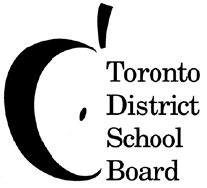

Suggested PA Announcement

TDSB STUDENT SUPERCOUNCIL ELECTIONS CONFERENCE 2017

Conference to Elect TDSB SuperCouncil Executive Council

Are you an outgoing, hardworking, ambitious individual who wants to make a difference for the students across the Toronto District School Board? Do you want to be involved in the TDSB Student SuperCouncil?
So, what is SuperCouncil?
SuperCouncil is a group of 24 democratically elected students who work on advocating for students, promoting students’ voice and supporting active student governance. Also, SuperCouncil facilitates communication between Trustees, staff and all students in the TDSB and provides opportunities that foster student leadership through conferences, retreats, mentoring and various other activities.
Annually, the SuperCouncil organizes an Elections Conference to elect the SuperCouncil Executive and a Student Trustee for the next school year. This year the Elections Conference will be held at North York Civic Centre on Friday, May 5, 2017.
If you are interested in this leadership opportunity, please ask your Principal or your Student Council for more information. This leadership experience is one that you will never forget!

MAP TO THE TDSB STUDENT SUPERCOUNCIL ELECTIONS CONFERENCE

The conference is held at the North York Civic Centre, 5100 Yonge St., Toronto, Ontario. Registration begins at 8:00 a.m.

North York Civic Centre is located near the North York Centre station on the Yonge TTC line…walk a short distance south along Yonge Street toward Sheppard Avenue. North York Civic Centre is right by the Toronto District School Board and Mel Lastman Square (on the east side). For further information, please contact Cynthia Nguyen, Vice Principal, Etobicoke School of the Arts at 416-394-6910 or on the day of the conference at 416-985-1760.

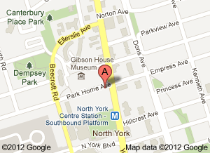
Please see the map below:
