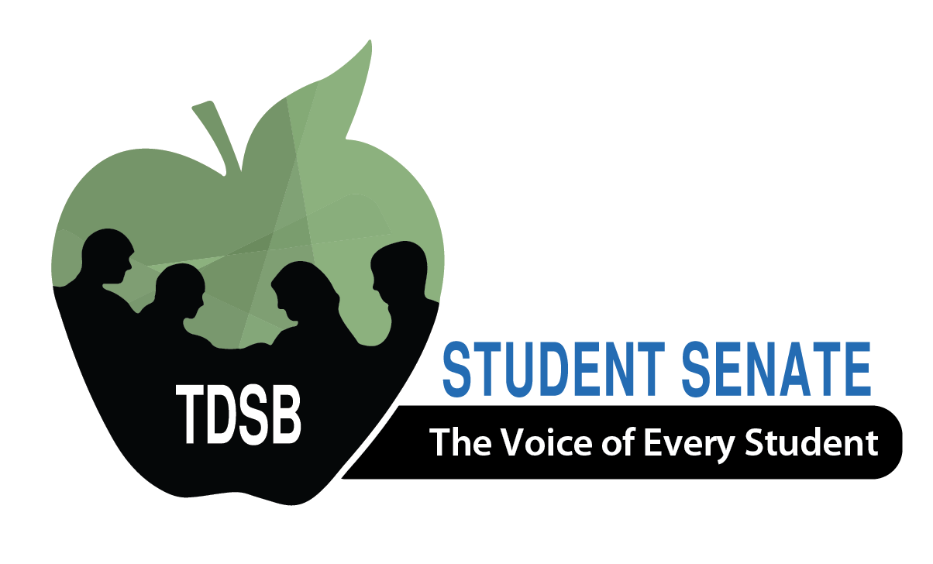

Presented by:
Toronto District School Board Student Senate

Elections Conference 2018 Registration Package

Date: Friday, May 11, 2018 Time: 8:00am – 3:00pm
Location: North York Civic Centre

DATE: April 3, 2018

TO: All Intermediate & Secondary Principals and Vice Principals

RE: ANNUAL STUDENT SENATE ELECTIONS CONFERENCE 2018

The Student Senate elections conference is held each year to elect both the Student Trustee and the Student Senate Executives.

TDSB Student Senate is a group of 24 democratically elected students who work on advocating for students, promoting students’ voice and supporting active student governance. Furthermore, Student Senate facilitates communication between Trustees, staff and all students in the TDSB and provides opportunities that foster student leadership through conferences, retreats, mentoring and various other activities.

School administrators play a key role in supporting student leadership and the election of a new team of student leaders who will be the voice for TDSB students.

PRINCIPALS/VICE PRINCIPALS – PLEASE NOTE THE FOLLOWING:

- Schools can send a maximum of three (3) students. These students can be candidates, delegates, or a combination of the two (2). Strict adherence to the cap is necessary to be equitable and fair.

- A Principal or Vice Principal must short-list/select the three (3) students whom they will be sending to the conference as candidate and/or delegates.

- The Principal or Vice Principal must register these three (3) students that the school will be sending to the conference by using the Google link:
https://goo.gl/forms/sRXXsvreeArxiRX22

- Students who wish to run for any Executive position must have the support of their Principal or Vice Principal and be a full-time student with a minimum of eight (8) credits successfully completed or passing eight (8) credits at the time of the application.

- A Principal or Vice Principal must sign the necessary Candidate Application forms for students who are wishing to run for an Executive position in order for the applications to be considered.

- Following the on-line registration, Principals/Vice Principals must submit the hard copy excursion and media release forms for delegates and/or application forms for candidates (Candidate Application Form, Candidate Reference Form, TDSB Student Media/Website Release Form) to Cynthia Nguyen, Principal, Emery EdVance SS & Adult LC via Board mail or by email to cynthia.nguyen@tdsb.on.ca by 12 NOON Thursday, April 19, 2018.

Registration/Candidate application packages will NOT be accepted after this date.

- A suggested P.A. announcement can be found in this package to assist schools in publicizing this event.

Thank you for your ongoing support of our students and we look forward to seeing you at the Student Senate elections conference on Friday, May 11, 2018.

Important Timelines/Deadlines: All Candidates must adhere to these timelines/deadlines.

  - Tuesday, April 3, 2018:
    - Student Senate Elections Registration Package shared system-wide

  - Thursday, April 19, 2018:
    - Registration/Candidate Application Package due by 12 Noon to Ms. Nguyen via Board Mail or email (cynthia.nguyen@tdsb.on.ca)

  - Thursday, April 23, 2018 (Toronto District School Board Office: 5050 Yonge Street – Cafeteria/Board Office):
    - All Candidates Meeting – MANDATORY for students running for an Executive position (i.e. Student Trustee, President, Vice-President, Secretary/Treasurer, Communications Officer, Conference Chair)
      - 4:00-4:30 p.m.
        - Overview of Elections Process
      - 4:30-5:30 p.m.
        - Executive Candidates – Breakout meeting with Current Student Senate Executives (President, Vice-President, Secretary/Treasurer, Communications Officer, Conference Chair)
        - Student Trustee Candidates – meet with the Chair of the Board, Staff Advisors, current Student Trustees
      - 5:30-7:30 p.m.
        - Participate/Observe in Student Senate Executive meeting

  - Thursday, April 26, 2018 (Toronto District School Board Office: 5050 Yonge Street):
    - Student Trustee Candidate Interviews – more information will be emailed to Student Trustee candidates

  - Monday, April 30, 2018:
    - Candidate Poster & Speech are due to Ms. Nguyen (cynthia.nguyen@tdsb.on.ca) via email by this deadline.

  - Monday, May 3, 2018:
    - Campaign officially begins (provided that candidate posters have been approved by Staff Advisors).

  - Thursday, May 10, 2018:
    - Last day of Campaigning for all candidates.

  - Friday, May 11, 2018 (North York Civic Centre):
    - Student Senate Elections Day – No campaigning permitted!
    - Registration – 8:00 AM

TDSB STUDENT SENATE: EXECUTIVE COUNCIL POSITIONS & RESPONSIBILITIES
President
- Acts as the primary spokesperson (news and media outlets) for the Student Senate
  - Sets meeting dates, and sets agendas in consultation with Executive and Staff Advisors for all Learning Centres (LC) and Executive meetings
  - Is responsible for meeting with VP & Student Trustees to plan LC Agenda prior to the weekend before LC meetings to take place
  - Is responsible for hosting four separate calls with each LC to go over agenda to ensure that each LC understands the agenda and is prepared for their meetings (These four calls can take up to three hours.)
  - Is responsible for emailing the agenda to Student Senate Staff Advisors in advance of the Executive meeting
  - Participates in an Agenda Clearing Conference Call with Staff Advisors to review Student Senate Executive Agenda
  - Chairs all Executive meetings and Student Senate meetings to ensure that the meetings stay on point and within time allotment; all Executives are on task and focused, and the discussions are engaging and adhere to decorum
  - Helps facilitate communication among Executive members, and representatives from the four (4) Learning Centres
  - Addresses any questions and concerns from the Student Senate in a timely fashion
  - Ensures that all Student Senate members are informed of all issues that may arise
  - Is a member of every committee within Student Senate
  - Approves along with Student Senate Staff Advisors any guest speakers who wish to attend Executive meetings
  - Is willing to commit time to Student Senate activities (3-4 hours per week)
  - Must currently be in Grade 9, 10, or 11

Vice-President
  - Performs the duties and responsibilities of the President when the President is not available
  - These duties may include but are not limited to organizing conference calls, chairing meetings and conferences (see President Role description for a detailed outline on said duties)
  - Performs specific duties as assigned by the President
  - Serves as Executive liaison for one of the Student Senate Learning Centres
  - Is responsible for organizing the annual Student Senate Executive Leadership Retreat and the Grade 9/10 Student Leadership Conference
  - Is responsible (along with Staff Advisors) for the planning and running of both retreats that include setting agenda, organizing activities, and planning the menus
  - Is willing to commit time to Student Senate activities (3-4 hours per week)
  - Must currently be in Grade 9, 10, or 11

Secretary/Treasurer
  - Is responsible for taking the minutes and attendance of all Executive and Student Senate meetings
  - Produces the agendas in consultation with the President
  - Produces and distributes the minutes in a timely fashion
  - Maintains correspondence with other groups as required
  - Keeps accounts of money spent as well as requests for meetings and conference
  - Serves as Executive liaison for one of the Student Senate Learning Centres
  - Must currently be in Grade 9, 10, or 11

Conference Chair
  - Organizes and chairs a committee to plan various conferences such as Student Leadership Day (November); Grade 7/8 Mental Health and Well-being Symposium (April); Elections Conference (May)
  - Chairs the annual Elections Conference if not running for an Executive position
  - Liaises with Staff Advisors regarding the conferences
  - Coordinates the promotion of the conference to students across the TDSB
  - Serves as Executive liaison for one of the Student Senate Learning Centres
  - Must demonstrate strong organizational, communications and leadership skills
  - Is willing to commit time to planning the various conferences (several weeks needed for each conference planning)
  - Must currently be in Grade 9, 10, or 11

Communications Officer
- Is responsible for managing the public relations, social media, digital media distribution of the TDSB Student Senate
- Liaises with the Staff Advisors and the staff in the Government, Public & Community Relations Department to assist in publicizing activities of TDSB Student Senate through the following Social Media platforms: Facebook (/TDSBStudent Senate); Twitter (@Student Senate); Instagram(@TDSBStudentSenate); Snapchat (@StudentSenate); and YouTube (/TDSB StudentSenate)
- Manages and creates content for all of these sites with Staff Advisor approval
- Is responsible for producing the annual TDSB Student Senate newsletter, with Staff Advisor approval, to be distributed across the TDSB that outlines the Student Senate’s accomplishments, events, etc.
- Takes the promotional content lead for all Student Senate related initiatives (e.g. monthly LC meetings, Student Leadership Day, Mental Health Symposium, Leadership Retreat, Student Senate Elections)
- Serves as Executive Liaison for one of the Student Senate Learning Centres
- Must currently be in Grade 9, 10, or 11

Student Trustee – One (1) Position, One-YearTerm (Student must be in Grade 10 or 11)

(Student Trustee, a pivotal role, serves as the voice for all students within the Board at the TDSB’s Board of Trustees.)

  - Represents the students’ voice at monthly Board meetings and Board Standing Committees
  - Receives input, ideas, and/or recommendations from students through the Student Senate Executive meetings, Learning Centre meetings and from Student Senate events
  - Attends all Executive and Learning Centre meetings
  - Informs Executives of policies (which affect students) brought to Board for consideration by Standing Committees to assist them in the preparation of TDSB Student Senate meetings
  - Has a regular role on Student Senate agenda to report and to get input
  - Be a General Assembly Member of the Ontario Student Trustees’ Association - l'Association des Élèves conseillers et conseillères de l'Ontario (OSTA-AECO).
  - Attends OSTA/AECO tri-annual General Assembly meetings held in Toronto and Ottawa with Student Trustees from across the province to work on Provincial education topics as well as to receive professional development for their roles.
  - Provides mentorship to their successors
  - Attends (by invitation) all official Board functions
  - Upholds and promote the Board’s mission and values in the performance of duties
  - Must demonstrate strong leadership with excellent skills in the areas of communications, critical thinking, time management/organizational skills
  - Must demonstrate passion, dedication and commitment to role
  - Is willing to commit time to Board and Student Senate activities (10-20 hours per week)
  - Must currently be in Grade 10 or 11

The following positions will be elected during the afternoon of the conference. Candidates for these positions do not need to fill out the Candidate Registration Form and the Candidate Reference Form. Voting delegates and/or unsuccessful candidates from the morning elections may run for these positions.

Alternative School Representative (one (1) in TDSB):
- Be a liaison between Student Senate, the Alternative School Advisory Committee and the students attending alternative schools in the TDSB
- Bring the concerns of alternative schools to the forefront of Student Senate when it is felt to be appropriate
- Be responsible for any additional duties as assigned by the Student Senate President
- Must be enrolled in an Alternative School

Learning Centre Co-Chair (two (2) per LC):
- Organize and chair their respective monthly LC meetings (2 hours per meeting)
- Be available for agenda call with President and VP to go over agenda before LC meetings
- Facilitate discussions of agenda and ensure that discussions are focused and engaging
- Publicize and promote LC meetings through social media
- Liaise with other LC Co-Chairs
- Liaise with their respective LC Staff Advisor
- Be responsible for planning and organizing a year-end fundraiser initiative
- Shall have a regular role on the Student Senate Executive meeting agenda to report and get input
- Be responsible for any additional duties as assigned by the Student Senate President
- Is willing to commit time to role (6-8 hours per month)
- Must currently be in Grade 8, 9, 10, or 11

Learning Centre Secretary (one (1) per LC):
- Take minutes at every LC meeting, and distribute them to members of the LC Council
- Update and maintain a contact list of members of the LC Council
- Liaise with other LC Council Secretaries
- Liaise with their respective LC Staff Advisor
- Shall have a regular role on the Student Senate Executive meeting agenda to report and get input, in liaison with the Co-Chairs of their LC
- Be responsible for any additional duties as assigned by the Student Senate President
- Must currently be in Grade 8, 9, 10, or 11

Grade 7 and 8 Representative (one (1) per LC):
  - Liaise with the two (2) LC Co-Chairs and one (1) LC Secretary of their respective areas
  - Have a regular role on the Student Senate Executive meeting agenda under the LC Report section to report and get input
  - Attend all executive meetings
  - Lead discussions pertaining to Grade 7 and 8 students at the monthly area meetings
  - Work under the guidance of the two (2) LC co-chairs and one (1) LC secretary in the planning of the annual area initiative
  - Is willing to commit time to role (1-2 hours per week)
  - Must currently be in Grade 6 or 7

Further information about the responsibilities of each position will be provided at the All Candidates meeting.

Suggested PA Announcement

TDSB STUDENT STUDENT SENATE ELECTIONS CONFERENCE 2018

Conference to Elect TDSB Student Senate Executive Council

Are you an out-going, hardworking, ambitious individual who wants to make a difference for the students across the city of Toronto? Do you want to be involved in the TDSB Student Senate? Student Senate represents all Grade 7-12 students in the TDSB and works to strengthen the student voice, in furthering the needs, interests and welfare of all TDSB students. Annually, the Student Senate organizes an Elections Conference to elect the Student Senate Executive for the next school year. This year it will be held at North York Civic Centre on Friday, May 11, 2018. Each school may send three (3) students. If you are interested in this leadership opportunity please ask your Principal or your Student Council for more information. This leadership experience is one that you will never forget!

MAP TO THE TDSB STUDENT SENATE ELECTIONS CONFERENCE

The conference is held at the North York Civic Centre, 5100 Yonge St., Toronto, Ontario. Registration begins at 8:00 a.m.

North York Civic Centre is located near the North York Centre station on the Yonge TTC line…walk a short distance south along Yonge Street toward Sheppard Avenue. North York Civic Centre is right by the Toronto District School Board and Mel Lastman Square (on the east side). For further information, please contact Cynthia Nguyen, Principal, Emery EdVance SS & Adult LC at (416) 395-3225 or on the day of the conference at (416) 985-1760.

Please see the map below:
