**FSL PROGRAM REVIEW CONTEXTUAL INFORMATION**

## Context

The Vision for French as Second Language (FSL) Programming in the Toronto District School Board detailed below was developed in response to a comprehensive French as Second Language Program Review conducted in the Spring of 2018 with the goal of identifying program needs and recommending strategies for ensuring the ongoing viability of and improving access for all students to intensive FSL Programs, as well as enhancing the program and experience of students and staff in Core French.

The Vision is aligned with the *Board’s Multi-Year Strategic Plan*and the *Guiding Principles for the Long-Term Program and Accommodation Strategy*. While the proposed recommendations reflect the challenge of implementing the necessary changes within the constraints imposed by recently announced Provincial funding reductions, they are nevertheless consistent with the Board’s *Budget Strategic Drivers 2019-2020*, allocating resources equitably to improve access to FI programming for all families across the system that choose this path.

As Canada’s largest and most diverse school district, the TDSB is committed to providing equitable access to learning opportunities so that all students can gain the foundational skills they will need to thrive, whatever future pathway they choose.

Whether that path lies right here in Toronto, or takes them across Canada or even around the globe, the ability to communicate in both of Canada’s official languages is one such foundational skill. We know that learning French can unlock critical future opportunities allowing our English-speaking students to move on to study, work and live in all parts of Canada. As *The Ontario Curriculum, French as a Second Language* points out:

*“The ability to speak and understand French allows students to communicate with French-speaking people in Canada and around the world and to develop and benefit from a competitive advantage in the workforce.” [1]*

Similarly, lack of equitable access to enhanced French-language Programs creates a fundamental opportunity gap, and for this reason, increasing system-wide access to intensive French Programs and improving FSL programming for all TDSB students has been identified as a priority for the Board.

**History**

## Intensive French Programs

The Early French Immersion program began with a handful of Toronto schools in the early 1970’s; at amalgamation, there were 41 Early French Immersion entry sites in the TDSB. The Junior Extended French program was introduced in seven TDSB schools in 2004, and has since grown to 38 sites. In 2009, PR597 came into effect, establishing a process for program growth and allowing for accommodation of all families who apply to an Early French Immersion or Junior Extended French program by the annual deadline. Since that time, the Board has opened 30 new sites to accommodate growing demand for the program by parents and communities.

Currently, with an overall combined enrolment of almost 29,000 students, the Board’s delivery model for intensive FSL programs is unusual. Unlike other boards, which typically provide one or two entry points into an intensive French program, the TDSB offers six. Two of these are entry points into the two system-wide programs:

1. Early French Immersion (SK entry), with a total entry enrolment of 2,985 students in 2018-19, and
2. Junior Extended French (Grade 4 entry), with a total entry enrolment of 1,116 students in 2018-19.

In addition, the Board currently offers four locally-managed intensive French Programs with different entry points. These smaller programs operate in a limited number of schools, where they reflect local historical legacy-program models:

* Middle French Immersion (Grade 4 entry), in 2 schools with a total overall enrolment of 146 students;
* Intermediate Extended French (Grade 7 entry), 14 schools, with a total overall enrolment of 1,232 students;
* Cosburn MS Intensive Extended French (Grade 6 entry), in 1 school with a total overall enrolment of 138 students;
* Hawthorne II Bilingual Alternative (JK entry), 1 school with a total overall enrolment of 192 students.

The total number of SK students in 2018-19 was 14,526 of which 2,985 were enrolled in the Early French Immersion program (SK entry). The number of students participating in Early French Immersion for 2018-19 is 21% of those in SK as of October 31, 2018. There are 71 SK French Immersion sites to date, all of which are Full Day Kindergarten (FDK).

The total number of Grade 4 students in 2018-19 was 12,819 of which 1,116 were currently enrolled in the Junior Extended French program (Grade 4 entry). The number of students participating in Junior Extended French for 2018-19 is 9% of those in Grade 4 as of October 31, 2018. There are currently 38Junior Extended French sites.

## French as a Second Language Programs Review

In June 2017, the Board approved a Long Term Program and Accommodation Strategy, establishing Program Priorities aligned with the Vision for Learning and the Integrated Equity Framework, and identifying equity of access to French programs as a key priority for the Board.

During spring 2018, as part of the Director’s Response to the Enhanced Equity Task Force Report, a review was conducted to provide a comprehensive environmental scan of the Board’s FSL Programs—Core and intensive French programs. This extensive consultation process captured representative feedback on the TDSB’s French programming. Multiple stakeholders were included and also given multiple opportunities to comment on the TDSB’s French programs. This process included community meetings, student forums, staff forums, focus groups, as well as on-line surveys. There were a total of five community meetings held in May 2018 for any community members (i.e. parents/guardians, staff, and other community members). In addition, there was a meeting held specifically for TDSB staff, and a meeting for students in Grades 9-12 representative of the Core French, Extended and Immersion programs. Additionally, two focus group meetings were held for Parent Advisory Committees: one involving representatives from all Parent Advisory Committees and one particularly for the French as a Second Language Community Advisory Committee.

In addition, three on-line surveys were developed and shared of which one was designed for parents/guardians, one was designed for staff and one was designed for students in Grades 6-12.

Participation and engagement in these consultations was high as evidenced in the chart below. In total, the review captured feedback from 10,535 individuals.

|  |  |  |
| --- | --- | --- |
| **Stakeholder Group** | **Online Survey Responses** | **In-person Consultation** |
| Students (Grades 6-12) | 6,844 | 81 |
| Parent/Community Member | 1,988 | 146 (parents/community)  27 (advisory committee members) |
| Staff | 1,427 | 22 |

The [review findings](https://www.tdsb.on.ca/Community/Public-Consultations/French-Review) also provided a comprehensive overview of the Board’s FSL programs, highlighting system successes (e.g., growth in number of French Immersion/Extended French program sites), but also identified challenges in a number of areas. This data was also used to inform the present recommendations, and will continue to guide next steps.

The intent of the review was to identify program strengthens and needs, and recommend strategies for ensuring ongoing viability of and improving access for all students to intensive FSL programs, as well as enhancing the program and experience of students and staff in Core French. The review captured feedback from over 10,000 individuals.

On June 19, 2019 it was recommended and approved by the Board of Trustees that staff was to restructure the Board’s intensive FSL programs leading to a single program model with two entry points and the elimination of all other entry points. Therefore, JK and Gr. 4 were identified as the two Immersion entry points. The streamlining will increase access to an intensive FSL program for students in the board. It will permit the focus of resources, both material and human, in order to serve students better, and to strengthen the Core French programming that serves all students in Gr. 4-9 (and beyond) in TDSB schools who do not choose an intensive FSL program. This will also allow a more effective deployment of FSL qualified teachers.

For more information, please refer to the [Questions & Answers – FSL Program Review Recommendations](https://www.tdsb.on.ca/Elementary-School/School-Choices/French-Programs).

Below are some citations from the Summary of Findings and FSL Review that speak to areas of improvement and entry points.

Citation below taken from P.8 of Summary of Findings, FSL Review, Spring 2018:

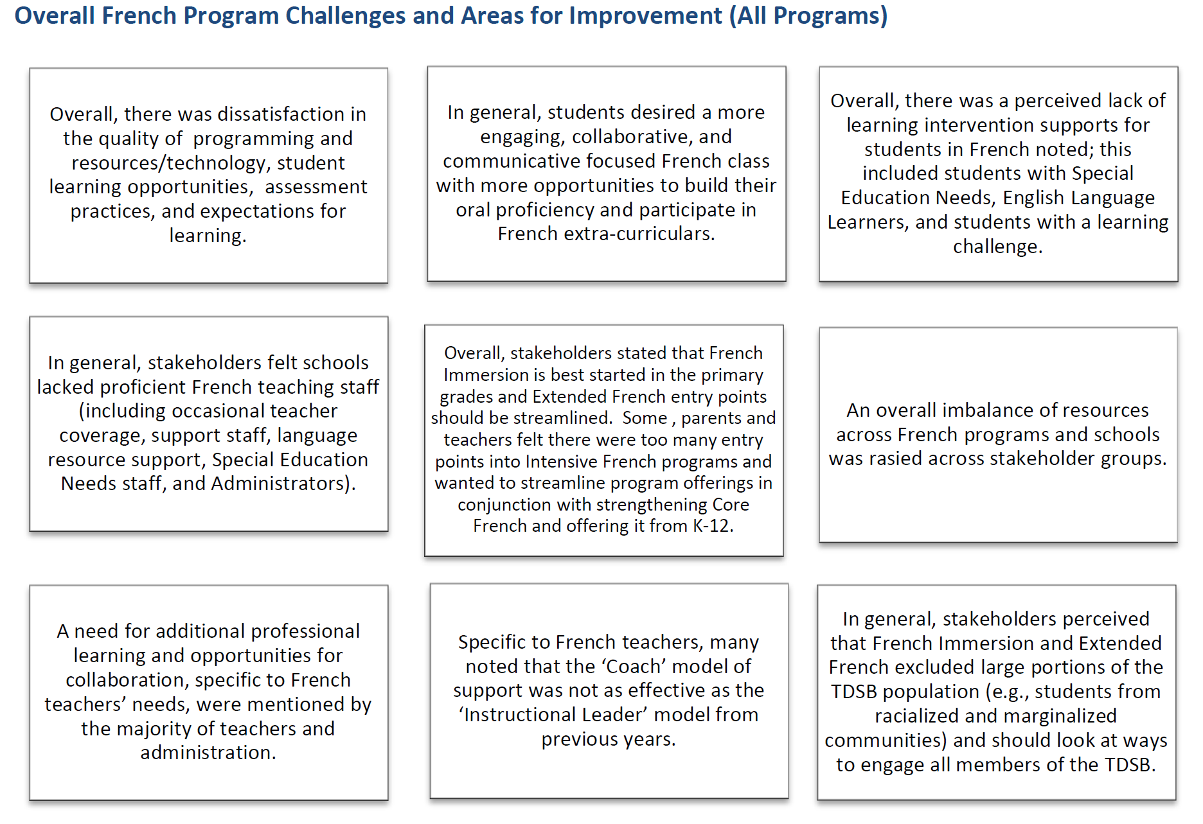

In the FSL Review, Spring 2018 (P.53), 68% of parents indicated a preference for a Kindergarten entry to French Immersion and 13% indicated a preference for Grade 1, and (P.53), 5% of parents indicated a preference for Extended French entry at Gr. 7.

Citation below taken from P.53 of Final FSL Review, Spring 2018:

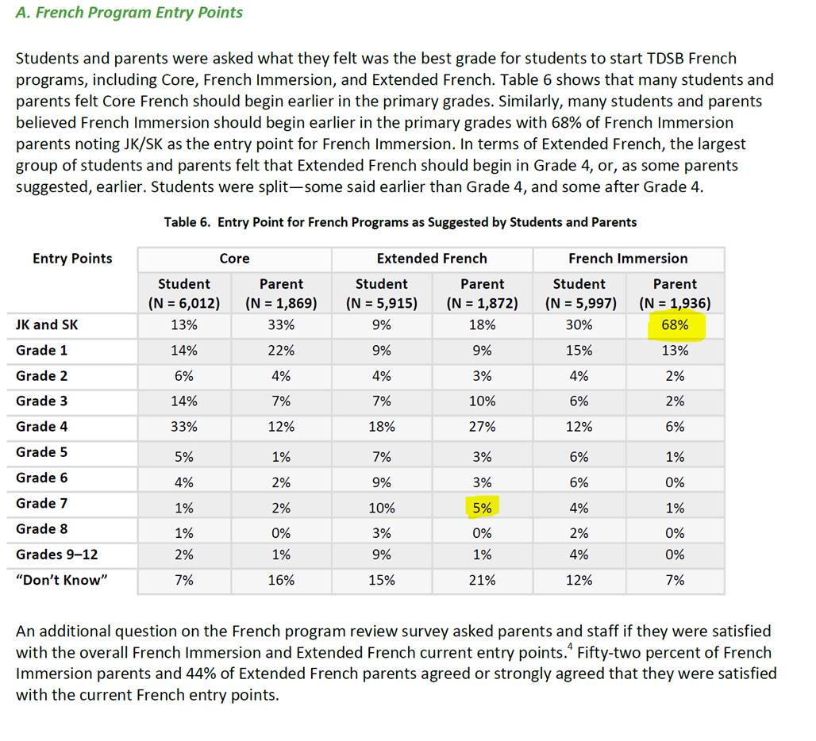

1. *Vision and Goals for French as a Second Language – Core, Extended, and Immersion, Grades 1 to 12* in *­­The Ontario Curriculum, French as Second Language* p. 6 (2013)<http://www.edu.gov.on.ca/eng/curriculum/elementary/fsl18-2013curr.pdf> The Ontario Curriculum, French as Second Language p. 6 (2013)