TDSB SEAC Report
Nadir Khan & Adam Giancola

EXECUTIVE SUMMARY

The Special Education Advisory Committee (SEAC) of the Toronto District School Board (TDSB) conducted an extensive survey of the parents of children with special education needs enrolled in TDSB schools. The following report details the results of this survey, highlighting the challenges faced by children with special education needs and presenting some ideas for addressing their concerns. With responses from over 700 parents, the information in the results carries substantial validity and weight. This report is based on responses received up to and including March 25th, 2017. Since that time, more responses have been submitted, so further analysis will be required.

The survey was divided into five main sections, focusing on the overall concerns and recommendations of parents, the particular needs of the students, the experiences of parents with the TDSB, feedback on the Individual Education Plan (IEP), and an evaluation of the Identification Placement Review Committee (IPRC) and Special Education Placement Review Committee (SEPRC).

SECTION B: IDENTIFYING THE NEEDS
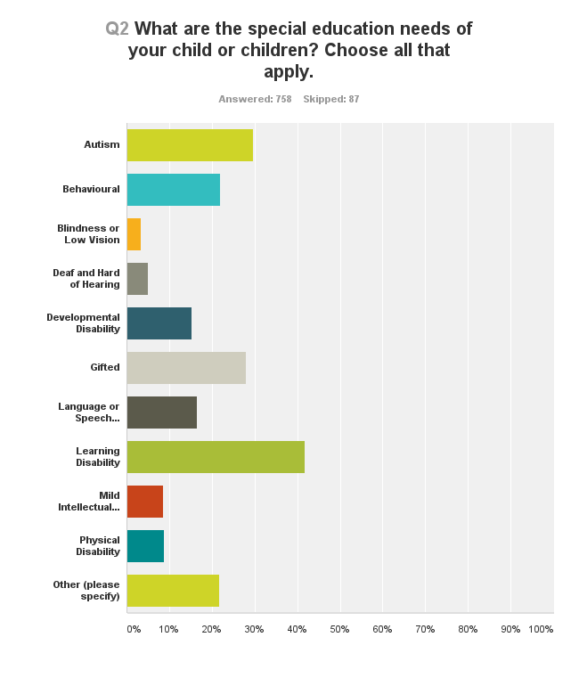

The responses revealed that the majority of children surveyed had either a learning disability (317), autism (224), or were gifted (210). Additionally, behavioural needs (166) and language or speech impairment (125) were also cited as important needs of students.

Among the needs not listed in the survey, ADHD and anxiety were most frequently mentioned by the respondents.

The data also reveals that many students have multiple needs that need to be addressed and cannot be readily separated into groups with singular needs.

SECTION C: EXPERIENCES WITH THE TDSB

Parents were asked to speak about their respective experiences in dealing with the Toronto District School Board. The questions in this section focused on the time when their child’s special needs were noticed, their knowledge of existing support systems for their child, and their overall satisfaction with the TDSB’s management of their child’s particular needs.

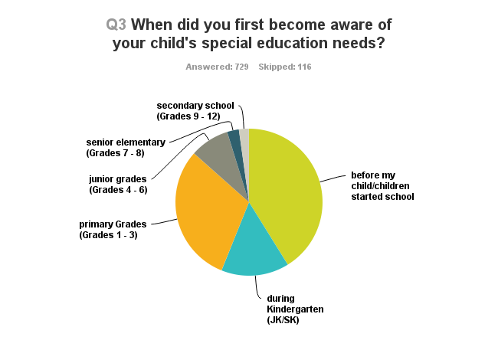
For 300 of the 727 respondents, their child’s needs were known to them early on, before they were of school-going age. For those that were identified later, the largest number were picked up between Kindergarten and Grade 3 (330). The data would suggest that there should be more vigilance in the earlier classes so that these needs are identified at the earliest time of manifestation. A positive takeaway from this information is that the school administration can take a proactive role in reaching out to parents with special needs children prior to their enrollment and tailor their procedures to better cater to their needs.

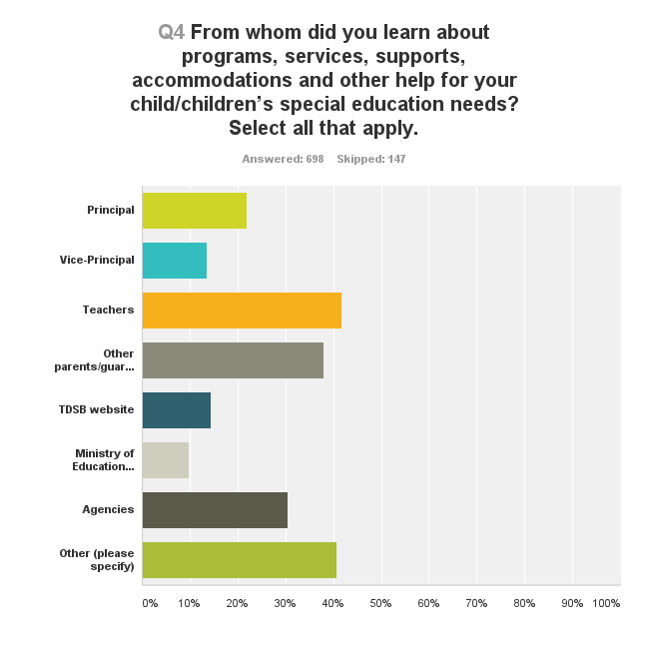
In terms of learning about programs for their children, teachers, and other parents were the most commonly mentioned source of information for the respondents.

The TDSB Website and the Ministry of Education Website received some of the lowest responses. As a large number of respondents cited their own research and social media in learning about relevant programs, the TDSB and MOE websites need to provide better information for such parents.

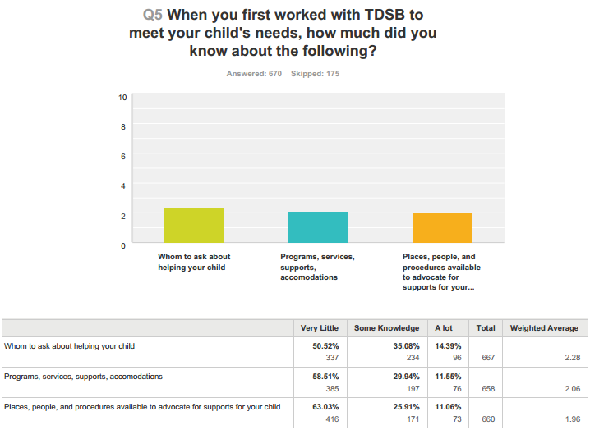
Parents were asked the extent to which they were familiar with the supports for special needs students. For each of the categories surveyed, “whom to ask about help”, “programs, services, supports” and “places, people and procedure for advocate for your child”, the majority of respondents had very little knowledge. The percentage of parents that were well informed was woefully low in each category, highlighting the need for the TDSB to better communicate with such parents in advance of these needs arising. Additionally, in the comments section for this question, many respondents lamented the fact that they were often misguided or had their question unsatisfactorily answered by the school personnel and had to do their own research to learn more about accommodation.

It is in response to questions about their overall satisfaction with the TDSB that some interesting insights can be drawn. Discounting the “neither agree nor disagree” respondents and combining the “strongly agree” and “agree” and the “strongly disagree” and “disagree” categories, we found that several respondents were dissatisfied with the TDSB’s staff in addressing their needs.
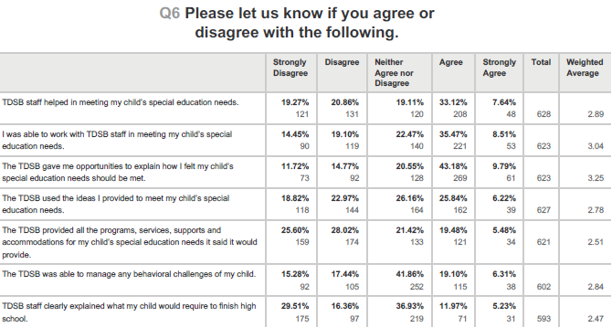

SECTION D: THE INDIVIDUAL EDUCATION PLAN (IEP)

This section deals with the Individual Education Plan (IEP), and asks parents to discuss their experience with their child’s IEP. Of 646 responses collected, 611 parents (94.58%) indicated that they were aware that the IEP is used for children with special needs. Only 35 parents (5.42%) were not aware that the IEP is used for this purpose.
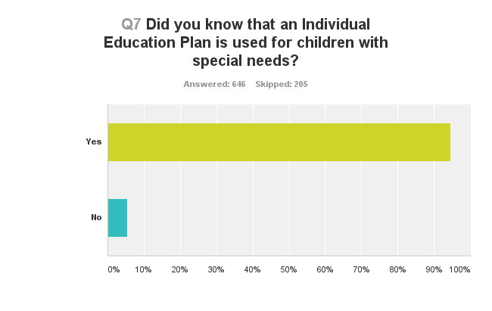
When asked about whether or not their child has or at one point had an IEP, 636 parents submitted a response. Of those responses, 558 (87.74%) parents indicated that their child had an IEP. 78 (12.26%) parents indicated that their child did not.
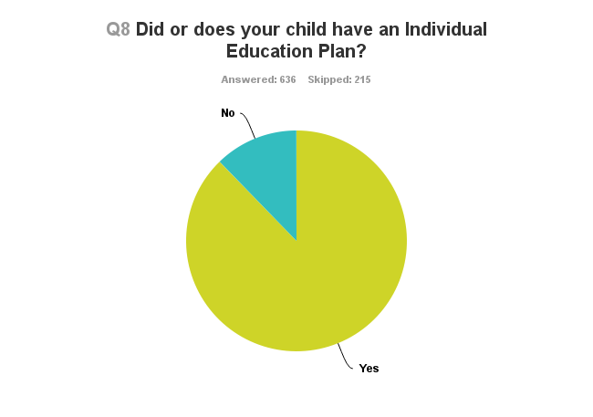
When asked about their level of satisfaction with their child’s IEP, 617 parents provided responses. Of those responses, 46 (7.46%) parents indicated that the question was “Not Applicable.” The greatest response rate came from 218 (35.33%) parents, who indicated that they were “Satisfied” with their child’s IEP. Another 67 (10.86%) parents indicated that they were “Very Satisfied.” However, 169 (27.39%) parents indicated that they were “Not Satisfied,” with their child’s IEP, while 117 (18.96%) parents stated that they were “Not Satisfied at all.” Taken together, of those parents who responded to the question and found the question applicable, they were almost equally split on their impressions of the IEP. 46.19% of the total respondent parents expressed some sort of favourable view of their child’s IEP, while 46.35% expressed an unfavourable view.

Q9 If your child has or had an Individual Education Plan, how satisfied are you or were you with it?
Answered: 617 Skipped: 234

– | Not satisfied at all– | Not satisfied– | Satisfied– | Very Satisfied– | Not Applicable– | Total– | Weighted Average–
–  (no label) | 18.96%  117 | 27.39%  169 | 35.33%  218 | 10.86%  67 | 7.46%  46 | 617 | 2.60

Some of the comments from parents responding to this question suggest a wide spectrum of experiences and concerns. One of the most frequent concerns cited involved wait times. A number of respondents indicated that they had to wait (or are still waiting) lengthy periods of time to get an IEP for their child. One parent also noted that they did not have “a clear mechanism for measuring [their] child progress(regress) in place.” One parent noted that their child’s IEP was sometimes was used as a “weapon” by teachers to belittle them. For those parents that indicated that they were satisfied with their child’s IEP, a number of the respondents commented that their satisfaction was an eventual result, only after certain steps were taken to put the IEP into effect.

SECTION E: THE IPRC AND SEPRC
In this section, parents were asked to discuss their experiences with the Identification Placement Review Committee (IPRC) and/or the Special Education Placement Review Committee (SEPRC). Both of these committees make recommendations about what kind of placement a child should be in, i.e. a regular classroom or a special education classroom, or a combination of the two. From 604 responses collected, 460 (76.16%) respondents indicated that they were aware of or had the school explain what these committees do. Conversely, 144 (23.84%) respondents indicated that they were not aware of these committees. However, some of the comments from parents suggest that, of those parents who were aware of the committees, many were not aware of the specific programs that each committee offers. A number of parents indicated that they had to do their own research to find out further information.
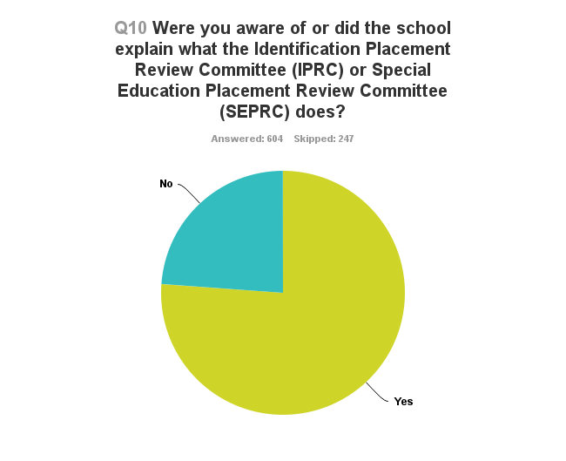
Of 606 responses collected, 435 (71.78%) of parents indicated that the school referred their child to the IRC or SEPRC. Conversely, 171 (28.22%) of parents indicated that they were not referred.
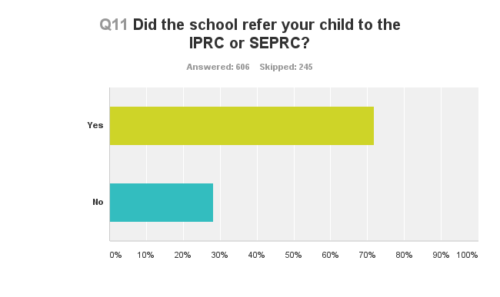
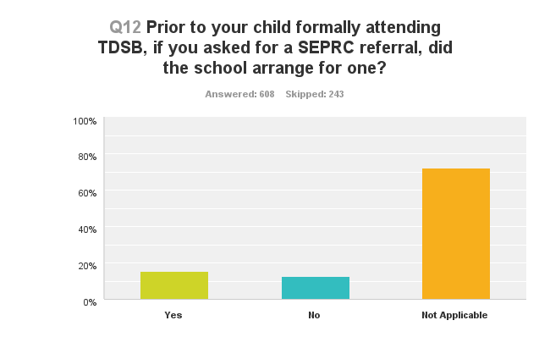
Parents were then asked about whether the school arranged for their child to receive an SEPRC referral following their request for one. Of 608 responses collected, only 170 responses were applicable. 93 (15.30%) parents indicated that the school had arranged for one, while 77 (12.66%) indicated that the school had not.

Parents were then asked about their various courses of action following a special education placement recommendations by the SEPRC. Of 597 responses collected, 370 parents indicated that the question was inapplicable. 88 (14.74%) parents indicated that they accepted the placement, and agreed with the decision. 49 (8.21%) parents accepted the placement, but only because they were told their child could not be properly supported in a regular classroom. 17 (2.85%) parents accepted the placement, but only because they did not know they could say no and opt for a regular classroom. 31 (5.19%) parents declined to accept the placement and asked for a placement in a regular classroom. The remaining 42 (7.04%) parents indicated “Other” on the survey and provided additional responses. Some parents indicated that instead asked for blended learning, combining in-class and special needs teaching. Other parents noted their concerns about losing decision-making capacity with regards to the direction of their child’s education.
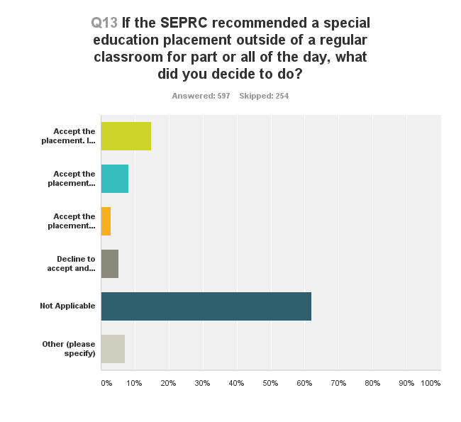
When asked about referrals to the IRPC in the TDSB, 598 parents gave responses. Of those responses, 279 (46.66%) parents found the question inapplicable. 255 (42.64%) parents indicated that the school arranged the referrals, while 64 (10.70%) parents indicated that the school did not.
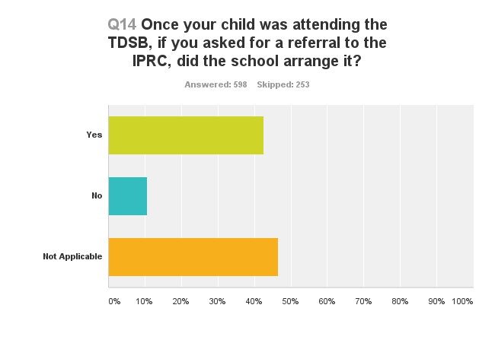
592 parents responded to the question regarding courses of action following an IPRC recommendation for a placement outside of a regular classroom. Of those responses, 283 (47.80%) parents found the question inapplicable. 161 (27.20%) parents accepted the placement because they agreed with the IPRC decision. 74 (12.50%) parents accepted the placement because they were told their child could not be properly supported in a regular classroom. 21 (3.55%) parents appealed the IPRC decision, and 53 (8.95%) parents took other courses of action, including declining the placement to keep the child in French immersion, keeping the child in the regular classroom, accepting the placement because of particular people (i.e. the principal) at the placement school, and accepting the placement because it was nearby.
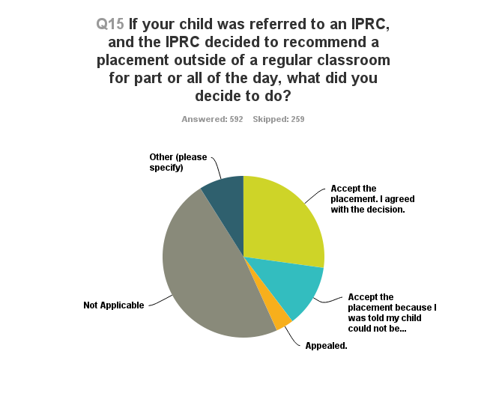
The last question in the section asked parents to agree or disagree with the statement: “I was given enough information about services and programs available to students who are placed in 1) a regular classroom for the whole day; 2) a regular classroom for more than half of the instructional day and in a special education setting for the remainder of the day; 3) A special education classroom for more than half or all of the instructional day.” 577 parents submitted a response.
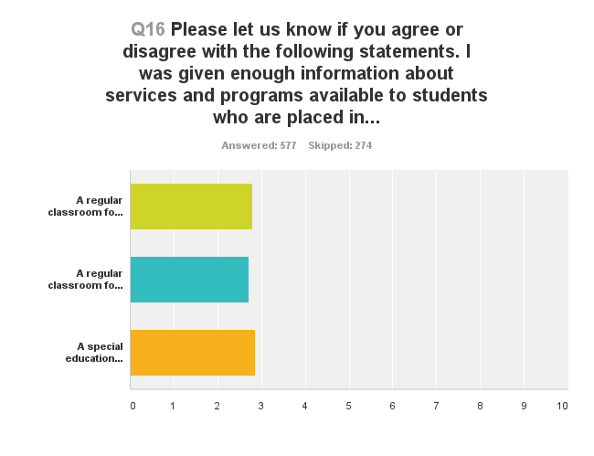
Below is a statistical breakdown of the scale of agreement or disagreement among parent respondents for each school setting type. Overall, responses varied across the board, with slightly more parents agreeing that they received sufficient information about the regular classroom full-day option. This option had an average agreement score of 2.79. The option with the least amount of agreement as to information having been provided was “the special education classroom for more than half or all of the instructional day” option, which had an average agreement score of 2.0.

– | Strongly Disagree– | Disagree– | Neither Agree Nor Disagree– | Agree– | Strongly Agree– | Total– | Weighted Average–
–  A regular classroom for the entire day. | 19.17%  106 | 22.78%  126 | 24.77%  137 | 26.76%  148 | 6.51%  36 | 553 | 2.79
–  A regular classroom for more than half of the instructional day and in a special education setting for the remainder of the day. | 20.15%  107 | 21.09%  112 | 31.64%  168 | 21.66%  115 | 5.46%  29 | 531 | 2.71
–  A special education classroom for more than half or all of the instructional day. | 16.57%  87 | 19.81%  104 | 32.57%  171 | 23.43%  123 | 7.62%  40 | 525 | 2

APPENDIX: ADDITIONAL COMMENTS AND TRENDS
In this section, we highlight some important trends and key quotations that were observed throughout the survey. In particular, questions 17 and 18 of the survey asked respondents to provide general comments and feedback on their IPRC or SEPRC experiences, as well as their experiences with special education programs more generally. Many of the responses to these questions are incorporated into the trends discussed below.
Trend #1: The Ongoing Fight Among Parents for Information and Services
Parents throughout expressed their dismay with the difficulties of seeking out more information and accountability for services offered. Below is a sample of quotations reflecting this theme:
“Where to begin...... It has been hard work as a parent. It is hard not to feel defensive and like you are battling the TDSB for your child. At the classroom and school level there have been some incredibly devoted and open teachers along the way. Overall I think that the expertise in misplaced in the school board and by that I mean that I believe parent should be seen and treated as the expert on their child. Too often the systems sets up the professionals within it to be the experts.”
“Takes a lot of fight, efforts, money to get the right information, services, placement for a child. A temporary solution of DFO (direct funding options) for families to find the appropriate education elsewhere or to home school could be an option till TDSB clears and fix the mess.”
“As a parent, I have been through a lot to fight for my child, and things are moving now, l have had many disappointments, but I always knew that I was on the right... Things have changed for my child, and are changing because I know that I have the support of the higher ups of the tdsb, education ministry and the government. My concern is that I shouldn't have to write to the director or the minister every time my child is denied her basic rights.... I appreciate this survey and the people at the board who want to make things better for all of us...”
“The process has been disempowering for parents and students. The system failed her. We approached the Superintendent last Spring - the 'team' assigned assured us that they would follow her progress from now on. Haven't heard from them. Lack of accountability is guaranteed. It has been exhausting!!”
“Everything is a struggle and fight. Parents with children without a disability are not subject to the intense advocacy skills needed to traverse the TDSB and get an education for their child. It is exhausting.”
“for the most part it has been a disaster I have spent so much time and energy advocating for both kids that I cant work getting them s.e.a claims was ridiculous....when it should have been so easy...it took forever and the special ed teacher had no clue what she was doing....totally pathetic she couldn't have been any more incompetent and she is still teaching ..lol.... so many kids lives she is damaging..... maybe someone can really see that she is not in the right position...she is the special ed mart at morse street school. Educate the principals....many don't have any idea what they are doing...and now ...we have one at the one school..who is highly knowlegable ...who is fully supportive and has basically given us back part of our lives....just by doing her job well...she is the principal of Bowmore jr /sr school. Get her to teach the other principals.. Our lives have been put on hold and ruined since our children entered school...it has been hell...and I would wish it on no one.”
Trend #2: Lack of Consistency among TDSB Staff
Parents repeatedly complained about the lack of care and effort among staff and administration. In addition, several parents complained about a lack of training or understanding among teachers when engaging and working with special needs children. On many occasions, decisions about placements for children were based on whether the staff at a given placement school actually cared about the child.
“There is no consistency across schools. Friends have had wonderful experiences. Some staff are incredibly knowledgable and supportive. Our experience until grade five was awful. The only reason I did not file an official complaint was that I feared the staff would respond negatively and give my child even less support. Parents of special needs children are so dependent on the goodwill of school administrators that we have almost no power. It is an unconscionable situation that must be fixed. It breaks my heart to have to say this as a proud TDSB employee who works with many wonderful teachers and people in other supportive roles.”
“Staff and administration are not engaging transparently or authentically with families. They do not want to actively support children with special needs in a regular class setting and instead focus their efforts on trying to guilt the family to agree to a diagnostic placement. The teacher repeatedly telling the family she has 29 other children and is unable to spend time to assist in meeting the child's needs. The Principal not engageing the Board for other supports/ assessments to assist the teacher. These children are not appropriately being supported by the TDSB in a regular class placement.”
“Not good. I came very close to reporting one teacher, one principal, and the SE consultant to OCT. I was lied to many times over, hired advocates, a psychologist and a remedial teacher to do what should have been done automatically and with grace, professionalism and respect by the TDSB staff . At one point the superintendent of SE for TDSB became involved because of the many brick walls that my child was facing. This was ultimately helpful. Prior to this the local superintendent bullied me as well in response to my attempts to advocate for my child.”
“I would like to think that the most multi-cultural board in all of Canada does follow its Equity Policy. I think we are failing Spec. Ed. kids who are not seen as important in the eyes of many, from Admin. to teachers. TDSB needs to change that culture. There are Administrators promoting dumbing down of everything for these kids and that is not the way to go. These students are human beings with worth and value and intelligence but they don't get treated as such in many schools. Send out a survey to these kids, their parents, their teachers. The superintendent should visit schools and meet with Special Ed. staff . and teachers and find out the truth of what goes on. There is a lot more that TDSB can do and TDSB needs to make all parties accountable.”

Trend #3: IRPC and SEPRC Meetings are largely Inaccessible, Ineffective, and Infrequent
The large majority of respondents described negative experiences regarding their child’s IRPC / SEPRC meetings. Several respondents described the meetings as “stressful,” “scary,” “intimidating,” “cold,” and “uncaring.” There were, however, a few respondents who found the meetings to be clear, comfortable, and informative. A frequent concern raised was that parents felt that decisions regarding their child had been made prior to the meeting having taken place. Meetings were also arranged on short notice, and were far too short in length.
“Cold, uncaring, insensitive, rushed, bureaucratic, and over-staffed. There should be a system in place whereby: - parents/caregivers are able to view a realistic (but fictional) video so they have an idea what these meetings are like when they first attend - there should be a "mentoring" system via a "special ed council" (parents of special ed kids can accompany first timers to these meetings ) - there should be a feedback system whereby parents/caregivers can meet with administrators as a group, and make/receive suggestions for improvement of the system as a whole.”
“Schools are having IPRC's only once per year, mostly in May-June, doesn't matter when you request the meeting . If parents request the meeting , it should be clear that it's a case of emergency. We do not request a meeting for no reason.”
“We had only SEPRC so far. Our child is with ASD and non-verbal. On the placement meeting we were told that we are being send to classroom where the staff has experience working with kids with these needs. On the first meeting with the school staff that was confirmed : "Yes, we have experinece with non-verbal kids" and with Autism. To our surprise we discovered very soon after the start of the school year (last year) that the knowledge about Autism is very minimal to the point that staff is not familiar even with the basic terminology . Also, there was no knowledge at all on the use of PECS and AAC and the iPad was not initially allowed as was considered a toy. We were wondering during the whole year why we were send there and why such a misinformation. Speaking of that - using placements as a distribution of funds among schools should not be permitted and we would like to see consequences for the participants in such an actions. It's your job SEAC to stop this!”
“It was fairly clear that parents/caregivers who are uninformed, indifferent, or whom have barriers to advocating for their student would be at great disadvantage through the process. The panel format of the meetings is very intimidating, particularly if the parent/caregiver does not have an experienced trustworthy advocate with them for assistance or is unable to articulate their needs and concerns in that setting. It might be helpful to allow written submissions from all parties to consider in advance of the meetings .”
“Not enough notice / time to prepare for the meeting - feel like someone dropped the ball In our case somewhere since we only had two business days notice. The actual meetings are too short in time.... We felt rushed and ill prepared on what questions to ask etc.”
“The IPRC meeting provided us with clear information about the role of the committee and how the gifted program would be beneficial in supporting our daughter's needs. We felt confident about the choice we were making as a result of the information we received at this meeting .”
“IPRCs were always very stressful, we always felt out-numbered and that our role was to listen and agree. It was never entirely clear (or consistent) what we could and could not talk about. All too often we felt that the first concern was for the school and the teachers, with the educational needs of our child a secondary concern. Given the amount of influence and control the people on the other side of the table had over our son during his school day, we definitely felt it was necessary to be cautious in our comments and avoiid criticism. I used to joke that I prepared more for an IPRC meeting that for the most important sales meetings of my business life. My husband and I would literally work out what we would and would not say, how we would indicate to each other if we felt things were getting difficult, and developed a strategy of asking for more than we wanted so that we could appear to concede when we were actually achieving our aims.”
“The experience was mostly positive. However I did not feel that the tdsb special education representative ( not the teacher or principal) was advocating for my child. Fortunately I was comfortable in the meetings and had the support of the staff at my child's school. It would have been helpful to feel we could discuss all options.”
“It seemed that the principal had met with other meeting participants beforehand to come up with a plan of attack against me.”
“At no time during any IPRC meeting have I not felt intimidated or that the IPRC was truly impartial and acting in the best interests of our child. I am happy that managed to get into contact with an advocate so at least I know what the TDSB "should" be doing.”
“A 5 minute meeting to determine the needs of my child is not enough time. Placements are already decided before they even know my child. It's all based on spaces not best fit. The system is so flawed.”
“It is an awful experience. I feel like I have to face a firing squad at every meeting . I have to kick and scream and write letters to Mr. Robinson to get heard. It's an exhausting process.”
Trend #4: The Mixed Response to Putting Children in Regular Classes
Parents had mixed feelings about having their children placed in regular classes. A relative majority of parents noted that regular classes are not equipped to give the special attention that children with special needs require. In particular, children with special needs who are gifted lose out. Nevertheless, some parents noted that special education classes were problematic and would have preferred full integration. In particular, special education classes isolated the children from the rest of the class and stunted their learning. In either case, parents noted that the individual needs of the child were being overlooked.
“How are regular classroom teachers suppose to accommodate special education learners with LD, MID, ADHD, anxiety, concussion, gifted, etc. in a classroom of 30 to 35 students. Really? It's no wonder that teachers get burned out so quickly. Let's remove all barriers so all students are the same and take class size into consideration when talking about supporting students with special education (anxiety, concussion, gifted, etc.).”
“Special education was terrible. My boys learned nothing but bad habits such as hitting and biting and. It did not help them one bit as the class looked like more like a babysitting place. Because TDSB has to full classes they out all kids from all different levels in the same class and it's a disaster. Within two weeks of removing them from special education class and putting green them in regular class all the hitting and biting stopped. Use of words soared and hundreds of new vocabularies was learn. So in my opinion special needs class is terrible. Kids should receive help in regular class setting as opposed to isolating them in pwcial education.”
“There should be more schools that offer separate classes for disabled kids. Placing kids with development disabilities into classes with regular kids DOES NOT WORK. My son moved from regular class where he had a support worked to a special school and the change in his behavior is amazing. He is not as shy as he used to be and seems to be developing much faster. I believe the peer pressure of the abilities of regular kids mentally suppresses the kids with disabilities.”
“… My son is in a regular classroom but is painfully aware that his skills are not up to par. He has been called "stupid" and is regularly chosen last for groupwork. Luckily he makes friends easily - so he hates school time and lives for recess. My friend's son who has mild ASD is not so lucky. He's frustrated during class (as evidenced by multiple meltdowns), gets minimal work done, and is alone in the playground. For true "inclusion", there would have to be money to pay for someone to mentor him during outside time, help him regulate his emotions, and keep him attentive to school work. Right now he's just lost in the shuffle.”
“Phase out segregated classes ... my son's experience at the TDSB was a failure. He has proven he can learn in a regular class and the staff will acquire the skills necessary if you provide the training and expect them to accommodate.”
“Our experience prior to the full time special education class wasn't good. My child's needs were not, and I feel could not, be met in the regular classroom. Once she was properly placed she flourished. She started to like school, to feel better about herself, to make friends, to feel like she could learn and do well, to see a future.”
“I don't support the philosophy of full integration - the needs of the child with a learning disability often get overlooked in a regular class .”

