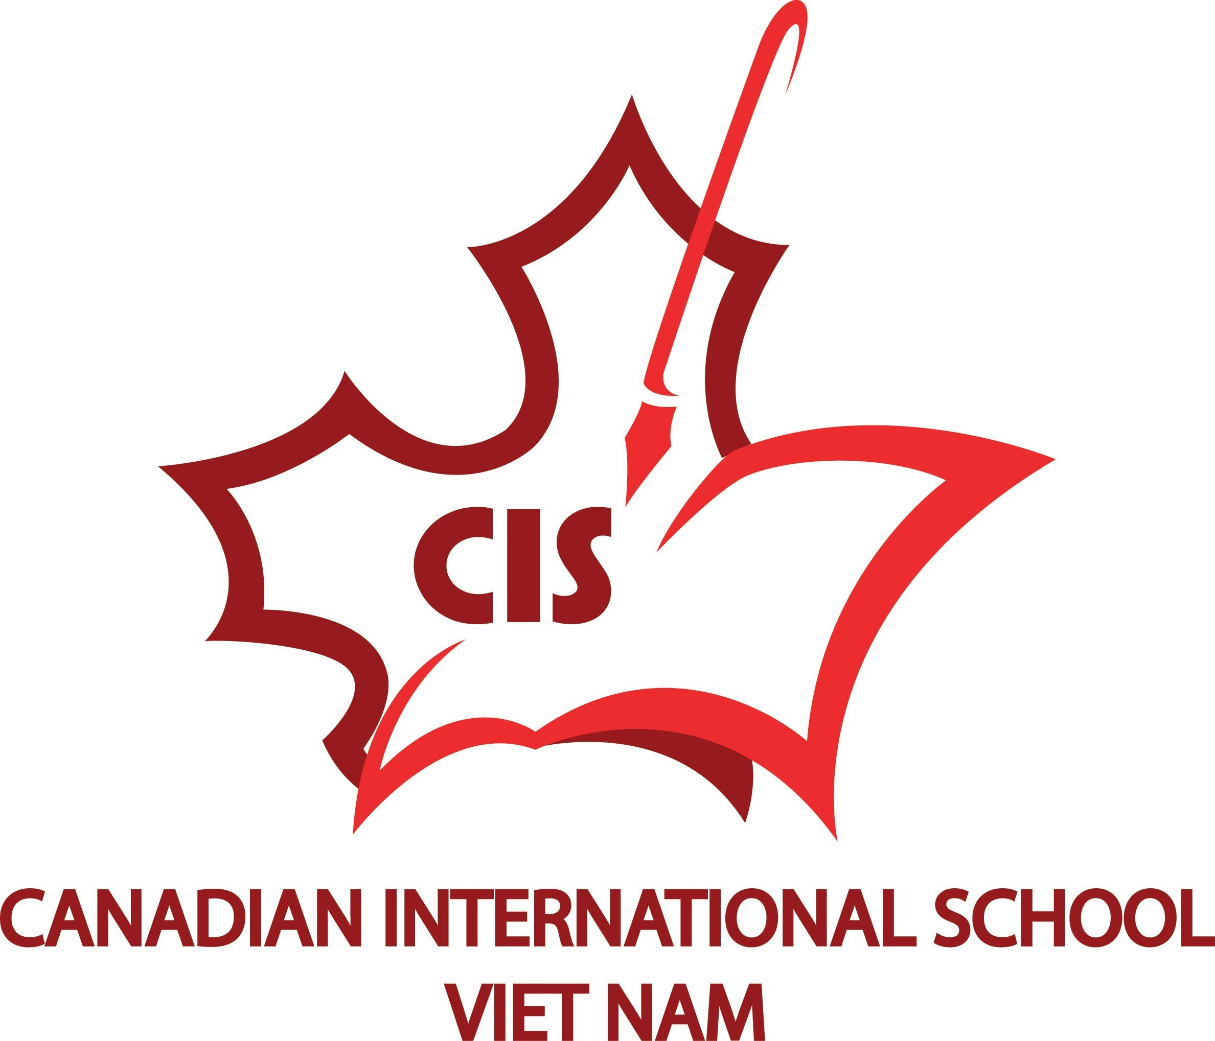
Position of Elementary Principal
CANADIAN INTERNATIONAL SCHOOL
HO CHI MINH CITY, VIETNAM

Commencing August 1, 2016 for a two-year contract period
The Canadian International School System – Vietnam (CISS) consists of
- The Canadian International School (CIS) serving Kindergarten – Grade 12 students where the Ontario curriculum is taught. The IB Diploma Programme is also offered to students in Grades 11 and 12.
- The Bilingual Canadian International School (BCIS) serving Grade 1 -12 where both Vietnamese and Ontario curriculum are taught.
- The Canada-Vietnam Kindergarten (CVK) serving children ages 2 – 5 years.
- The Albert Einstein School (AES) where the Vietnamese curriculum is taught and students learn English 17 periods per week.

The Board of Directors of the Canadian International School System Vietnam (CISS) is seeking a dynamic, experienced and committed educational leader for the position of Elementary Principal for their Canadian International School (CIS) located in Ho Chi Minh City, Phu My Hung, District 7, Vietnam.
The Canadian International School delivers the Ontario Curricula in English. In lieu of French language study, all Vietnamese National students must study Vietnamese language and culture for a total of 200 minutes per week; non Vietnamese students study French in accordance with the Ontario Curriculum. Currently CIS houses 870 students, of which 680 are studying from Kindergarten through to Grade 8.
CIS is committed to providing outstanding learning opportunities for students to demonstrate academic excellence, life skills and character development. The School Improvement Plan is built on four pillars: Literacy, Numeracy/Math, Character Education and Life of the School. Through our Consultancy Agreement with the Toronto District School Board, Grade 12 CIS students study their Grade 12 Program on line and are eligible to graduate with an Ontario Secondary School Diploma (OSSD). In 2016 – 2017 CIS began offering the IB Diploma Programme.
Currently CIS employs 65 teachers all of whom are qualified or eligible to be qualified through the Ontario College of Teachers (OCT). The Leadership Team consisting of an Elementary Principal and Vice Principal and a Secondary Principal and Vice Principal works closely with the Curriculum Council comprised of Division Leads - teachers from each division (Kindergarten, Primary, Junior, Intermediate and Senior) specialty teachers representing Arts, Athletics, Community, Action Service (CAS), English Language Learning (ELL), Language teachers - French and Vietnamese, Library, Student Success, Student Services and Technical Committee.
The Principal is an employee of the CISS and will report to the Board of Directors of the CISS, Ho Chi Minh City, Vietnam

Responsibilities of the Principal

- Supports the CISS educational vision and strategic directions in building a world class private school system as determined by the Board of Directors;
- Supports the work of the Board of Directors on new initiatives to widen the scope of CIS’s programs and activities;
- Is accountable for student achievement and well-being, student enrolment and retention, and sustainability of a highly qualified staff;
- Demonstrates the ability to work collaboratively with the Board of Directors, the Leadership Team of Principals and Vice Principals, the Operations Manager, all academic and administrative staff, parents and community partners;
- Inspires confidence of CIS parents and community in the delivery of education for all students as a world class private school;
- Supports the strategic and systematic professional learning of the teaching staff of CIS;
- Demonstrates expertise as an effective K-8 educational leader who is student-centered, able to build a culture of excellence, and lead staff with programs and instruction that will engage and meet the needs of CIS students;
- Supports quality partnerships that support the work of the staff in the provision of a rich program of co-curricular, sports and athletics, and outdoor learning and leadership experiences and arts education that students experience a holistic values-based education;
- Promotes and models strategic use of data to improve learning and ensure a safe, caring and dynamic learning environment and school culture;
- Co-implements with the Principals and Vice Principals of BCIS and CVK the annual school improvement planning process for all 3 schools and works to ensure the School Improvement Plans are aligned and coherent with the Board of Directors’ vision and strategic directions;
- Supports the Board of Directors in the effective development and result-oriented implementation of curriculum and co-curriculum that ensures students success as English as a Second Language Learners;
- Assists in the hiring and supervision of academic staff to ensure high quality teaching and teaching methodologies that meet the needs of students where English is their second language
- Collaborates with Admissions and Public Relations Marketing Staff in the public relations, marketing, and admissions processes;
- Collaborates with the Ministry of Education and Training (MOET) Vietnam, District of Education and Training (DOET) Ho Chi Minh, and the Toronto District School Board as the consulting District School Board to CISS.

Professional Qualifications
- Ontario Principal’s Qualifications
- Demonstrated Vice Principal Experience
- International or private school experience preferred
- PYP (Primary Years) and MYP (Middle Years) experience an asset

Professional Attributes and Experience
- Proven ability to motivate, lead and supervise staff in a Kindergarten - Grade 8 school;
- Evidence of data-based decision making
- Experience in developing and implementing school improvement plans
- Superior leadership ability;
- Excellent communication and organizational skills,
- Demonstrated commitment to student success;
- Successful academic leadership experience in education or education-related fields.
- Experience in the international environment.
- Experience in working with English Language Learners and/or in Extended Language or Immersion Programs
- Proven cultural competencies
- Ability to work well under pressure
- Demonstrated ability in public relations

The CISS invites qualified, capable and highly effective educational leaders to apply for the above position. This position is for the period stated above and can be extended by mutual agreement of the parties. Candidates must have a willingness to adapt to a different cultural context and to work as a team in a challenging educational environment.
Remuneration
Remuneration is based on experience and qualifications. It also includes housing allowance, costs of flight to and from Canada to Ho Chi Minh City once per year, a one-time settling-in allowance, transportation to and from school, lunches each day from the school cafeteria, and free tuition for children of the successful applicant. Basic medical and health insurance is provided.

Application Process
- Review online information about CIS by visiting http://www.cis.edu.vn/en-us/home.aspx
- Submit the following:
- Your cover letter;
- Your resume;
- The names and contact information (tel. number(s). and email addresses) of three professional references. Your referees are, preferably, those who have been in a supervisory role to you and who can be readily contacted to provide a reference by phone or email.
- Make your application to the President of the CISS Board of Directors, Nguyễn Thị Kiều Oanh at nguyenoanh@cis.edu.vn

If you have questions, please contact: Ms. Nguyen Thi Kim Ngan at ngan.nguyen@admin.cis.edu.vn

Only applicants selected for an interview will be contacted.

