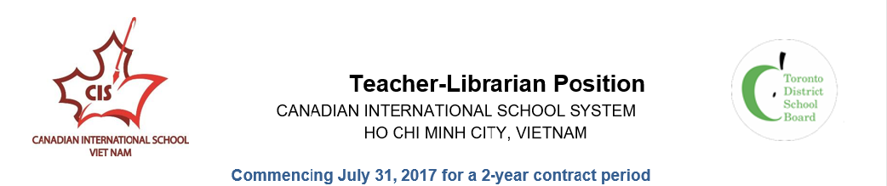
The Canadian International School System – Vietnam (CISS) consists of
· The Canadian International School (CIS) serving K - Grade 12 students where the Ontario curriculum is taught.
· The Bilingual Canadian International School (BCIS) serving Grade 1 -12 where both Vietnamese and Ontario curriculum are taught.
· The Canada-Vietnam Kindergarten (CVK) serving children ages 2 – 5 years.

The Board of Directors of the Canadian International School System Vietnam (CISS) is seeking a dynamic, experienced and committed educator for the position of Teacher-Librarian (K-12) for their Bilingual Canadian International School (BCIS) located in Ho Chi Minh City, Vietnam.
The Bilingual Canadian International School-Vietnam (CIS) is an international private school, with a student population of 700 students from grades 1 to 12. BCIS accepts Vietnamese nationals and students of other nationalities. Students study in their native language for approximately 50% of their day following the Ministry of Education Vietnamese curriculum. During the English portion of the day students develop English language skills of reading, writing, communication (listening and speaking), and media literacy following the Canadian Language curriculum. BCIS provides outstanding learning opportunities for students to demonstrate academic excellence, life skills and character development, graduating to reputable post-secondary institutions. Students of the BCIS gain their Vietnamese High School Diploma

The Teacher-Librarian will be an employee of the CISS and will report to the Secondary and Elementary Principals of the CISS, Ho Chi Minh City, Vietnam

Responsibilities of the Teacher-Librarian

- Employ assessment for learning and assessment as learning within the library program, as set out in Growing Success: Assessment, Evaluation and Reporting in Ontario Schools
- Offer opportunities for critical literacy and implement strategies found in the Literacy and Numeracy Secretariat’s Building Capacity Series: Critical Literacy Special Edition 9, August, 2009
- Implement CISS policy in the selection of learning resources for the library
- Follow protocols if concerns regarding controversial and sensitive issues in learning resources are raised
- Create a warm and welcoming environment with flexible areas for collaborative learning
- Develop a culturally inclusive and curriculum-relevant collection
- Ensure all Health and Safety, and school policies are reflected in the library’s physical and virtual spaces
- Encourage the placement of assistive technologies and devices in the library
- Collaborate fully with teachers in design, delivery, and assessment
- Explicitly teach transferable skills such as search strategies and resource evaluation
- Create pathfinders and booklists to support curricular activities
- Apply Achievement Chart criteria of Knowledge and Understanding, Thinking, Communication, and Application to research and inquiry

...2
-2-

- Use appropriate tools to assess learning, i.e. anchor charts, organizers and templates, checklists, rubrics, portfolios and surveys
- Teach software and digital applications for student learning, collaboration, and creating/demonstrating new knowledge if applicable
- Plan for project-based research tasks that provide authentic learning experiences
- Demonstrate models of inquiry/research
- Build lesson and unit design around stages of inquiry
- Incorporate a gradual release of responsibility
- Use a skills continuum for research across all grades and subjects
- Provide assessment for and assessment as learning as part of instructional practice
- Maintain a current, engaging collection in a variety of genres, formats, and levels of complexity
- Work with CISS Purchasing officer(s) and Storekeeper(s) to order, inventory, and manage all print resources for CIS, including all textbooks
- Ensure opportunities for critical literacy for student discussion, reflection, and sharing
- Run supplementary reading programs and book clubs
- Organize book fairs and literacy nights for parents and students
- Participate in city-wide literacy programs and events
- Include authors and topics that reflect the diversity of the CISS student population
- Use displays, newsletters, school announcements, and online communications to build circulation
- Collaborate with teachers to suggest current and engaging titles for literature circles, class novel studies, and student independent reading
- Collaborate with the second teacher-librarian in the CIS library for co-planning and efficient use of human resources and library resources and materials
- Provide explicit instruction for the use of online databases, websites for learning, and online tools for collaboration
- Model use of new presentation tools and software within library program
- Match new technologies to student need and preferences for online collaborative activities
- Offer workshops for teachers to build technological capacity
- Provide opportunities for student use of mobile devices
- Promote free digital resources that expand opportunities for learning
- Provide orientations for students, teachers, and parents/guardians
- Attend School Council meetings as requested
- Present library program and resources to parents/guardians
- Seek out and maintain community partnerships
- Build connections with post-secondary institutions for both student use and planning

Professional Qualifications
- Ontario Certified Teacher with some Teacher-Librarian experience in a school setting
- Part 2 or Specialist Qualifications in Library; those with Part 1 Library will be considered
- Qualifications in Literacy/Reading/Writing/ESL an asset
- Experience with library management software (i.e. Follett or Horizon) an asset

...3
-3-

Professional Attributes and Experience
- Proven ability to motivate and lead students and staff
- Proven ability to develop the capacities of staff by building on their strengths;
- Superior leadership ability;
- Excellent communication and organizational skills
- Demonstrated commitment to student success;
- Experience in the international environment;
- Experience in a bilingual program with English as a second language is an asset.

The CISS invites qualified, capable and highly effective teachers to apply for the above position. This position is for the period stated above and can be extended by mutual agreement of both parties. Candidates must have a willingness to adapt to a different cultural context and to work as a team in a challenging educational environment.

Remuneration
Remuneration is based on experience and qualifications. It also includes housing allowance, costs of flight to and from Canada (Toronto or Vancouver) to Ho Chi Minh City once per year, a one-time settling-in allowance, free tuition for the first child, and 50% for the second child, of successful applicant. Basic medical and health insurance is provided.

Application Process
Review online information about CIS by visiting: http://bcis.edu.vn
Submit the following:
· Your cover letter;
· Your resume;
· The names and contact information (tel. number(s). + email addresses) of three professional references. Your referees are, preferably, those who have been in a supervisory role to you and who can be readily contacted to provide a reference by phone or email.

- Submit your application online to: http://surveys.tdsb.on.ca/index.php?r=survey/index/sid/521923/lang/en

If you have questions, please contact Bonnie.Thibodeau@admin.cis.edu.vn

Only applicants selected for an interview will be contacted.

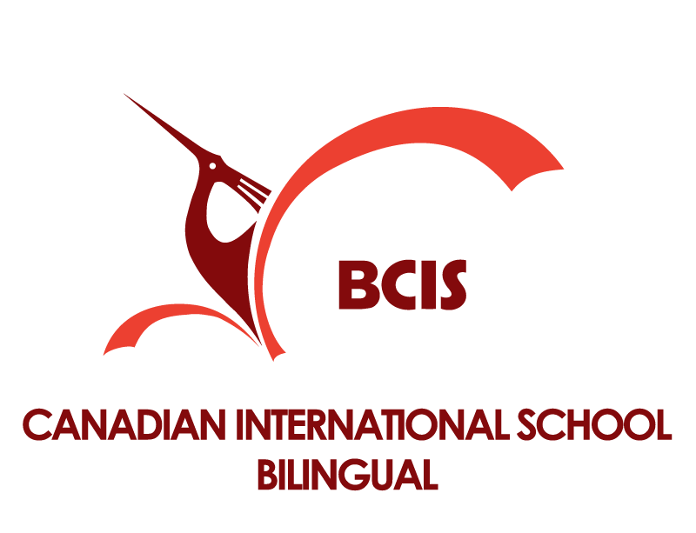
Canadian International School - Bilingual –Vietnam
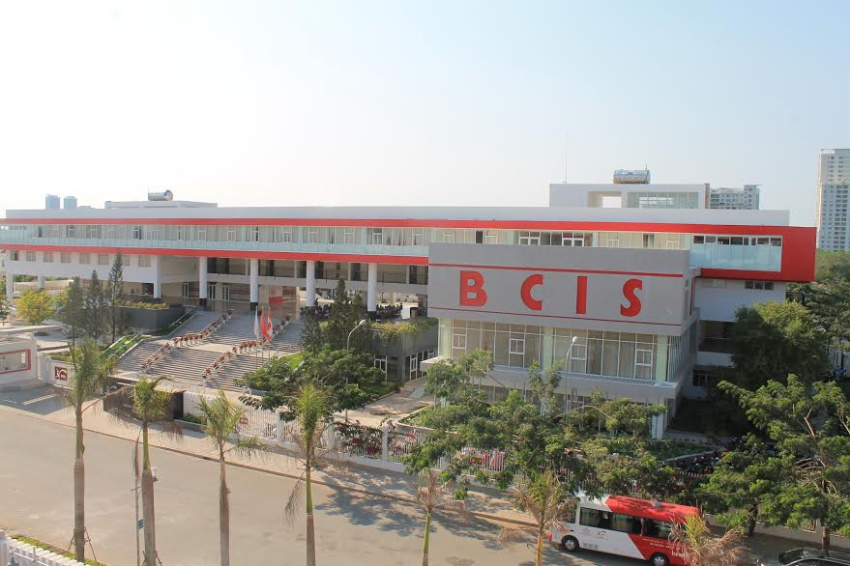

The Canadian International School Bilingual-Vietnam (BCIS-VN) is a renowned International private school in Ho Chi Minh City, Vietnam. BCIS-VN has received approval from the Ministry of Education and Training in Vietnam and the Department of Education and Training in Ho Chi Minh City to accept both Vietnamese nationals and expatriate nationals learning together as students in our school. The school’s languages of instruction are Vietnamese and English. The Canadian International School - Bilingual is committed to providing outstanding learning opportunities for our students to demonstrate academic excellence. We have chosen to follow the structure and curriculum used in Canadian public schools in the Province of Ontario, Canada for the English program in our school.
The BCIS-VN Academic Leadership Team (1-12) is comprised of experienced and accredited system and school leaders from Ontario who are building a professional learning community in an international setting committed to enhancing student learning and achievement. At BCIS we understand the importance of providing a supportive and stimulating learning environment for all of our students. We are committed to the intellectual and personal development of each student and our core objectives, we believe, prepare all students for a purposeful life as a global citizen in the 21st century.
We know our greatest asset is our teaching staff. We recruit Canadian trained, Ontario certified educators who are members in good standing with the Ontario College of Teachers. Delivering instruction using the inclusive Ontario curriculum at all grade levels Grade 1–Grade 12, our dedicated teachers provide a caring environment committed to the individual success of each student. Our Character Education in Action program is exemplary.

