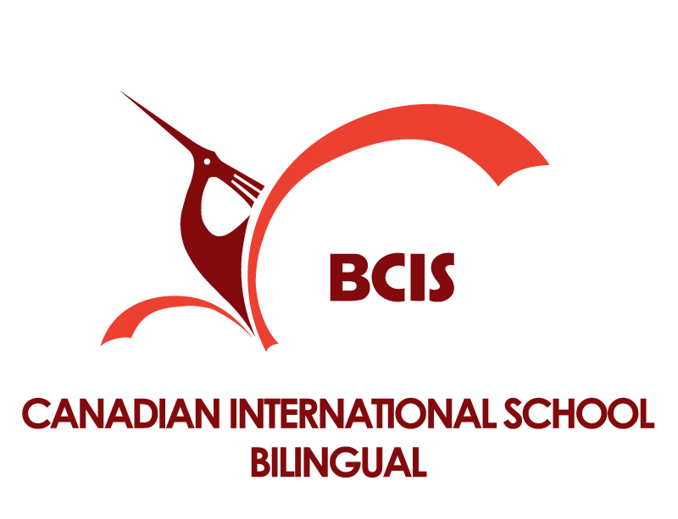
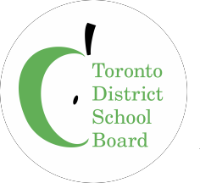

International Teaching Position

Elementary / Secondary
Bilingual Canadian International School

At the Canadian International School System-Vietnam (CISS) Ho Chi Minh City

The Canadian International School System (CISS) operates four school programs in Ho Chi Minh City, Vietnam. CISS consists of the Canadian International School—Vietnam (CIS), the Bilingual Canadian International School—Vietnam (BCIS), the Canada-Vietnam Kindergarten (CVK) and the Albert Einstein School – Vietnam (AES).

The Toronto District School Board (TDSB) provides staffing and recruitment consulting services to CISS-VN for CIS, BCIS, CVK and AES. The TDSB also provides consulting services on programming to assist CISS-VN meet and maintain the curriculum standards based on the Province of Ontario standards. All applications are provided to CISS. Applicants are hired by CISS, and if successful, will be an employee of the CISS—VN, reporting to the CISS-VN Principal.

The positions listed in this posting are for the duration of 2-years. The contract period may be extended upon mutual agreement.

Current TDSB staff, who would like to apply, will be considered for a leave of absence from Toronto DSB to CIS- Vietnam when successful in his/her application.

Positions | Subject (s) | Grades
- Elementary classrooms  - Intermediate classrooms  - High School classrooms | - Listening, Speaking, Reading and Writing for EAL students  - Additionally, for HS Subject qualifications in social sciences/business would be an asset. | Grades 1-5  Grades 6-8  Grades 9-12

Required Qualifications and Commitments:
- Teacher certification in the subject specialization and division for the above position
- A valid Ontario Certificate of Qualification and in good standing with the Ontario College of Teachers (or have eligibility to become in good standing with OCT with another Canadian certification)
- English as a Second Language Part 1 additional qualification, or willing to undertake in 2018 – 2019 as an online AQ course

The Ideal Candidate will:
- contribute effectively to the ongoing success of the school in providing high quality education for all students, showing flexibility in working as a member of a small team;
- develop students as global learners and citizens, through a caring and safe learning environment;
- support all students in developing a love of learning and in achieving their full potential;
- ensure that all students develop literacy competencies through creativity, communication, collaboration, and thinking skills;
- develop caring and positive relationships with students and staff modelling attributes of the character education program;
- participate fully in the development of short and long range teaching and implement effective teaching and learning strategies that include use of technology; using meaningful and authentic print and digital learning resources;
- develop assessment, evaluation, and reporting strategies and practices specific to EAL students;
- work as a member of the professional learning community to provide rich learning experiences for students;
- work with the school leadership team in the implementation of school improvement work;
- inspire public confidence in BCIS programs through positive relationships with the school community.

Experience:
- Demonstrated ability to work effectively with teachers, parents, administrators, and students.
- Experience in teaching in an EAL environment would be an asset.
- Experience working or living abroad would be an asset.
- Experience with PM levels and STEP assessment would be an asset.

Remuneration:
Remuneration is based on experience and qualifications and includes:

- Housing allowance;
- Costs of flight to and from Toronto or Vancouver to Ho Chi Minh City once per year;
- A one-time settling-in allowance;
- Free tuition for the first child and a 50% reduction in tuition fees for the second child;
- Basic medical and health insurance up to $1,000 USD provided.

Start Date:
The position is for 2018-2020 school years beginning July 30, 2018.

Application Process:
Submit the following:

- Your cover letter;
- Your resume;
- The names and contact information (tel. number(s). + email addresses) of three (3) professional references.
Your referees are, preferably, those who have been in a supervisory role to you and who can be readily contacted to provide a reference by phone or email.

- Submit your application online to: http://surveys.tdsb.on.ca/index.php?r=survey/index/sid/521923/lang/en

If you have questions, please contact: Barb Gage, BCIS Principal
Barb.Gage@admin.cis.edu.vn

ALL applications to be submitted to both

http://surveys.tdsb.on.ca/index.php?r=survey/index/sid/521923/lang/en

and
CIS Human Resources jobapplication@admin.cis.edu.vn

Only applicants selected for an interview will be contacted.

Canadian International School - Bilingual – Vietnam

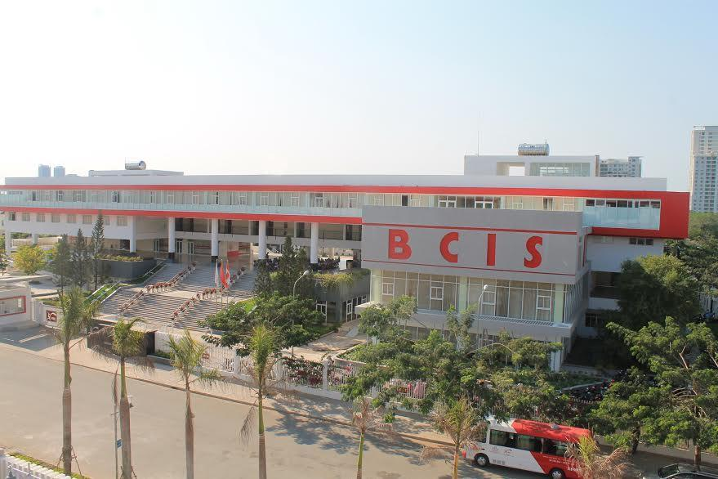

The Canadian International School Bilingual-Vietnam (BCIS-VN) is a renowned International private school in Ho Chi Minh City, Vietnam. BCIS-VN has received approval from the Ministry of Education and Training in Vietnam and the Department of Education and Training in Ho Chi Minh City to accept both Vietnamese nationals and expatriate nationals learning together as students in our school. The school’s languages of instruction are Vietnamese and English. The Bilingual Canadian International School - is committed to providing outstanding learning opportunities for our students to demonstrate academic excellence. We have chosen to follow the structure and curriculum used in Canadian public schools in the Province of Ontario, Canada for the English program in our school.

The BCIS-VN Academic Leadership Team (1-12) is comprised of experienced and accredited system and school leaders from Ontario who are building a professional learning community in an international setting committed to enhancing student learning and achievement. At BCIS we understand the importance of providing a supportive and stimulating learning environment for all of our students. We are committed to the intellectual and personal development of each student and our core objectives, we believe, prepare all students for a purposeful life as a global citizen in the 21st century.

We know our greatest asset is our teaching staff. We recruit Canadian trained, Ontario certified educators who are members in good standing with the Ontario College of Teachers. Delivering instruction using the inclusive Ontario curriculum at all grade levels Grade 1– 12, our dedicated teachers provide a caring environment committed to the individual success of each student. Our Character Education in Action program is exemplary.

For more information, visit http://bcis.edu.vn

