TDSB Logo colour

**OFFICE OF THE DIRECTOR OF EDUCATION**

5050 Yonge Street, Toronto, Ontario M2N 5N8

January 1, 2018

Pat Rocco  
Executive Superintendent  
Employee Services  
  
Dear Pat,  
  
During the 2017-2018 school year, I would ask you to focus on the following key areas while fulfilling all of the duties of your position:

* Review all promotion processes and revise as appropriate so that our commitment to leadership culture is honoured through these processes.
* Determine how to improve Employee Services so that the department is seen as responsive.
* Develop a strategic plan for the work of the Professional Learning Unit with an emphasis on orientation activities, training and the system tools needed for our improvement efforts (e.g. Coaching, facilitation, etc.) in conjunction with Teaching & Learning.
* Determine how to improve relationships with all unions and employer.
* Support all of Senior Team to be more effective in terms of Employee Services using the Learning Centre model.
* Review and revise PR560 as appropriate to ensure effective investigations in a timely and compassionate manner for all involved in conjunction with our education partners.

I ask that you collaborate intentionally and strategically with the following colleagues to achieve the above:

* Manon Gardner, Jim Spyropoulos, Colleen Russell-Rawlins and Uton Robinson.

Thank you for your Executive leadership in TDSB.  
  
Sincerely,

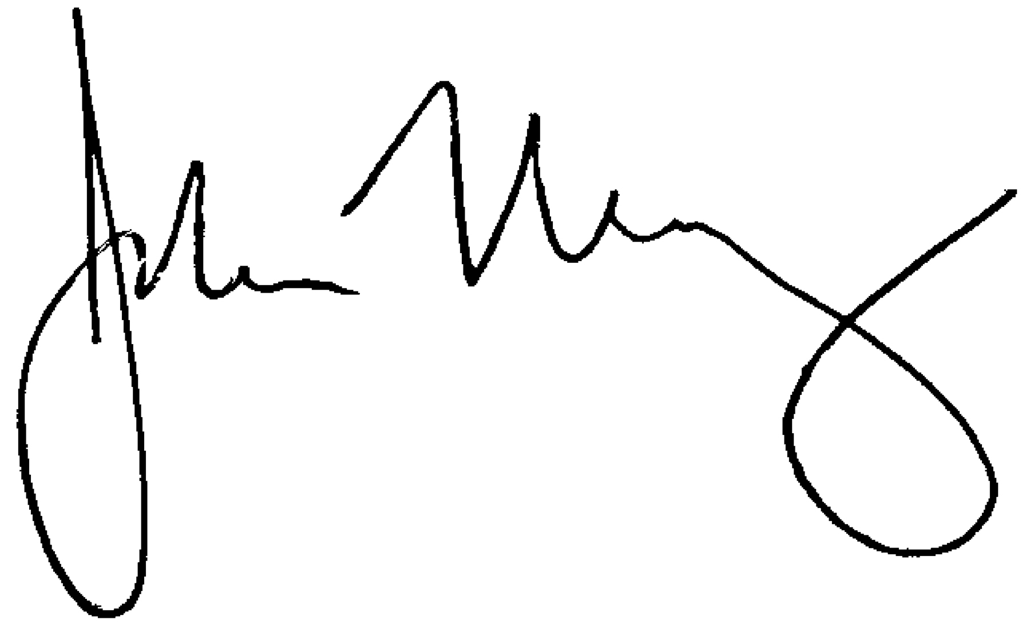

John Malloy

Director of Education