OFFICE OF THE DIRECTOR OF EDUCATION
5050 Yonge Street, Toronto, Ontario M2N 5N8

January 1, 2018

Christopher Usih
Associate Director
Dear Christopher,

During the 2017-2018 school year, I will focus on the following key areas while fulfilling all of the duties of my position:

- Strengthen our well-being efforts and oversee implementation of Student Support Initiatives (Professional Support Services and Mental Health Strategy) aligned with the Integrated Equity Framework.

- Build capacity of staff through ongoing professional learning, to create the conditions for every staff member in every school to improve the well-being of their students aligned with the area of focus that was determined in each school.

- Create opportunities for Speech Language Pathologists and Early Years to work together to improve oral language development and early literacy (in collaboration with the Exec Lead for Early Years)

- Collaborate with senior team to support our improvement efforts for all students (especially students with special learning needs).

- Support the Director on any matters related to the entire system as assigned.
Thank you for your Executive leadership in TDSB.
Sincerely,
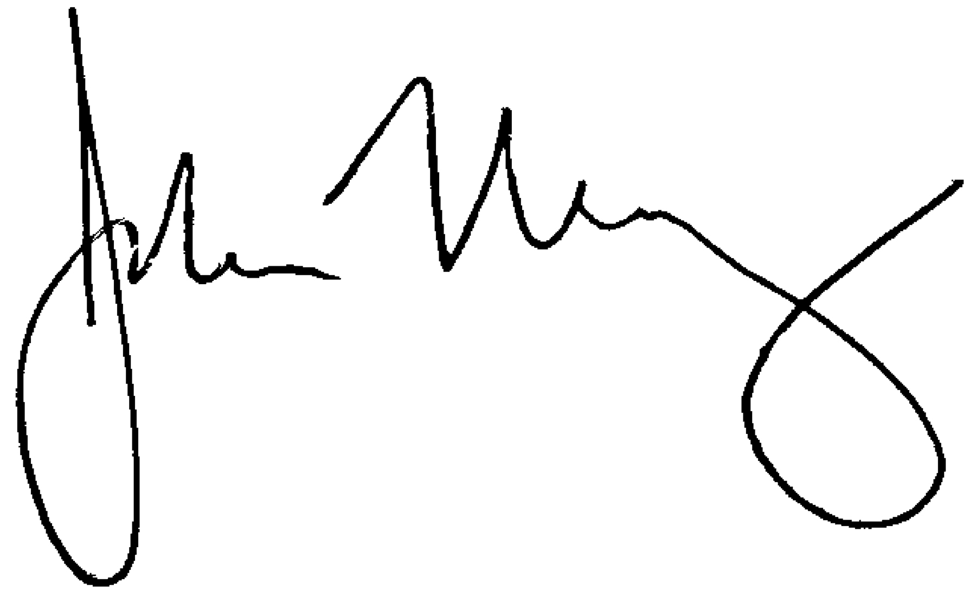
John Malloy
Director of Education

